Ultrasonic extraction and quantification of artichoke antioxidants (Cynara scolymus)

Name: Fabiola Mallon Mercado
Instituto Politecnico Nacional CICATA Unidad Legaria, CP 11500, MX

Abstract

The Artichoke (Cynara scolymus) is an herbaceous plant originally and cultivated mostly in the Mediterranean region of Europe where it has been studied and appreciated for its goodness in health, for which it is known and consumed worldwide. In Mexico there is a minor crop of this plant, although it is not yet mass consumption in the population, the interest of this research is to study and characterize the artichoke produced in Mexico, comparing its properties with what has already been reported, also with these results to promote and publicize the benefits of including it in food.
The ultrasonic extraction methodology (UAE) was used, through which it was possible to obtain an extract with a total phenolic content of: 124±19 mg EAG / g ES, flavonoid content: 80±17 mg EC / g ES , iron reducing capacity: 610±43 µM ET / 1000ppm, the EC50 value for the DPPH of 110±0.4 ppm and the mass extraction yield was 8.33%. With these results it is concluded that the artichoke has an important phenolic and antioxidant content so there is potential in its use as a source of bioactive compounds with antioxidant activity in the food industry.

Image
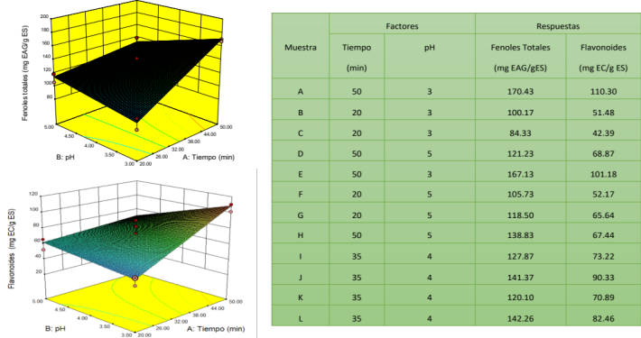
Figure. Design of experiments and response surfaces
Recent Publications (minimum 5)
- Kuklinski, C. Farmacognosia : Estudio de Las Drogas y Sustancias Medicamentosas de Origen Natural; Omega, 2000.
- Mocelin, R.; Marcon, M.; Santo, G. D.; Zanatta, L.; Sachett, A.; Schönell, A. P.; Bevilaqua, F.; Giachini, M.; Chitolina, R.; Wildner, S. M.; et al. Hypolipidemic and Antiatherogenic Effects of Cynara Scolymus in Cholesterol-Fed Rats. Brazilian J. Pharmacogn. 2016, 26 (2), 233–239. https://doi.org/10.1016/j.bjp.2015.11.004.
- Lattanzio, V.; Kroon, P. A.; Linsalata, V.; Cardinali, A. Globe Artichoke: A Functional Food and Source of Nutraceutical Ingredients. J. Funct. Foods 2009, 1 (2), 131–144. https://doi.org/10.1016/j.jff.2009.01.002.
- Pandino, G.; Lombardo, S.; Mauromicale, G.; Williamson, G. Profile of Polyphenols and Phenolic Acids in Bracts and Receptacles of Globe Artichoke (Cynara Cardunculus Var. Scolymus) Germplasm. J. Food Compos. Anal. 2011, 24 (2), 148–153. https://doi.org/10.1016/J.JFCA.2010.04.010.
- Mohamed Abdel Magied, M.; Din Hussien, S. EL; Mohamed Zaki, S.; Mohamed Said, R. EL. Artichoke (Cynara Scolymus L.) Leaves and Heads Extracts as Hypoglycemic and Hypocholesterolemic in Rats. J. Food Nutr. Res. 2016, 4 (1), 60–68. https://doi.org/10.12691/jfnr-4-1-10.


Biography
Fabiola Mallon is Food Engineer, currently specializes in obtaining, studying and characterizing natural extracts and a passion to improve health and well-being through the benefits of natural foods. She joined the postgraduate Biomaterials team which specialize in the subject, improving the study and evaluation techniques learned. Uses a method of economic extraction, fast and low energy achieving good results that will soon be applied to an in vivo model followed by the design of a new product qualified as functional food.
Email: fabiola.mallon@gmail.com

Notes/Comments:

