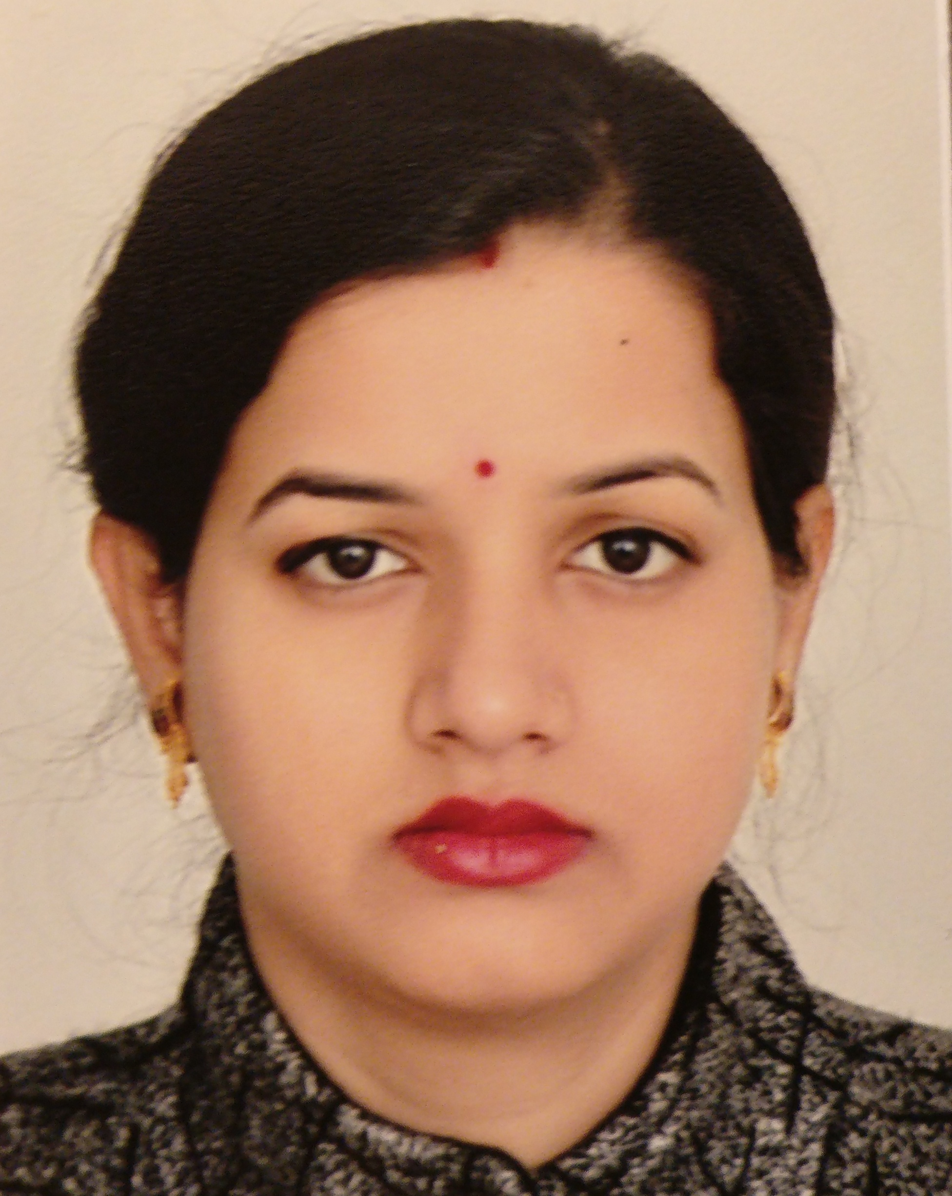
Title: Protective effect of Exacum lawii and its isolated compound swertiamerin on cisplatin induced toxicity in human embryonic kidney cells (HEK-293)

Name: Sonam Sharma
Department of Pharmaceutical Engineering & Technology, Indian Institute of Technology, Banaras Hindu University, Varanasi-221005, India

Ethnopharmacological relevance: Exacum lawii C.B. Clarke (Gentianaceae), bitter folklore medicinal herb. Indigenous practitioners in Satara district of Maharashtra and bababudan hills of Mysore, Karnataka used to treat kidney problems. Purpose: To isolate marker compound swertiamerin from Exacum lawii extract and to demonstrate effect of Exacum lawii extract and isolated swertiamerin in cisplatin treated Human embryonic kidney cell line (HEK-293).
Methods: The swertiamerin was isolated from Exacum lawii by column chromatography and characterized using analytical techniques. Its potency and selectivity was explored to inhibit the iNOS enzyme using docking studies. MTT cytotoxicity assay was performed for cisplatin, Exacum lawii and swertiamerin. Nephroprotective action of Exacum lawii extract and swertiamerin was evaluated in HEK-293 by measuring iNOS expression using western blot analysis, proinflammatory cytokine level, ROS estimation, cell cycle analysis using flow cytometry, DNA fragmentation assay was done by gel electrophoresis and morphology of cells were also observed. Results: Docking study of swertiamerin showed binding energy -6.38 Kcal/mol. Predicted Inhibition constant was 21.17 mM and it was properly positioned in the enzyme cleft and showed optimal interactions with active site of iNOS. The western blot assay showed selectively inhibition iNOS expression by swertiamerin and extract in cispaltin treated HEK-293. Exacum lawii extract was significantly more effective than swertiamerin alone, by attenuating the oxidative stress, inflammation and apoptosis in the HEK-293 cell line and DNA damage. It also preserves the morphology of cisplatin treated cells. Conclusion: Our results suggested that Exacum lawii might be a promising new protective strategy against cisplatin-induced nephrotoxicity.

Biography

Sonam Sharma has completed his PhD at the age of 30 years from Department of Pharmaceutical Engineering & Technology, Indian Institute of Technology, Banaras Hindu University. She has published more than 4 papers in reputed journals.

Presenting author details
Full name: Sonam Sharma
Contact number:+917068835255, +33638256061
Category: (Oral presentation/ poster presentation)

