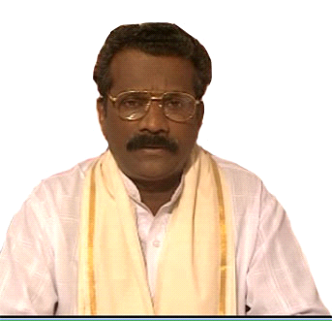

Brahma Meditation Therapy an Alternative Treatment to Cure Chronic Diseases due to Negativity
Ravi.M.D, Santosh. K.M. & T.K.Prasad
(www.brahmadharmalayam.org)
1 Affiliation for first author:
Brahmadharmalayam Super Spirituality Healing Center, Mamood, Changanasserry, Kottayam, India, drmdravimaster@yahoo.com
2 Affiliation for second author:
Dept. of Physical Oceanography, Cochin University of Science & Technology, Cochin-682016, India, drsantoshkm@cusat.ac.in
2 Affiliation for second author:
Advocate, Mavelikkara Court, Kerala, India

Objective / Purpose:
To introduce and give emphasis on Negativity
How to remove Negativity from human beings by using spiritual power and heal them
To help the world suffering community, who are rejected by modern medical sciences due to chronic diseases.
Abstract:
Patients with Chronic diseases rejected my Modern Medical Sciences are treated through Brahma meditation therapy an alternative treatment to remove negativity and cure the patient through spiritual powers. At present era “Negativity” plays a great role in human beings, which cause numerous diseases in human body. This can produce cancer, psoriasis, congestive heart failure, severe backache, migraine, mental diseases and others like suicidal tendency, alcoholic addiction, quarrel and negative approaches towards life etc. This treatment is a great astonishment and this sort of treatment is existed in this world since ancient period but due to the growth of modern science, we rejected these types of treatments. This paper discusses in detail about the unique treatment Brahma meditation therapy.
Key words: Negativity, Brahma Meditation Therapy, Chronic Disease
Biography
M.D. Ravi has awarded PhD at the age of 48 years by Indian Board of alternative Medicines, Kolkatta (Affiliated with The Open International University for Complementary Medicines) Also he has achieved Doctor of Medicine in Alternative medicine from the same Institute. He is the Supreme of Brahmadharmalayam, Kottayam, India.
K.M.Santosh who has been awarded PhD from Mangalore University, India in 2004 in the discipline of Bio-Science. He has worked in prestigious Institutions abroad and India. Presently working as a Facullty in CUSAT, India.

