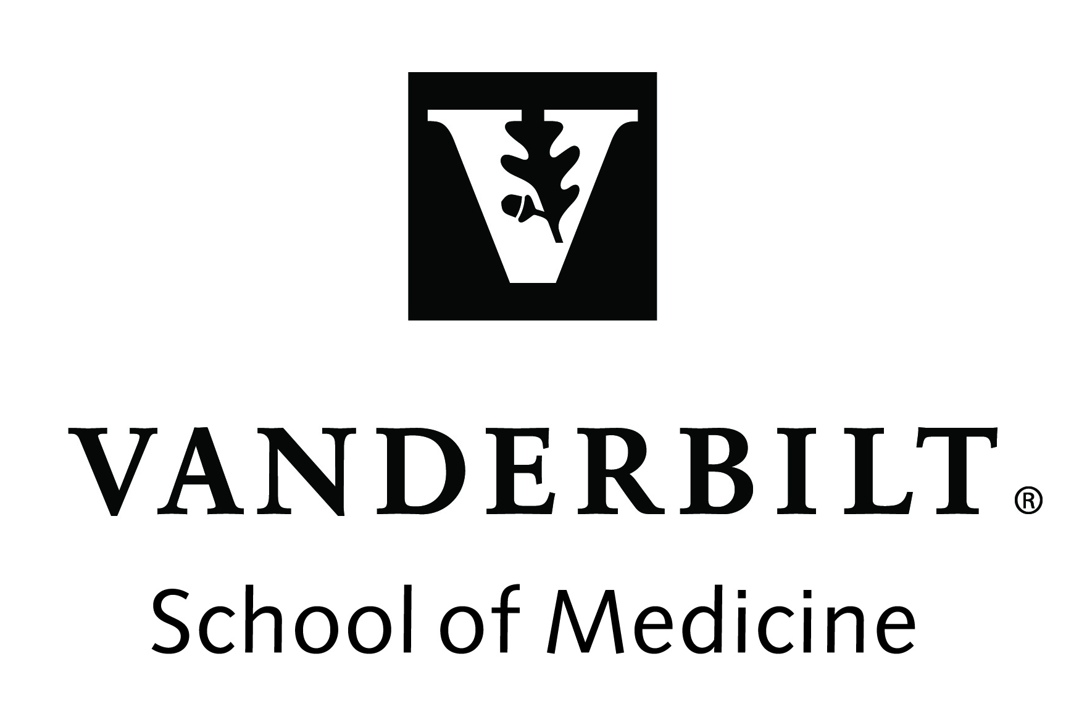
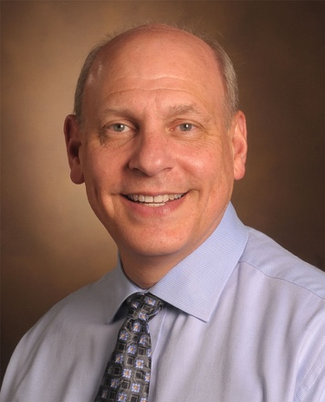

Title: Phytochemicals as Anticancer and Chemopreventive Topoisomerase II Poisons

Name: Neil Osheroff

Vanderbilt University School of Medicine, TN 37232, USA

Phytochemicals are a rich source of anticancer drugs and chemopreventive agents. Several of these chemicals appear to exert at least some of their effects on human health through interactions with human type II topoisomerases. These ubiquitous enzymes regulate DNA supercoiling (under- and overwinding) and remove knots and tangles from the genome. Topoisomerase II-active phytochemicals function by stabilizing covalent enzyme-cleaved DNA complexes that are requisite intermediates in the catalytic cycle of the enzyme. By doing so, they convert topoisomerase II to a cellular toxin that fragments the genome. Consequently, these compounds are referred to as topoisomerase II poisons. This talk will briefly familiarize the audience with the cellular and catalytic functions of type II topoisomerases and the mechanisms used by different classes of topoisomerase II poisons. It will go on to discuss the effects of several phytochemicals on the DNA cleavage activity of type II topoisomerases, including etoposide, a widely used anticancer drug that is derived from podophyllotoxin (from Podophyllum peltatum or mayapples) as well as chemopreventative bioflavonoids such as genistein (from Gylcine max or soybeans), catechins such as epigallocatechin gallate (EGCG, from Camellia sinensis or green tea), and polyphenols such as curcumin (from Curcuma longa or tumeric), thymoquinone (from Nigella sativa or black seed), and hydroxytyrosol and oleuropein (from Phillyrea latifolia L., Olea europea, and other members of the olive family). In addition to describing the effects of purified compounds on topoisomerase II-mediated DNA cleavage, the effects of plant extracts on type II topoisomerases will also be discussed.

Biography

Neil Osheroff received his Ph.D. in Biochemistry and Molecular Biology from Northwestern University in 1979 followed by a Helen Hay Whitney Foundation postdoctoral fellowship in the Department of Biochemistry, Stanford University School of Medicine. He currently is Professor of Biochemistry and Medicine in the Vanderbilt University School of Medicine and holds the John G. Coniglio Chair in Biochemistry. He directs the Academy for Excellence in Education, spent a combined 27 years on the editorial boards of The Journal of Biological Chemistry and Biochemistry, chaired the NCI-I “Transition to Independence” study section, and has authored over 250 scientific and educational articles.

