Yoga as an alternative Medical therapy
Rakhi Chawla, BAMS, MS NHRM, India
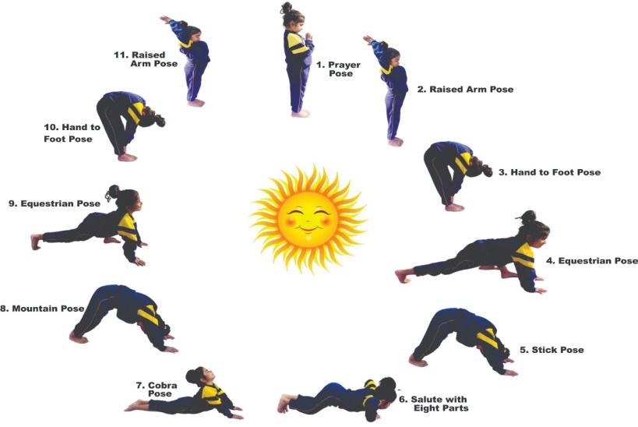
Gurpreet Kaur, Pre-doctoral scholar, T.I.E.T, India

Abstract (300 word limit)

Yoga is rooted in Indian philosophy and has been a part of traditional Indian spiritual practice for millennia.Yoga requires pratice, It is a combination of breathing exercises, physical postures, and meditation, practiced for over 5,000 years.Yoga is used to prevent specific diseases by keeping the energy meridians open and life energy flowing .Beyond the physical elements of yoga, which are important and effective for strengthening the body, yoga as alternative therapy also incorporates appropriate breathing techniques, mindfulness, and meditation in order to achieve the maximum benefits. Multiple studies have shown that yoga can positively impact the body in many ways, including helping to regulate blood glucose levels and treating type 2 Diabetes ¹, treatment for musculoskeletal discomforts² ,and helps in reversibility of Ischemic heart diseases³. It also has been shown to have important psychological benefits, as the practice of yoga can help to increase mental energy and positive feelings, and decrease negative feelings of aggressiveness, depression and anxiety⁴.Yoga can help in the management of bronchial Asthma⁵ andAasana (postures) and pranayam (breathing patterns) based on yoga has been outlined as effective method of exercises for post COVID rehabilitation.⁶ The most crucial aspect of exercises is the right technique and posture for the maximum benefit. Although there are multiple excercises or yoga postures for different remedies, Suryanamaskar is one of the most important exercise which is deals witth the whole body benefit and constitutes of 11 subsequent steps as shown in image. It consists of breathing, meditation, strengthening , acupressure and whole aspect of yoga.

Recent Publications
1.Arkiath Veettil Raveendran, Anjali Deshpandae, and Shashank R. Joshi Therapeutic Role of Yoga in Type 2 Diabetes,Endocrinol Metab (Seoul). 2018 Sep; 33(3): 307–317.
2.YOGA AS A TREATMENT FORMUSCULOSKELETAL DISCOMFORTS
• a hypothesis •Seyedeh Nahal Sadiri, Mothna Mohammed**, Farah Layth Naji**, Chemmy Pei Chian***,Bahram Sangelaji****
3.Yogendra J, Yogendra HJ, Ambardekar S, Lele RD, Shetty S, Dave M, et al. Beneficial effects of yoga lifestyle on reversibility of ischaemic heart disease: Caring heart project of International Board of Yoga. J Assoc Physicians India. 2004;52:283–9.
4.Yoga for anxiety: a systematic review of the research evidence
.G Kirkwood, H Rampes, V Tuffrey, J Richardson, K Pilkington, and S Ramaratnam
5.Vempati R, Bijlani RL, Deepak KK. The efficacy of a comprehensive lifestyle modification programme based on yoga in the management of bronchial asthma: A randomized controlled trial. BMC Pulm Med. 2009;9:37.
6Bhawna Verma,Zile Singh Kundu,Exercise and Yoga as Modalities for Post COVID-19 Rehabilitation .April 2021International Journal of Science and Research (IJSR) 10(2):75-85


Biography (150 word limit)
Dr. Rakhi Chawla is serving nation as Ayurvedic Medical Officer under the national rural health mission, Government of India since 10 years. She has done her Bachelors in Ayurvedic Medicines and Masters in Pschyology
Email: gsainibt@gmail.com

Notes/Comments:

Presenting author details
Full name: RAKHI CHAWLA
Contact number: 7009301798
Twitter account:
Linked In account:
Session name/ number:
Category: Poster presentation

