Wireless sensor network for monitoring and early warning system of landslides

Sangseom Jeong, Professor, Yonsei University, Korea
Kwangwoo Lee, Ph.D Student, Yonsei University, Korea

Abstract
Landslides induced by heavy rainfall cause significant damages to civil infrastructure. A lot of methods and technologies have been proposed to detect the landslides and slope movements. There have been increasing interests in developing and landslide monitoring systems to observe movements using sensors installed on the slope. Wireless sensor networks (WSN) are a promising new in-situ measurement technology for large areas. This study describes the wireless sensor network system for landslide detection and early warning system at regional scale that is able to check the landslide condition real-time in the Internet environment with monitoring data in connection with the field installed system. The system consist of a base station, nodes and sensors. Nodes are installed in a landslide hazard area to acquire data through sensors. The acquired data is transmits the base station. The base station collects data from each node and provides it to the Internet server. The sensors for detecting landslide are equipped with a tensio meter, soil moisture sensor, inclinometer, and rainfall gauge. In order to confirm the applicability, WSN was applied to actual mountain area in Seoul, Korea. As a result, the change of water content and matric suction due to rainfall could be measured at the watershed scale, and the most dangerous areas could be selected. The measurement data can be used as a landslide early warning system. It can also be used as initial input values or verification data of landslide analysis.

Image
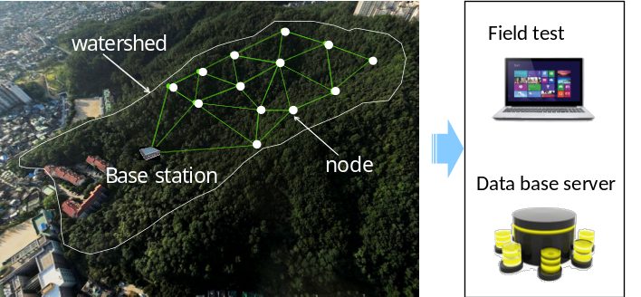
Figure 1 over view of the wireless sensor network system for landslide detection.
Recent Publications
- Yongmin Kim, Sangseom Jeong, Jaehong Kim (2016) Coupled infiltration model of unsaturated porous media for steady rainfall. Soils and Foundations 56:1071-1081.
- Sangseom Jeong, Yongmin Kim, Joonkyu Lee, Junghwan Kim (2015) The 27 July 2011 debris flows at umyeonsan, Seoul, Korea. Landslides 12:799-813.
- Junghwan Kim, Kwangwoo Lee, Sangseom Jeong, Gwangseob Kim (2014) GIS-based prediction method of landslide susceptibility using a rainfall infiltration-groundwater flow model. 182:63-78.
- Sangseom Jeong, Junghwan Kim, Yongmin Kim, Dukhyo Bae (2014) Susceptibility assessment of landslides under extreme-rainfall events using hydro-geotechnical model: a case study of Umyeonsan. Nature Hazards and Earth System Science 2:5575-5601
5. Yongmin Kim, Sungjune Lee, Sangseom Jeong (2013) The effect of pressure-grouted soil nails on the stability of weathered soil slopes. Computers and Geotechnics 49:253-263.

Biography
Sangseom Jeong is a professor of Yonsei University, a president of Korean Geotechnical Society (KGS), a vice president of TC212 (Deep foundations) in ISSMGE(International Society of Soil Mechanics and Geotechnical Engineering), a chair of Asian TC-18 (Mega Foundations), a president of GIT4CC center.
He has authored and served as a reviewer for many geotechnical journals. He has co-edited 15 national geotechnical engineering text books and authored about 68 SCI articles in major reputable international journals, 132 national journals, 76 international conference papers, 80 technical consulting reports and 30 patents in deep and shallow foundations, excavation and slope stability.
Email: soj9081@yonsei.ac.kr

