Assessment of Mining Induced Seismicity in and around the mined out areas of Kolar Gold Fields, Karnataka

Praveena Das Jennifer, Balasubramaniam VR, Goverdhan K
National Institute of Rock Mechanics, Bengaluru, India

Abstract
Geo-hazards related to long-term stability of a deep hardrock underground mined out area is still a major challenge for human settlements, especially for a mine with a long mining history and mining induced seismicity. Attention needs to be drawn towards the risks associated with mined out sites which are no longer active and closed. One of the major difficulties with abandoned mines is that, it becomes difficult to conduct direct investigations, to quantify the geo-risks associated with the mined out voids on complete closure due to stability issues and ingress of water. There seems to be no particular guidelines or a proper procedure laid out to assess the seismicity of an abandoned mine and the long term risks associated with it.
In this study, mining induced seismicity has been studied at mined out areas of Kolar Gold Fields in India, located in Kolar district of Karnataka, aimed to assess the local seismicity with a view to gain better understanding of the pattern of occurrence and the reason for recent post-mining occurrences such as sinkhole formations and subsidence events. Seismic data was acquired between the period May 2017 and May 2018, using five triaxial surface geophone sensors installed covering the entire stretch of the mining region. This five station seismic monitoring network was very useful in identifying seismic events with their hypocentres within 1000m depth from the surface. The data was processed with SEISAN (data processing software) and InSite- Geo (data analysis – 2D and 3D).
Around 40 events were identified with a magnitude ranging from -0.82 to 1.05 (M_{L}). Based on seismic event location and depth, the effects of other associated seismic source parameters like magnitude, radiated energy, apparent stress and stress drop were independently analysed. The ground motion parameters, Peak Ground Acceleration (PGA) and Peak Ground Velocity (PGV) was computed for all events to study the overall impact to the surface structures. The study was helpful in identifying and demarcating the seismic vulnerable regions on a scale from low to high quantitatively.

Image
Figure 1: 3D visualisation of the size of the seismic events with depth in the mining area.
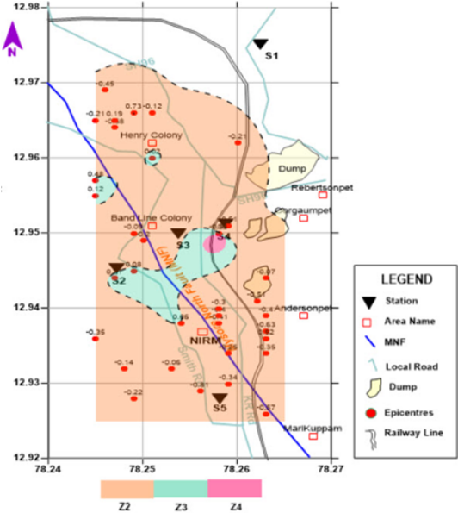
Figure 2: Seismic Hazard Index Map of the mining area of KGF

Recent Publications
- Praveena Das J, Balasubramaniam VR, Goverdhan Kantepudi, Ganapathy GP (2016) Overview of seismic monitoring and assessment of seismic hazard based on a decade of seismic events. Proc. of the International Conference on Recent Advances in Rock Engineering (RARE-2016) Nov. 16-18, Bengaluru, India, 238-245. Published by Atlantis Press ISBN: 978-94-6252-260-2, ISSN: 2352-5401.
- Goverdhan K, Balasubramaniam VR, Praveena Das Jennifer and Sivakumar C (2018) Preliminary assessment of seismic hazard in old mining area using surface mounted seismic sensors. Journal of Indian Geophysical Union, v.22, no.6 pp: 598-606.
- Praveena Das Jennifer and Porchelvan P (2018) Seismic Hazard Assessment based on induced seismicity in underground mines: a comparative review of approach to hazard quantification. National Conference on Prospects and Retrospect in Engineering Geology, Geophysics & Instrumentation (EGCON-2018) scheduled at GSI, Hyderabad during 3rd -5th, December.
- Srinivasan C, Willy Y A and Carter R M (2013) Characteristics of Rockbursts in the flooded mines of Kolar Gold Fields. 8th International conference of Rockbursts and Seismicity in mines, Moscow, Russia.

- Srinivasan C, Ahnoch Willy Y, and Nawani P C (2009) Post-Closure Seismicity in the mines of Kolar Gold Fields. Controlling Seismic Hazard and Sustainable Development of Deep Mines (v.2) The 7th International Symposium on Rockburst and Seismicity in Mines (RaSiM7) pp: 1325-1336.

 Biography
Praveena Das Jennifer is a Civil engineer, with a Master’s degree in Civil Engineering. She has worked in Rock Fracture Mechanics Laboratory and was associated with Geotechnical Investigation Projects. She has carried out several Soil Investigation studies for various mines. She has been involved in seismological data processing and analysis (seismic events like earthquakes- regional and distant) and is currently carrying out research work on seismic hazard due to shallow seismic events and their impacts to surface structures.
Email: pravi.jenniferdas@gmail.com

Notes/Comments:

