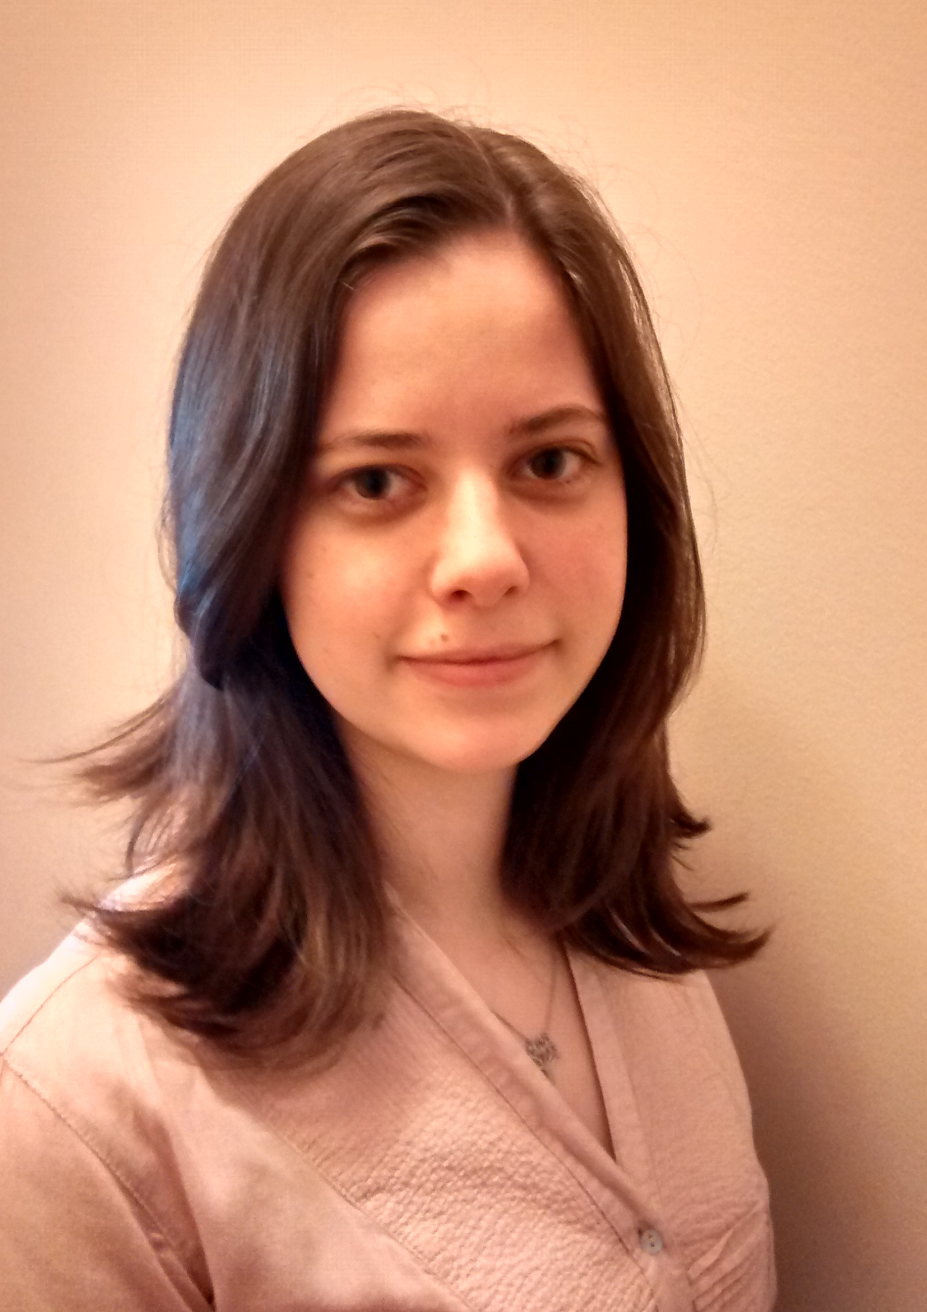
Title: Hybrid material: yeast biomass from alcohol industry impregnated with magnetite nanoparticles. The potencial uses in oil spills

Names: Karina Bugan Debs¹, Débora Selene Cardona¹, Paula Haddad¹, Geórgia Labuto¹
¹Universidade Federal de São Paulo, SP 09972-270, Brazil

Oil spills are a relevant concern because they can potentially impact the whole ecosystem. Finding materials that are able to remove oil from aqueous solution and remediate oil spills is, therefore, a necessity. On this study, yeast biomass from alcohol industry and magnetite nanoparticles are combined to form a hybrid material, which has magnetic properties. The magnetite nanoparticles were synthesized by co-precipitation of FeCl₂.4H₂O and FeCl₃.6H₂O. The hybrid material and magnetite nanoparticles were characterized using XRD, FTIR, SEM and VSM, those techniques confirmed the formation of the hybrid material. The material was tested for two oil removals (motor used/new oil), at different temperatures (5 °C, 25 °C and 45 °C). In the used oil study, the temperature did not contribute with the removal capacity. The experiments showed an excellent oil removal capacity, and the results were also compared to magnetite nanoparticles itself. The removal capacity varied from 1338 to 3272 g/kg of material, being the best result obtained at 5 °C by the magnetite nanoparticle. Possibly it occurs because the nanoparticles have a higher magnetic constant than the hybrid material, getting more oil stucked by the magnetic field.

Biography

Karina Bugan Debs has concluded her undergraduate course in Chemistry at Universidade Federal de São Paulo (Brazil) in 2013. During the undergraduated she was University monitor for one year, worked with scientific research and also was intern in an Environmental Company (CETESB) for one year and a half. Since 2015, she is enrolled in an Academic Master Program, named Science and Technology for Sustainability at the same University.

Presenting author details
Full name: Karina Bugan Debs
Contact number: +55 11 963071290
Twitter account: Don`t have
Linked In account: https://br.linkedin.com/in/karina-debs-347aa757
Session name/ number: Track 10-5 Nanotechnology for water – Challenges and solutions
Category: Oral presentation

