Shifa Muneer, PhD Scholar, Division of Entomology, SKUAST-K, Shalimar, Jammu and Kashmir, India
F.A.Zaki, Professor and Dean (Horticulture), SKUAST-K, Shalimar, Jammu and Kashmir, India
Malik Mukhtar, Assistant Professor, Division of Entomology, SKUAST-K, Shalimar, Jammu and Kashmir, India

A Comparison of Nano-thiacloprid and its Commercial Formulation against Green Apple Aphid (Aphis pomi) on Apple.

Chemical insecticides are the agents of controlling insects wherein the control may result from killing the insect or preventing it from engaging in behaviours deemed destructive. Different eras of insecticides brought a revolution and have been in use for more than 50 years. They have resulted in fast, economical and effective pest control. However, after all these years of utilizing chemical pesticides to control pests, some disadvantages came to surface as well, like resistance, resurgence, low solubility and led to shifting to modern methods of combating pests like nanotechnology. In this study we developed a nano-insecticide of thiacloprid by utilizing the purest form of this insecticide i.e. its technical grade. The nano-insecticide was developed by first synthesizing amphiphilic polymer and then encapsulating the active ingredient of this insecticide in the nanospheres of the developed amphiphilic polymer. Consequently, the nano-formulation synthesized viz. Nano-thiacloprid was then evaluated along with its respective commercial formulations viz. Thiacloprid (Alanto). These two insecticides were studied for mortality response using leaf dip method under graded response bioassay, against Green Apple Aphid (Aphis pomi). The mortality was recorded after 24 hours and these mortality counts were subjected to probit-regression analysis after percentage mortalities were corrected for calculating LC₅₀ values by Abbott’s formula.

LC₅₀ value of 1.02 ppm was recorded in case of nano-thiacloprid, while thiacloprid was found to be 6 times less efficient than its commercial formulation with LC₅₀ value of 6.05 ppm. Nano-formulation of thiacloprid proved to be efficient in comparison to its commercial formulations as LC₅₀ value was much lower as compared to commercial formulation. Owing to small surface area of nano-insecticides, better penetration occurs in insect body and longer persistence on leaf surface, as supported by the research findings. Nano-formulations of pesticides promise improved efficacy and can certainly replace the conventional pesticides in near future.
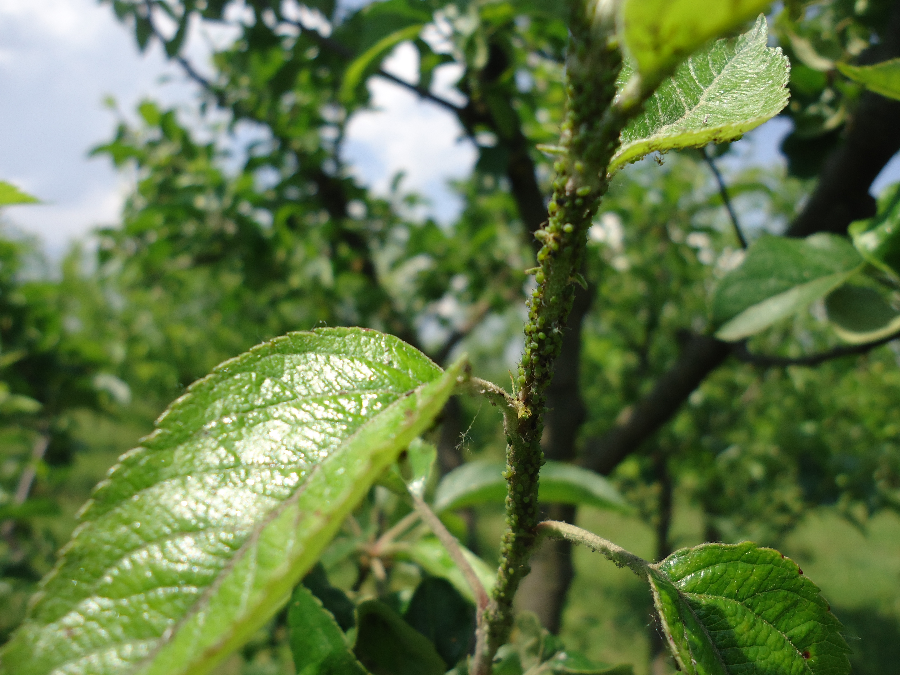

Fig. 1: Menace of Green Apple Aphids on Apple trees
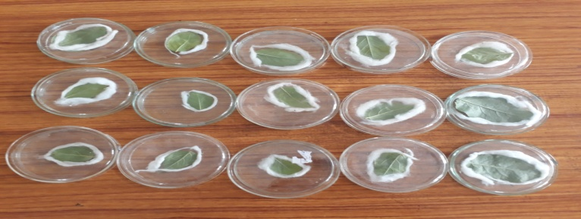
Fig. 2: Bioassay on Apple leaves

Recent Publications
- Shifa, Asma Sherwani and Malik Mukhtar. Dose mortality response of European Red Mite (Panonychus ulmi Koch) to various acaricides. Indian Journal of Ecology. 2016, 43:489-493

- Deelak Amin, M. A. Sofi, G. M. Mir, Shifa, Shahida Ibrahim and Asmat Ara. Indian Journal of Ecology. 2016, 43: 178-179

- Asmat Ara, Z.A. Dar, Asif Iqbal, Shifa and Deelak Amin Crop Environment Interaction Assessment in Brassica rapa var. Brown Sarson. Vegetos- An International Journal of Plant Research. 2016. 30(1): 87-92

- Shahzada Ramzan, M. A. Paray, S.H. Parrey, Munazah Yaqoob, Rizwana Khurshid, Shifa and Deelak Amin. Species richness and abundance of insect pollinators on pear blossoms in Kashmir Himalayans. Journal of Eco-friendly Agriculture. 2016. 12(1):54-57

Biography
Shifa Muneer is a young, enthusiastic and an innovative researcher working in the field of agriculture and horticulture with focus on nano-pesticides; intrinsic toxicity of pesticides and different toxicological parameters. Shifa has not only been a gold medallist in Bachelors in Agriculture, but also in Masters in Agriculture and has also been declared as the University topper amongst all the faculties of the university. Shifa is an awardee of the very prestigious INSPIRE fellowship, Department of Science and Technology (DST), India and has also been selected under the Nano-mission school sponsored by DST. Shifa has researched in collaboration with Indian Agricultural Research Institute, Pusa, New Delhi, India for synthesis of nano-formulations of pesticides. She strives to work towards synthesizing nano-pesticides and also testing and evaluating them. Her work is very imperative to the pesticide companies, different universities and is a breakthrough in the field of plant protection.
Email: shifamuneer2@yahoo.com

