A facile preparation of fluorescent carbon dot derived from alendronate for bone imaging

Kyung-Kwan Lee^{1,2}, Kyung-Jin Lee¹ and Chang-Soo Lee²

- Department of Chemical Engineering and Applied Chemistry, Chungnam National Univ., Yuseong-gu, Daejeon, 305-746, Korea
- Harzard Monitoring Bionano Research Center, Korea Research Institute of Bioscience and Biotechnology(KRIBB), Daejeon, 34141, korea

Abstract

Novel bone-specific carbon dots (CDs) were prepared from alendronate for bone imaging. Alendronate is widely used in the treatments of bone disorders and osteoporosis, which bears bisphosphonate group with a high affinity to Ca²⁺ ions related to bone mineral. One-Step synthesized alendronate based CDs (A-CDs) exhibited high binding activity charact-eristic for α-TCP ( artificial mineral component of bone) and bone like to rat femurs and zebrafish skull due to the presence of Bisphosphonate group on the A-CDs surface. In addition, an in vivo study revealed that A-CDs effectively accumulated in live-zebrafish skull tissues simiar to alizarin red staining. As A-CDs show remarkable specificity for zebrafish suggesting a feasibility in bone targeted imaging. Therefore, the results of this study suggest that A-CDs have potential for targeted imaging to bone tissue in vitro and in vivo investigation.

Image

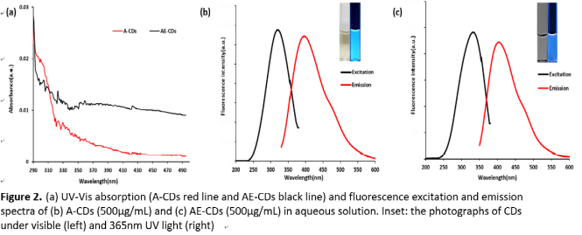

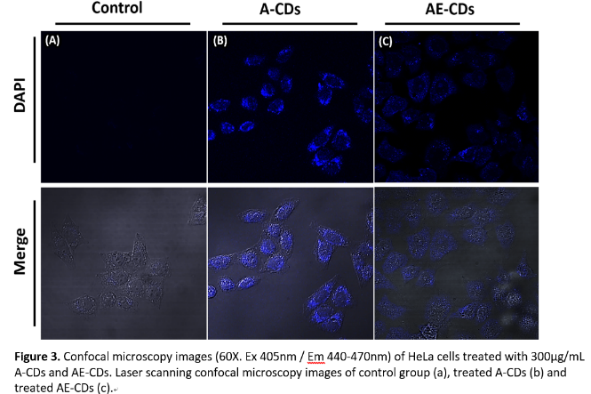

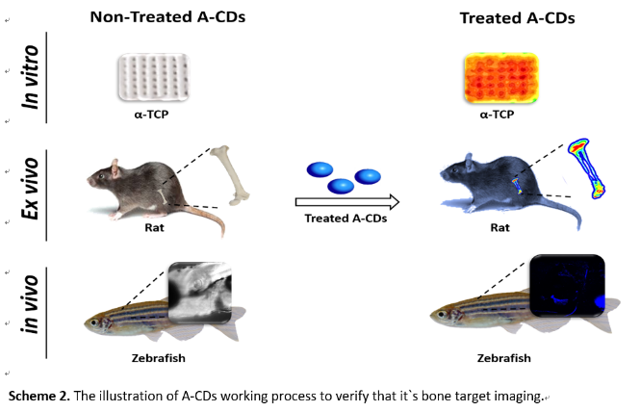

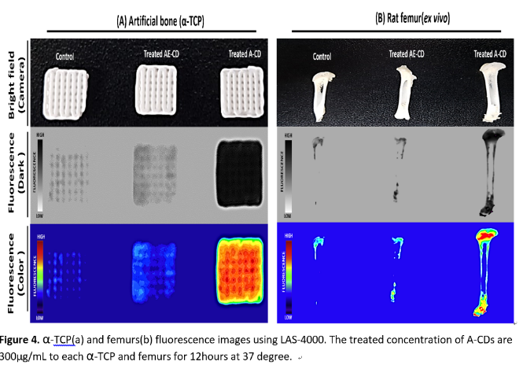
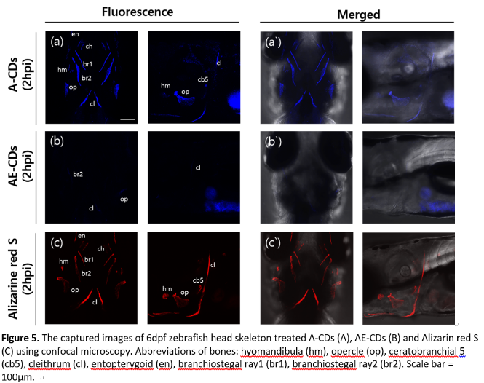
Recent Publications
- Y.P. Sun, B. Zhou, Y. Lin, W. Wang, K.A. Fernando, P. Pathak, M.J. Meziani, B.A. Harruff, X. Wang, H. Wang, P.G. Luo, H. Yang, M.E. Kose, B. Chen, L.M. Veca, S.Y. Xie, Quantum-sized carbon dots for bright and colorful photoluminescence, J Am Chem Soc 128(24) (2006) 7756-7.
- V. Georgakilas, J.A. Perman, J. Tucek, R. Zboril, Broad family of carbon nanoallotropes: classification, chemistry, and applications of fullerenes, carbon dots, nanotubes, graphene, nanodiamonds, and combined superstructures, Chem Rev 115(11) (2015) 4744-822.
- S. Zhu, Q. Meng, L. Wang, J. Zhang, Y. Song, H. Jin, K. Zhang, H. Sun, H. Wang, B. Yang, Highly photoluminescent carbon dots for multicolor patterning, sensors, and bioimaging, Angew Chem Int Ed Engl 52(14) (2013) 3953-7Room
- J. Moon, J. An, U. Sim, S.P. Cho, J.H. Kang, C. Chung, J.H. Seo, J. Lee, K.T. Nam, B.H. Hong, One-step synthesis of N-doped graphene quantum sheets from monolayer graphene by nitrogen plasma, Adv Mater 26(21) (2014) 3501-5.
- G.J. Lieschke, P.D. Currie, Animal models of human disease: zebrafish swim into view, Nat Rev Genet 8(5) (2007) 353-67.
- T.F. Schilling, C.B. Kimmel, Segment and cell type lineage restrictions during pharyngeal arch development in the zebrafish embryo, Development 120(3) (1994) 483-94.

 Biography

Kyung-Kwan Lee is master`s degree course student in the Department of Chemical engineering and Applied chemistry, Chung-Nam University and work at Korea Research Institute Bioscience & Biotechnology. His major is bio-nanomaterials and his research focuses on bio-content development for biological/chemical hazard detection and analysis using biocompatible fluorescent based nanomaterials.
Email: LKK@kribb.re.kr

Notes/Comments:

