Enhanced photocatalytic H₂ evolution from in situ formation of few-layered MoS₂/CdS nanosheet-based van der Waals heterostructures
Shahid Iqbal, Xi'an Jiaotong University, Shaanxi, China.

Abstract (300 word limit)

In a typical photocatalytic reaction, efficient solar light harvesting and charge generation, as well as effective charge transport, are key factors that determine the efficiency of the photocatalytic system for H₂ production. Atomically layered heterostructures have attracted significant research interest due to their unique layer-dependent catalysis and electronic properties. Previous studies have reported that the catalytic properties of MoS₂ layered materials are highly dependent on the number of layers, and the difficulty of controlling the number of layers over a substrate has been a bottleneck for widespread use. Therefore, developing a simple, facile and environmentally friendly method to fabricate van der Waals heterostructures (vdWHs) with precisely controlled MoS₂ layers for achieving highly efficient H₂ generation is still a challenge. Here we report for the first time that the H₂ bubbles generated by photocatalytic water splitting are effective in the layer-by-layer exfoliation of MoS₂ nanocrystals (NCs) into few layers (Figure 1). The as obtained few layers can be in situ assembled with CdS nanosheets (NSs) into vdWHs of few-layered MoS₂/CdS NSs which, in turn, are effective in charge separation and transfer, leading to enhanced photocatalytic H₂ production activity. The few-layered MoS₂/CdS vdWHs exhibited a H₂ evolution rate of 140 mmol g_{(CdS)}⁻¹ h⁻¹ and achieved an apparent quantum yield of 66% at 420 nm. This study provides a new strategy for the design of noble-metal-free few-layered MoS₂/CdS vdWH systems for photocatalytic H₂ generation. We believe that this bubble exfoliation strategy can be extended to a range of other layered transition metal dichalcogenide compounds.
Image
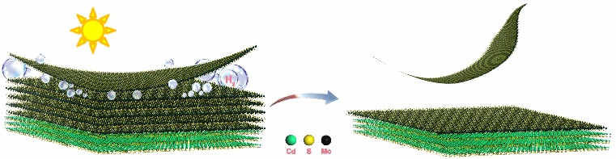
Figure 1: Figure demonstrating the fundamental question that we are tempting to solve experimentally: developing a simple, facile and environmentally friendly bubble exfoliation method to fabricate van der Waals heterostructures (vdWHs) with precisely controlled MoS₂ layers for achieving highly efficient H₂ generation.
Recent Publications (minimum 5)
1. Iqbal, S.; Pan, Z.; Zhou, K., Enhanced photocatalytic hydrogen evolution from in situ formation of few-layered MoS₂/CdS nanosheet-based van der Waals heterostructures. Nanoscale, 2017, 9, 6638-6642.
2. Waqas, M. ‡; Iqbal, S.‡; Bahadur, A.; Raheel, M.; Saeed, A.; Javed, M., “Designing of a spatially separated hetero-junction pseudobrookite (Fe₂TiO₅-TiO₂) yolk-shell hollow spheres as efficient photocatalyst for water oxidation reaction” Applied Catalysis B: Environmental, 219, 2017, 30-35. (‡Shared first authorship).
3. Iqbal, S.; Bahadur, A.; Saeed, A.; Zhou, K.; Shoaib, M.; Waqas, M., Electrochemical performance of 2D polyaniline anchored CuS/Graphene nano-active composite as anode material for lithium-ion battery. Journal of Colloid and Interface Science 2017, 502, 16-23.
4. Iqbal, S.; Khan, R. A.; Iqbal, M. J.; Waqas, M.; Nisar, J.; Shah, F.; Khan, A. R., Influence of Fe²⁺ and Ni²⁺ contents on the optical and electrical properties of ZnS quantum dots. Journal of Materials Science-Materials in Electronics 2017, 28 (5), 4449-4457.
5. Pan, Z.; Wang, R.; Li, J.; Iqbal, S.; Liu, W.; Zhou, K., Fe₂P nanoparticles as highly efficient freestanding co-catalyst for photocatalytic hydrogen evolution. International Journal of Hydrogen Energy 2018, 43, 5337-5345.

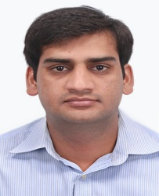Biography (150 word limit)
Dr. Shahid Iqbal received his Ph.D. degree at School of Chemistry and Chemical Engineering, National Engineering Laboratory for VOCs Pollution Control Material & Technology, University of Chinese Academy of Sciences, Beijing, China in 2017. Currently, he is a post-doctoral researcher at International Research Center for Renewable Energy, State Key Laboratory of Multiphase Flow in Power Engineering, School of Energy & Power Engineering, Xi’an Jiaotong University. He has published more than 17 peer-reviewed papers in reputed journals. His research interest is focused on the controlled synthesis and thickness-dependent catalytic properties of few-layered transition metal dichalcogenides (TMDs) for efficient photocatalytic hydrogen evolution and CO₂ conversion.

Email: shahidgcs10@yahoo.com

Notes/Comments:

