Thermomechanical Reactions in Memory Behavior of Shape Memory Alloys
Osman Adiguzel, Firat University, Department of Physics, Elazig, Turkey

Abstract
A series of materials take place in class of advanced smart materials with adaptive properties and stimulus response to the external changes. Shape memory alloys take place in this group, due to the shape reversibility and capacity of responding to changes in the environment. These alloys exhibit a peculiar property called shape memory effect, which is characterized by the recoverability of two certain shapes of material at different temperatures. These alloys have dual characteristics called thermoelasticity and superelasticity, from viewpoint of memory behavior. Two successive structural transformations, thermal and stress induced martensitic transformations govern shape memory phenomena in crystallographic basis. Thermal induced martensite occurs along with crystal twinning in self-accommodating manner on cooling and ordered parent phase structures turn into twinned martensite structures. Stress induced martensitic transformations occur along with crystal or lattice detwinning reaction by stressing material in low temperature condition. Superelasticity is performed by stressing and releasing material at a constant temperature in parent phase region, and shape recovery is performed simultaneously upon releasing the applied stress. Superelasticity exhibits the normal elastic materials, but it is performed in non-linear way; stressing and releasing paths are different in the stress-strain diagram, and hysteresis loop refers to energy dissipation. These alloys are used in building industry, against to the seismic events, due to this property. Thermal induced martensitic transformation occurs with the cooperative movement of atoms in <110>- type directions on {110}-type planes of austenite matrix, by means of shear-like mechanism.
Copper based alloys exhibit this property in metastable β-phase region. Lattice invariant shear is not uniform in copper-based shape memory alloys, and cause to the formation of long-period layered martensitic structures with lattice twinning on cooling. The long-period layered structures can be described by different unit cells as 3R, 9R or 18R depending on the stacking sequences on the close-packed planes of the ordered lattice. The unit cell and periodicity is completed through 18 layers in direction z, in case of 18R martensite, and unit cells are not periodic in short range in direction z.
In the present contribution, electron diffraction and x-ray diffraction studies performed on two copper based CuZnAl and CuAlMn alloys. Electron diffraction patterns and x-ray diffraction profiles show that these alloys exhibit super lattice reflections in martensitic condition. Specimens of these alloys aged at room temperature in martensitic condition, and a series of x-ray diffractions were taken duration aging at room temperature. Reached results show that diffraction angles and peak intensities change with aging time at room temperature. Specially, some of the successive peak pairs providing a special relation between Miller indices come close each other, and this result refers to the rearrangement of atoms in diffusive manner.
Keywords: Lattice twinning and detwinning, martensitic transformation, shape memory effect, superelasticity, thermoelasticity
Recent Publications
- O. Adiguzel, Phase Transitions and Microstructural Processes in Shape Memory Alloys, Materials Science Forum Vol. 762 (2013) pp 483-486, (2013) Trans Tech Publications, Switzerland
- O. Adiguzel, Self-accommodating Nature of Martensite Formation in Shape Memory Alloys, Solid State Phenomena Vol. 213 (2014) pp 114-118, © (2014) Trans Tech Publications,
- O. Adiguzel, Nanoscale Aspects of Phase Transitions in Copper Based Shape Memory Alloys, Nanotechnology in the Security Systems, NATO Science for Peace and Security Series C: Environmental Security 2015, pp. 131-134
- O. Adiguzel, Nano-Scale Mechanisms in the Formation of Displacive Transitions in Shape Memory Alloys, Physics, Chemistry and Applications of Nanostructures - Proceedings of the International Conference Nanomeeting - 2013. Edited by Borisenko Victor E et al. Published by World Scientific Publishing Co. Pte. Ltd
- O. Adiguzel, Thermoelasticity, Superelasticity and Nanoscale Aspects of Structural Transformations in Shape Memory Alloys. In: Struble L., Tebaldi G. (eds) Materials for Sustainable Infrastructure (2018), GeoMEast 2017.Sustainable Civil Infrastructures. Springer,

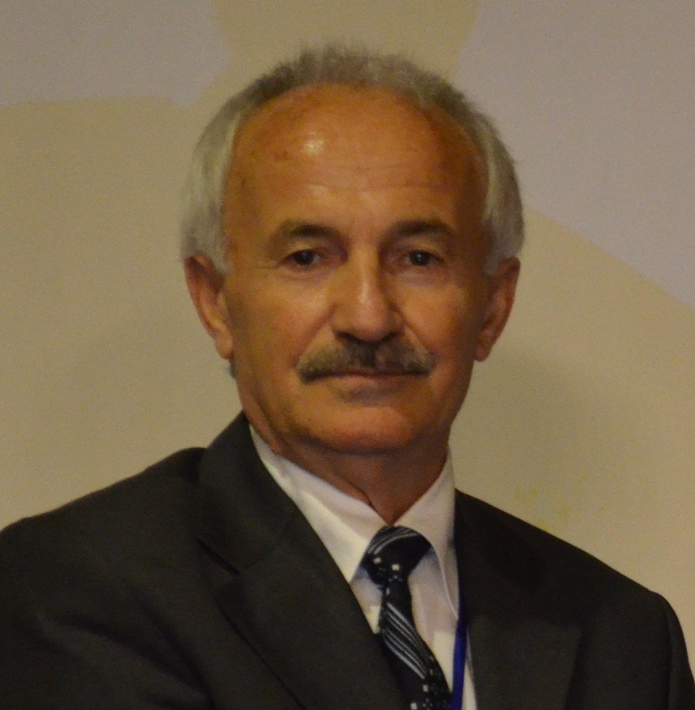
Biography
Dr Adiguzel graduated from Department of Physics, Ankara University, Turkey in 1974 and received PhD- degree from Dicle University, Diyarbakir-Turkey. He has studied at Surrey University, Guildford, UK, as a post-doctoral research scientist in 1986-1987, and studied on shape memory alloys. He worked as research assistant, 1975-80, at Dicle University and shifted to Firat University, Elazig, Turkey in 1980. He became professor in 1996, and he has already been working as professor. He published over 80 papers in international and national journals; He joined over 100 conferences and symposia in international and national level as participant, invited speaker or keynote speaker with contributions of oral or poster. He served the program chair or conference chair/co-chair in some of these activities. In particular, he joined in last seven years (2014 - 2020) over 70 conferences as Keynote Speaker and Conference Co-Chair organized by different companies. He supervised 5 PhD- theses and 3 M.Sc.- theses.
Dr. Adiguzel served his directorate of Graduate School of Natural and Applied Sciences, Firat University, in 1999-2004. He received a certificate awarded to him and his experimental group in recognition of significant contribution of 2 patterns to the Powder Diffraction File – Release 2000. The ICDD (International Centre for Diffraction Data) also appreciates cooperation of his group and interest in
Email: oadiguzel@firat.edu.tr

Presenting author details
Full name: Osman Adiguzel
Contact number: +90 536 5638403
Twitter account: -
Linked In account: -
Session name/ number: Advanced Materials
Category: Oral presentation, Preferably Keynote

