The effect of Al and Nb contents, cooling rate and rolling condition on the microstructure and corrosion behaviour of HSLA steel
Abdullah Qaban^{1,}, Tasneem Mohamed¹, M.M. Quazi² and Sumsun Naher¹

1Department of Mechanical Engineering and Aeronautics, City, University of London, UK
²Faculty of Mechanical and Automotive Engineering Technology, Universiti Malaysia Pahang, Pekan 26600 Pahang, Malaysia

Abstract. High-strength low-alloy steel (HSLA) has been widely used in many applications involving automobiles, aerospace, construction, and oil and gas pipelines due to their enhanced mechanical and chemical properties. One of the most critical elements used to improve these properties is Aluminium. This work will explore the effect of Al content on the corrosion behaviour of hot rolled high-strength low-alloy steel as a function of grain size. The method of investigation employed was weight loss technique. It was obvious that the increase in Al content enhanced corrosion resistance through refinement of grain size obtained through AlN precipitation by pinning grain boundaries and hindering their growth during solidification which was found to be beneficial in reducing corrosion rate.

INTRODUCTION

HSLA steel offers excellent mechanical and chemical properties and provides high corrosion resistance in various environments [1]. The properties exhibited by HSLA steels depend mainly upon the microstructural conditions and mainly grain size [2]. Grain size is controlled by thermal treatment or precipitation of particles during solidification [3]. Precipitation of AlN was reported to refine grain size leading to considerable changes in grain boundary residual stress, orientation and density [4]. All these factors have a critical effect on corrosion response [5].
Many studies have investigated the influence of grain size on the corrosion behaviour of steel. Chen and Zhang
- observed that corrosion resistance was considerably improved with refinement of grain size. Furthermore, Obayi et al. [7] reported that corrosion resistance was slightly improved in cold rolled and annealed pure iron as a result of refining grain size. In addition, homogeneous distribution of grain size enhanced passivation status leading to lower corrosion rate. Qaban et al. [8] examined the influence of Al on grain size of HSLA and found out that AlN precipitation was beneficial in pinning grain boundaries during solidification and thus refining microstructure and encouraging homogeneous distribution of grain size.
Hadzima et al. [9] reported that the change in grain size in hot rolled ferritic steel did not have any influence on corrosion resistance in neutral NaCl solutions. Moreover, Aghuy et al. [10] pointed out that grain size variation has no considerable influence on pitting corrosion of 304L stainless steel in 3.5 wt.% NaCl solution.
However, Li et al. [11] claimed that the finer grain size in low carbon steel increased corrosion rate and this was attributed to the increased number of the active sites in the grain boundaries during corrosion. In addition, Sherif and Seikh [12] investigated the influence of grain size refinement on the corrosion behaviour of BSK 46 microalloyed steel in 1N H₂SO₄ electrolyte. They stated that finer grain structure provided greater anodic areas than coarser grains leading to higher corrosion rate.
This uncertainty in literature on how grain size influences corrosion behaviour led to the current work which aims to establish a better understanding of grain size refinement by AlN precipitation on corrosion behaviour of HSLA steel.

EXPERIMENTAL

The steels were cast as 22 kg laboratory vacuum melts. The ingots were soaked at 1200°C and hot rolled to a thickness of 15mm, finish rolling at 950°C. The plates were air cooled from 950ºC to room temperature; the cooling rate through the transformation being 33K/min. The alloying composition of the steels investigated is presented in Table 1. The base composition of the steels was ~0.06%C, 1.4%Mn, 0.5%Si, 0.005%S, 0.005%P and 0.008%N.

Specimens of 1x1x1 cm were machined from the plates and the corrosion rate was evaluated using weight loss method. The samples were grinded by silicon carbide grit on 120, 240, 320, 400, and 600 then polished with diamond on 6 and 1μm sequentially. Samples were then washed using distilled water then by ethanol then dried. The corrosion experiment was conducted by immersing the specimens in 10% sulphuric acid solution H₂SO₄ with a total volume of 500ml for 72 hours at room temperature. The test was repeated three times for each composition to ensure reliability. The weight of the samples was measured before and after test in order to estimate the corrosion rate using formula (1) [13]:

Corrosion rate ( mm ) = 365(days) x 24(hours) x Weight loss x 10

(1)

year Sample area x 72(hours)x Steel density

Following the corrosion experiment, the samples were further examined under optical microscope in order to investigate the microstructure conditions effect on corrosion behaviour. The grain size was measured using the intercept line method. Further analysis using scanning electron microscope (SEM) examination was made to monitor the presence of AlN particles.

TABLE 1. Alloying composition of the investigated steels low Al (L) and high Al (H) wt-%

Steel | C | Mn | Si | S | P | Al | N | Fe
L | 0.051 | 1.4 | 0.47 | 0.0043 | 0.005 | 0.02 | 0.009 | Bal.
H | 0.060 | 1.4 | 0.46 | 0.0045 | 0.005 | 0.16 | 0.007 | Bal.

RESULTS AND DISCUSSIONS

The typical microstructure of the HSLA steel with low and high Al contents is shown in Fig. 1. It was observed that the increase of Al content in HSLA steel from 0.02 to 0.16% refined the average grain size from 27 to 20μm. This is attributed to the higher volume fraction AlN precipitation enhancing the grain boundary pinning during cooling and giving finer grain structure. It is important to mention that volume fraction of ferrite and pearlite phases for both steels was not affected by Al level and thus the microstructural influence on corrosion behaviour can be evaluated mainly by grain size parameter.

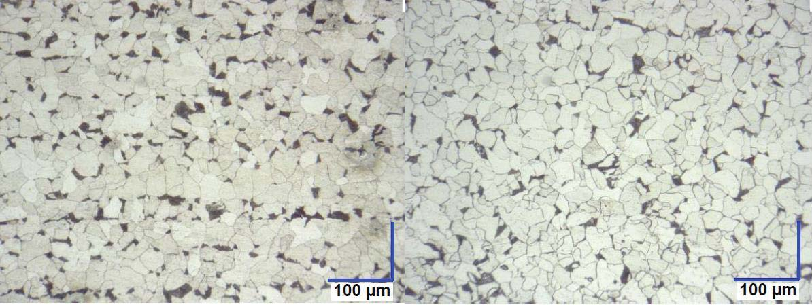
  - (b)

FIGURE 1. Microstructure of hot rolled HSLA steel (a) low Al, (b) high Al.
In general, corrosion behaviour showed a considerable dependence on grain size of HSLA steel. Refinement of grain size was shown to enhance corrosion resistance as shown in Fig. 2. The corrosion rate increased markedly from 0.9 to 1.2 mm/yr when the grain size grew up from 20 to 27μm. Therefore, beside its beneficial effect in enhancing mechanical properties [8], finer grain size also promoted corrosion resistance.
Grain size (μm)
27
20
1.4
1.2
1
0.8
0.6
0.4
0.2
0
Corrosion rate (mm/yr)

FIGURE 2. Corrosion rate of the HSLA steel as a function of grain size

Higher volume fraction of AlN precipitates were observed in the high Al containing steel, resulting in finer grain size. Similar behaviour was observed in previous work in which higher Al content at the same N content was found to enhance grain refinement significantly in steel due to higher volume fraction of AlN particles being more effective in pinning grain boundaries as shown in Table 2 [14,15].

TABLE 2. The effect of Al content on the grain size of steel at 0.007%N (wt%).

Steel | Al  (wt%) | N  (wt%) | Grain size  (μm) | Reference
1 | 0.03 | 0.007 | 150 | [14]
2 | 0.079 | 0.0072 | 50 | [15]

Precipitation kinetics of AlN occurs during cooling while their growth rate and distribution are dependant on the thermal history e.g. slower cooling rate was found to enhance growth of particles [16]. In the current work, the majority of AlN particles were found along the grain boundaries in the form of rod and plate-like particles as presented in Fig. 3.
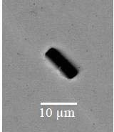
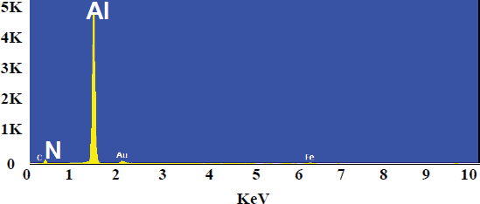
(a) (b)
FIGURE 3. High Al-bearing steel (a) SEM micrograph showing a rod-like AlN particle, (b) analysis spectrums proving the presence of AlN particle.

Although higher additions of Al may provide an additional improvement in corrosion resistance, it was reported that this can deteriorate toughness by the formation of lower transformation products such as martensite leading to poor impact behaviour [17]. It is hence important to consider mechanical behaviour when dealing with corrosion performance in order to produce practical steel with the desired properties that can be widely used in various applications. Another route utilised for grain refinement is thermal treatment such as control rolling which has been shown to promote ultrafine microstructure leading to better properties [18]. In terms of phases, carbon level was kept minimum 0.055% in order to reduce the volume fraction of pearlite phase in the microstructure. Higher amount of pearlite is not favourable when considering corrosion since pearlite consists of lamellar structure of ferrite (α-Fe) and cementite (Fe3C). Both phases have different atomic structure and electrode potentials and due to microstructural inhomogeneities localised anodic and cathodic microstructural areas develop in which ferrite acts as anode while cementite acts as cathode and due to the presence of electrolyte a galvanic microcell is formed and corrosion is favoured [19].

CONCLUSIONS

In this paper, the effect of grain size refinement by AlN precipitation on corrosion behaviour of HSLA steel has been investigated. It was observed that increasing Al content promoted AlN precipitation at grain boundaries, evidenced by the considerable refinement of grain size. Finer grain structure has been found to enhance corrosion resistance and it is hence expected that ultrafine grains can be more effective in reducing corrosion rate.

REFERENCES

- C. I. Garcia. High strength low alloyed (HSLA) steels (Automotive Steels, 2017), pp. 145-167.
- Y. B. Guo, C. Li, Y. C. Liu, L. M. Yu, Z. Q. Ma, C. X. Liu and H.J. Li. Effect of microstructure variation on the corrosion behavior of high-strength low-alloy steel in 3.5 wt% NaCl solution (International Journal of Minerals, Metallurgy, and Materials, 2015), 22(6), pp. 604-612.
- Z. Lv, X. P. Ren, Z. H. Li, Z. M. Lu and M. M. Gao. Effects of Two Different Cyclic Heat Treatments on Microstructure and Mechanical Properties of Ti-V Microalloyed Steel (Materials Research, 2015), 18(2), pp. 304-312.
- K. D. Ralston and N. Birbilis. Effect of grain size on corrosion: a review (Corrosion, 2010), 66(7), pp. 1- 13.
- K. D. Ralston, N. Birbilis, C. H. Davies. Revealing the relationship between grain size and corrosion rate of metals (Scripta Materialia. 2010), 63(12), pp. 1201-1204.
- Y. T. Chen and K. G. Zhang. Influence of Grain Size on Corrosion Resistance of a HSLA Steel (Advanced Materials Research, 2012), 557, pp. 143-146.
- C. S. Obayi, R. Tolouei, A. Mostavan, C. Paternoster, S. Turgeon, B. A. Okorie, D. O. Obikwelu and D. Mantovani. Effect of grain sizes on mechanical properties and biodegradation behavior of pure iron for cardiovascular stent application (Biomatter, 2016), 6(1).
- A. Qaban, B. Mintz and S. Naher, “Hot rolled high Al containing steels as a replacement for the control rolled high strength low alloy (HSLA) steels,” in AIP Conference Proceedings 1896, (American Institute of Physics, 2017), 33(14), pp. 1645-1656.
- B. Hadzima, M. Janeček, Y. Estrin and H. S. Kim. Microstructure and corrosion properties of ultrafine- grained interstitial free steel (Materials Science and Engineering: A, 2007), 462(1-2), pp. 243-247.
- A. Aghuy, M. Zakeri, M. H. Moayed and M. Mazinani. Effect of grain size on pitting corrosion of 304L austenitic stainless steel (Corrosion Science, 2015), 94, pp. 368-376.
- Y. Li, F. Wang and G. Liu. Grain size effect on the electrochemical corrosion behavior of surface nanocrystallized low-carbon steel (Corrosion, 2004), 60(10), pp. 891-896.
- E. S. Sherif and A. H. Seikh. Effects of grain refinement on the corrosion behaviour of microalloyed steel in sulphuric acid solutions (Int. J. Electrochem. Sci, 2012), 7, pp. 7567-7578.
- S. A. Amadi. Corrosion Control (Journal of school of Engineering RSUST, 2000), pp. 32.
- J, Fu, Y, Liu and H, Wu. The precipitation and effect of nano nitrides in HSLC steel (Science in China Series E: Technological Sciences, 2008), 51(7), pp. 989-998.
- W. C. Leslie, R. L. Rickett, C. L. Dotson and C. S. Walton. Solution and precipitation of aluminum nitride in relation to the structure of low carbon steels (Transactions of the American Society for Metals, 1954), 46, pp. 1470-1499.
- A. Qaban, B. Mintz, S. E. Kang and S. Naher. Hot ductility of high Al TWIP steels containing Nb and Nb-V
(Materials Science and Technology, 2017), 33(14), pp. 1645-1656.
- B. Mintz. The influence of Al on the mechanical properties of hot rolled steel plates (Materials Science Forum, 2003), 426, pp. 1219-1223.
- J. DeArdo. Niobium in modern steels (International Materials Reviews, 2003) 48(6), pp. 371-402.
- N. Perez. Electrochemistry and corrosion science (Kluwer Academic Publishers, 2004).

