Ionizing radiation sensors based on carbon nanotubes, with thermal regeneration capacity.

Kenneth Fontanez, Jose Duconge, Maria Cotto, and Francisco Marquez
Nanomaterials Research Group, School of Natural Sciences and Technology, Universidad Ana G. Mendez-Gurabo, 00778PR, USA

Abstract

Detection of ionizing radiation is crucial in different fields including energy, national security, biological and nuclear research, and other applications. One of the key characteristics of SWNTs for electronic and optoelectronic applications is that their metallic or semiconductor behavior, and the conductive properties of the material, depend on the presence of defects in the structure. The presence of a defect in the nanotube walls, i.e. a single atom missing, or the incorporation or interaction with another structure, can result locally in the change of the electronic distribution and, therefore, to the variation of the conductive characteristics of nanotubes. These defects, or the interaction with structures present in the environment, can be induced by the presence of ionizing radiation. The variations of these electrical properties can be measured, and, from these results, a clear correlation can be established with the radiation dose generated by the presence of these local defects in the nanotube. In this research, vertically aligned carbon nanotubes were grown by chemical vapor deposition (CVD) on a silicon oxide substrate with alternating layers of TiN (see Figure). The CNTs where exposed to nitrogen implantation and X-ray radiation to study later the change in resistivity. Preliminary results show an increase in the resistivity of the CNTs as a function of the time of exposure to radiation or ion implantation, which means that the structure is responding successfully to radiation exposure. The first evidences indicate that, in the case of defects generated by X-ray radiation, the process is reversible under heat treatment. This effect is currently being studied, although it is expected that it may be due to the presence of species generated during radiation exposure, from species present in the environment, that interact with the surface of the nanotube and that can be subsequently removed by heating.


Image
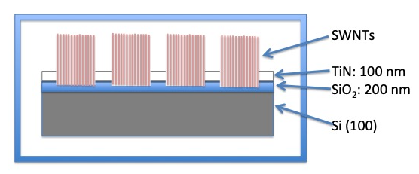
Scheme of the selective growth of SWNTs on SiO₂ surfaces.

Recent Publications
- Kenneth Fontánez, María del C Cotto-Maldonado, José Duconge, Carmen Morant, Sergio Pinilla and Francisco Márquez, Development of Ionizing Radiation Sensors Based on Carbon Nanotubes, American Journal of Engineering and Applied Sciences, 12 (2019) 185-192.
- Kenneth Fontánez, María del C Cotto-Maldonado, José Duconge, and Francisco Márquez, Ionizing Radiation Sensors Based on Carbon Nanotubes with Thermal Regeneration Capacity, American Journal of Engineering and Applied Sciences (In press).
- Sergio Pinilla, Teresa Campo, Jose M Sanz, Francisco M Marquez, Carmen Morant, Highly ordered metal-coated alumina membranes: Synthesis and RBS characterization. Surface and Coatings Technology 377 (2019) 124883.
- Teresa Campo, Sergio Pinilla, Santos Gálvez, José María Sanz, Francisco Márquez, Carmen Morant, Synthesis Procedure of Highly Densely Packed Carbon Nanotube Forests on TiN. Nanomaterials 9 (2019) 571.

Biography
Kenneth Fontanez graduated from an AD in Mechanical Engineering at Universidad Ana G. Méndez-Gurabo, Puerto Rico, and then began his studies in Chemistry. Kenneth Fontanez, a member of the Nanomaterials Research Group, is a research student working on different projects related to hydrogen production by electrolysis, photocatalytic hydrogen production by water splitting, ionizing radiation sensors based on carbon nanotubes, development of anodes for lithium-ion batteries, and solar cells sensitized by dyes. Kenneth has presented his research work at multiple international conferences in the United States, Spain, Italy, etc.

Email:kfontanez12@email.suagm.edu

Notes/Comments:

