Study of the Use of Nanonized Gold-Moringa Oleifera Leaf Extract for Possible Treatment of Breast Cancers.
D.O.N.Obikwelu*, C.O.Nebo*, Ada Nwokocha**, S.I.Ume***
*Department of Metallurgical & Materials Engineering, University of Nigeria. Nsukka
**College of Medicine, University of Nigeria. Nsukka.
*** Department of Crop Science, University of Nigeria. Nsukka
Abstract:
Inhabitants of Nigeria especially the northern part had been using Moringa Oleifera plant (MO) and its products to treat various diseases including cancer. In this investigative study of MO and its attributes using nanotechnology concepts, a nanonized MO extract-Gold nanoparticle(GNP) composite system (MOGNP) was produced for possible use in treating cancers especially the cancers of the breast and the prostrate organ due to their favorable structures. Using 80% methanol and 0.1 molar solution of sodium tetra-chloroaurate(Na AuCl4) at room temperature MOGNP solution was produced. The formation of stabilized MOGNP featuring this reduction reaction ( Au3+ to Au⁰ ) was observed by the change in color of the solution from pale yellow to purple red, the latter color confirming the formation of gold nanoparticles.
The stability of the gold nanoparticles was recorded with the UV-absorbance scan of the solution with the peak absorbance value at approximately 295nm wavelength.
Spectrophotometric analysis of the liquid extracted from the moringa leaf showed high levels of substances likely to be phytochemicals in the liquid at the absorbance value of 2393 and wavelength of 235 nanometers. These substances are known to be anti- oxidants and removers of free radicals in the body that cause cancer. If this finding is confirmed by further research the scourge of cancer especially the breast and prostrate cancers would be a thing of the past because MO is locally and copiously available in most countries of the world.
Keywords: moringa oleifera, nanotechnology, cancer, phytochemicals, nanoparticles.

1.0 Rationale:
- The intractable deadly cancer of the breast is spreading fast amongst both young and old women.
- Research efforts (1-8) abound in literatures to reduce the scourge of this disease.
- But it appears that little success is achieved partially because of lack of co-ordination of these useful efforts from various disciplines, lack of cooperation of seemingly antipodal disciplines and lack of will and effort to exploit the curative potentials of the locally available plants in the immediate environment.
- Inability of workers in the field to realize that cancer cure requires multi-disciplinary approach and it is only when seemingly antipodal fields merge and artificial boundaries melt that meaningful solution will appear.
2.0: Background Information:
- Nanostructures are of the order of 1 to 100 nanometers.
- According to Singer and Nicholson (9) biological and body structures fall into the nanometer range.
- A force of 1500 nanonewtons according to a report in the Science Daily (10) was just enough to separate a cell from a substrate, therefore a force of that magnitude can adhere an appropriately configured nanoparticle to a cancer cell.
- The mechanism of cancer cure is not clear but the comparable sizes of cancer cells with nanostructures will play a significant role.
- Substitutional and interstitial poisoning is a possibility in cancer cure.
- The role of the so-called T-cells which occurs naturally in the human immune system could join forces with nanostructures to cure cancer.
- Use of inorganic nanostructures to treat breast cancer was reported in the Science Daily (11).
- Use of nanoparticle probes like semiconductor quantum dots, organic dies and other chemical-base equipment in cancer detection and cure has been reported (12-13).
- But there is no serious mention or expected emphasis on the use of locally available plants in the environment prepared in any certified and prescribed format for the cure of cancer, for one thing it will be natural and well tolerated
- Such preparation will not depend on non-renewable metallic specie.
- Our belief is that organisms both human and animal can survive in their lifetime exploiting all that are locally available in its natural environment and this was the premise of the present investigation.
WEIRD OBSERVATION:
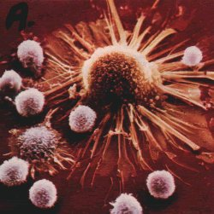

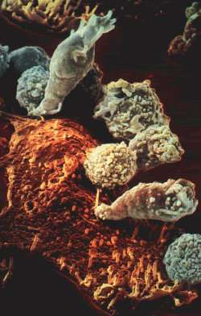

- The breast anatomy makes it amenable to our suggested treatment of its cancer disease.
- Its tree-like shape from the root (nipple) into the fine tubular structures in the interior provides pathways for effective therapy.
- It is supposed that considering surface energy effects cancer would probably initiate at the root of the tributary branch and eventually spread by the mechanism of grain (cell) or domain growth to effect the fatal event of the individual host.
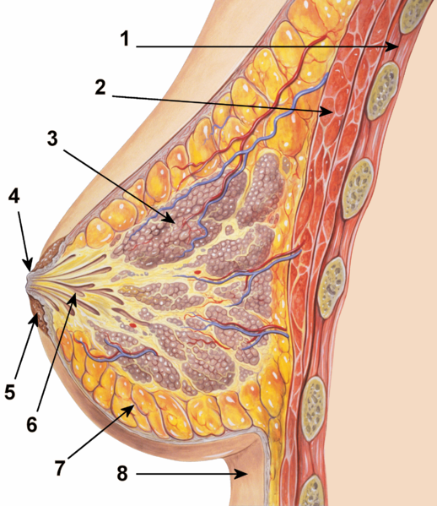
Breast structural features respectively named: chest wall, pectoralis, muscles, lobules, nipple, areola, lactiferous ducts, fatty tissue, skin.

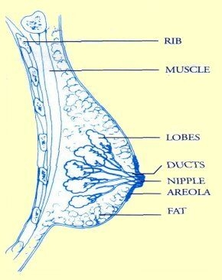Breast structure
- 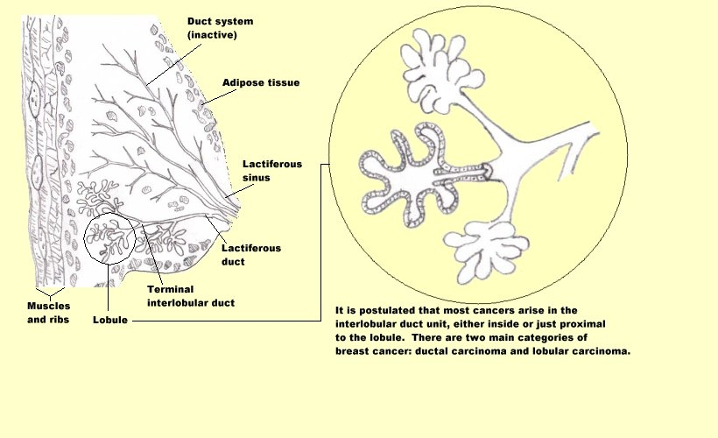
Breast Structure

- There are recorded exotic methods of producing nanoparticles in the literature but the organo-inorganic techniques which are direct and natural are less mentioned in the literature.
- Stable gold nanoparticles solution was produced --using aqueous medium of extracts from almond leaf (terminalia catappa) and chloro-auric acid solution(15)
- using 0.1 molar solution of sodium tetrachloroaurate, 80% methanol and moringa leaf extract (16).
-using lactic acid bacteria in buttermilk nanoparticles of gold, silver and their alloys were produced (17).
-using also bacteria and algae on ionic gold, gold nanoparticles were produced
There is no doubt that there is cellular uptake of gold nanoparticles but it is known that
- Gold is inert.
- It has no adverse effect on the body system.
- Any presence of gold even in very negligible concentration anywhere is very easily
-detected by silver using the autometallographic (AMG) technique.
- released into the urine and removed through simple filtration in the renal glomeruli.
- Evaldes Sadauskas et al of Denmark (18) in their study of Kupffer cells being central in the removal of nanoparticles from the body, using gold nanoparticles intravenously and intraperitoneally administered into adult mice proved the above assertions beyond reasonable doubt.
- 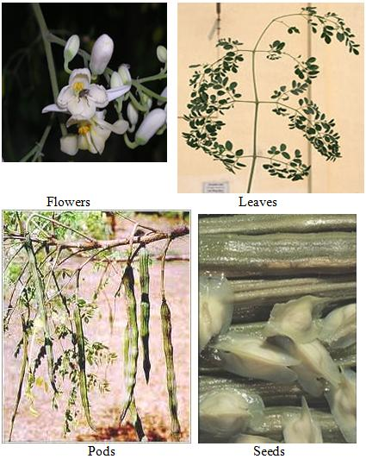A lot of work had been done on this plant but no researcher tied this plant and its products to the cure of this intractable cancer especially of the breast.
- Mehanaz Kamal and Talha Jawaid of Pharmacy Department of the Integrated University, Lucknow (20) documented a detailed phytochemical constituents of the roots, bark, gum exudates, whole pods, mature seeds and seed oil of this plant which is found in most parts of the world.
- Most workers concentrated on the excellent nutritional importance of this magic plant.
- Obikwelu et al (21) using the moringa dry leaf found high level of phytochemicals and using a special wet technique extracted the phytochemicals.
- Isoflavone and catechines which act as anti-oxidants and scavenging agents for dangerous free radicals in the body were identified in high levels in the extracts from the leaf, seed and bark using ultra violet (UV) Visible Spectrophotometer, confirming the speculative documentation by Kamal and Jawaid.

3.0: Materials and Methods:
3.1: Materials:
- Sodium tetrachloroaurate (Na Au Cl₄).
- Moringa Oleifera (MO)leaf
- Methanol.
3.2: Methods:
20 cc of MO extract in 80% methanol was mixed with 500 cc of 0.1 molar solution of sodium tetrachloroaurate at room temperature. The solution of the MO leaf extract was subjected to spectrophotometric analysis and the MOGNP composite solution was subjected to UV absorption.
4.0: Results and Discussion:
4.1: Results:
When MO extract in methanol in 80% methanol was mixed with 500cc of sodium tetrachloroaurate the solution turned from pale yellow to purple red due to the formation of gold nanoparticles in the solution.
UV visible spectrophotometric analysis of the liquid extracts from processed MO leaves high levels of substances called phytochemicals at the absorbance value of 2393 and wavelength of 235nm Fig 1. When the stabilized solution of gold nanoparticle-moringa extract was subjected to UV absorbance, gold nanoparticles were identified at the peak absorbance of approximately 295nm wavelength Fig 2.

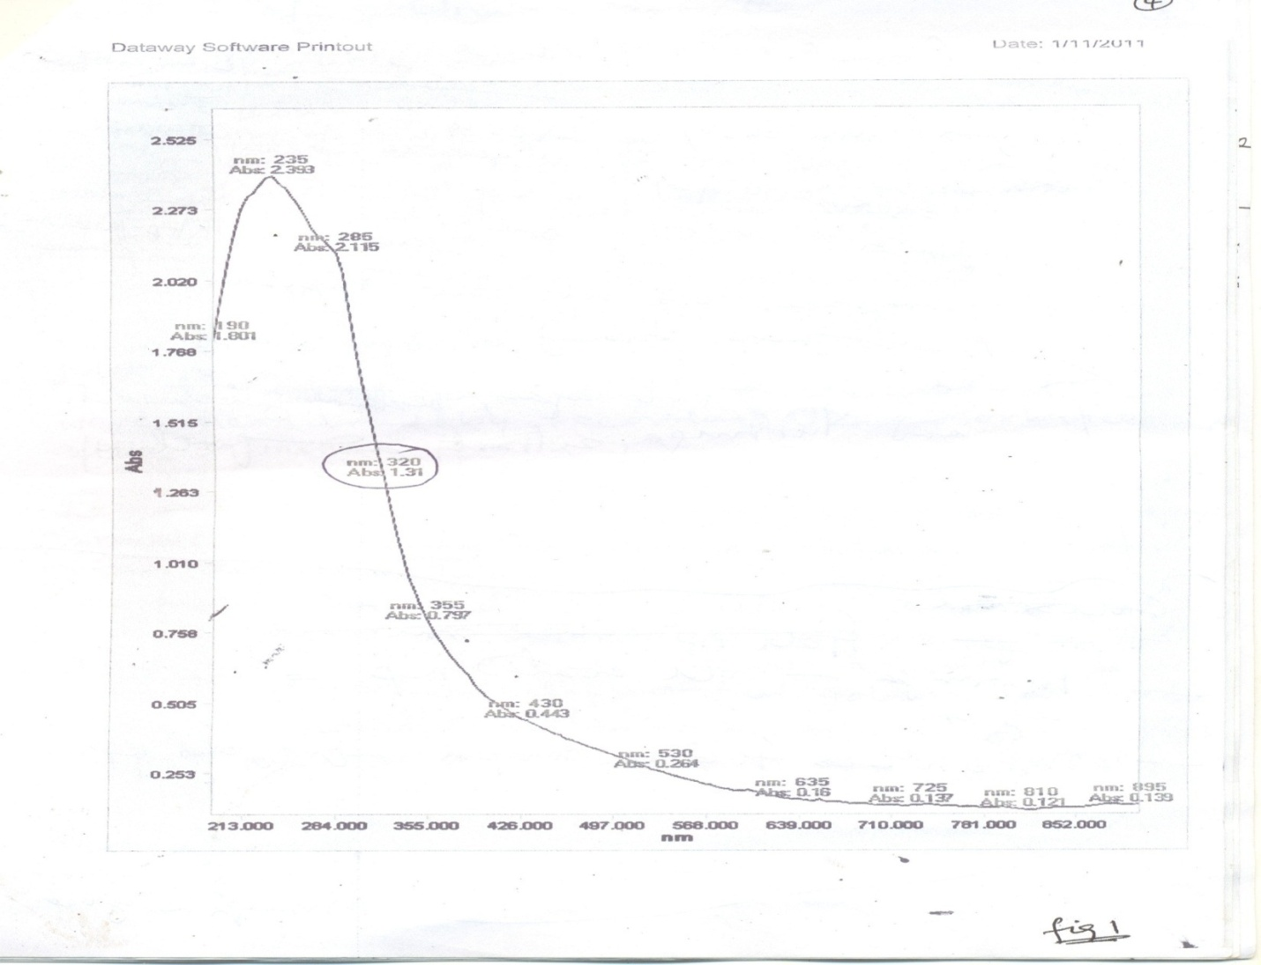
Fig. 1:UV visible Spectrophotometric Analysis the liquid of the MO extract
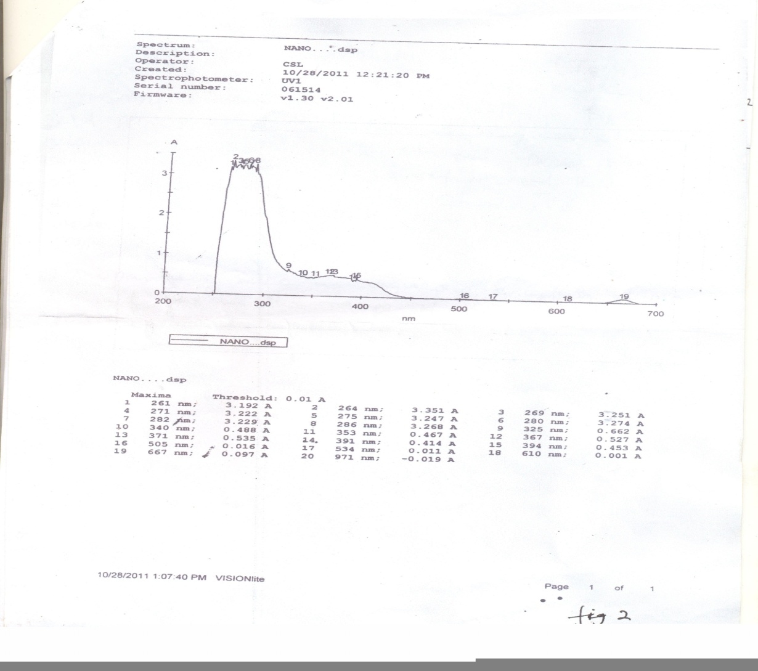
Fig 2: The Stability of Gold-Moringa Nanoparticle with UV Absorbance Scan

4.2: Discussion:
Various mechanisms proposed for the interaction of cancer with nano particles are described below:
- Y. Matsumura and H. Maeda(22) observed the enhanced permeability and retention(EPR) of nanoparticles around body tissues leading to the accumulation of nanoparticles around the tissue.
- EPR effect is promoted by increase in surface energy and tensile stress around the tumour site generating surface energy and tensile effect (SETE) proposed by Obikwelu(23).
- SETE effect makes the structures around the tumour permeable and the nanoparticles with comparable sizes with the structures kinetically leak into the tumour interstitium to effect the gradual annihilation the tumour.
- Interstitial tumour interstitium poisoning( ITP) recently proposed by Obikwelu et al (24) where nanoparticles of sizes 0.225 of the size of the adjoining infected cell units (tumour cells) locate in the interstitial sites to effect a cure.
Substitutional Poisoning (SP) (25) results from using varying sizes of nanoparticles in a domain of tumour cell units to retard or put a stop to the growth of the tumour interface.
- When nanoparticle composite is administered via the recommended routes in this paper, the particles will be suspended in the blood stream.
- Two major considerations come into play on the movement of the nanoparticle, namely: buoyancy force from the blood, because the blood is flowing slowly, an additional force with two components (skin friction or viscous force) and the form drag force due to pressure distribution in the blood comes into play.
- Skin or Viscous force (drag force on the particle) resulting from creeping flow is obtained from the solution of the hydrodynamic Navier-Stokes equations to be equal to 3πµdu where the skin friction is 2πµdu and the form drag force is negligible (µ is viscosity of blood, u is velocity relative to the particle.
- The particle is in the flowing blood along a blood vessel (pipe), therefore there is particle Reynold’s number, Re’=udρ/µ, ρ is the density of blood.
- There is another force per unit projected area of the particle which is the spherical area of tumour in the breast.
- If the blood is under gravity, the velocity of the particle will increase until the accelerating force is exactly balanced by the resistance force and terminal velocity results.
- This velocity depends directly on the size and density of the particle and inversely with the viscosity.
- With low Reynold’s number and very small particles like the nanoparticles, the drag force is equal to 3πµdu.
- It is postulated that cancer of the breast forms in the interlobular duct but its surface energy and the prevailing concentration gradient will direct the particle from the blood to the disturbed area at the lobe-duct joint where the already configured nanoparticle composite will nucleate heterogeneously.
- The decreasing surface free energy,ΔG(surface) is the driving force for more configured nano particle composite units with its therapeutic power to nucleate and wipe off the tumour surface.
- With high concentration of the finer and finer nanoparticle composite units in the blood the higher the free energy in the bulk of the blood and the more the driving force of the nanoparticles to the tumour in the breast and the more therapeutic efficiency.
Despite the drag force and bouyancy effects , the driving force for nanoparticle to attack the tumour in the breast is predominant because of the magnitude.
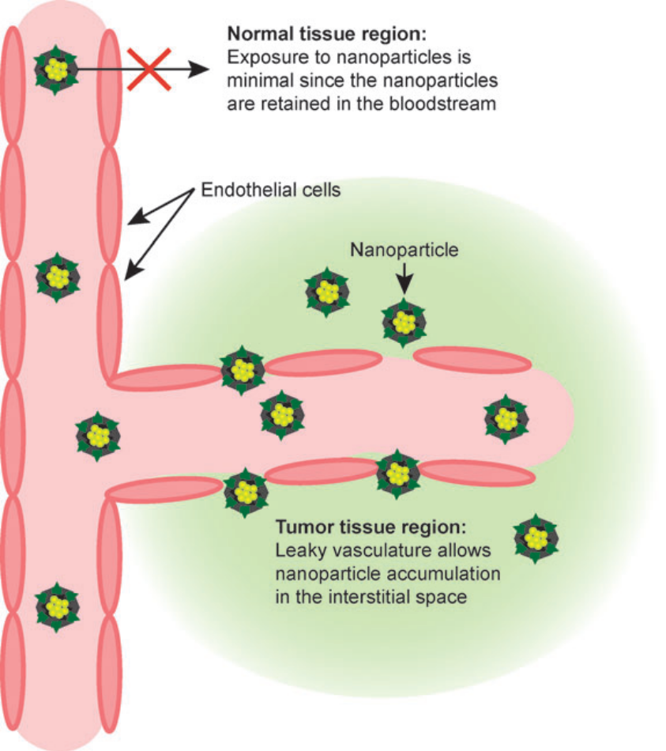

- From our preliminary analyses moringa leaf contained the highest concentration (about 1270mg/g) of phytochemicals, the seed (about 1080mg/g) and the stem about (107mg/g) especially of isoflavone.
- The moringa leaves or seeds, after appropriate hygenic treatment could be finely ground and dozed into edible purrie or slurry like colloidal corn flour(akamu), yam porridge, jollof rice or any other solid delicacy and eaten as food.
- The active ingredient would routinely dissolve in the blood stream and through the proposed mechanisms earlier discussed in this paper locate appropriately to effect the expected cure.
- Monitored dosage will determine the kinetics of the treatment.
The severity of the cancer disease will determine the dosage as decided by the medical specialists.

- Cell Internalization studies: Inoculated media containing breast or prostrate cancer cells will be prepared and allowed to grow for some days.
- Appropriate solution of
- moringa-gold nanoparticle ,
- moringa extract-agar or
- moringa extract –pectin or
- moringa extract-any biodegradable component will be prepared to produce nano- moringa extract coated with nano-biodegradable component or inert gold nanoparticles coated with moringa extract.

Any of these nanocomposites in the proper aqueuos medium will be injected into the cells of any guinea pig preferably rabbits and changes will be observed with an appropriate microscope.
- In-vitro stability of all the above will be studied using UV-Spectrophotometer.
- Then in-vivo studies in the guinea pigs will follow for further findings.
- Controlled injection of pharmacologically certified aqueous nanocomposite into the infected breast or prostrate for cure follows.
- Nanoencapsulation of these tested nano-moringa composite is an assignment with the pharmaceutical group.
REFERENCES:
- 1. W.C. Hanahan, R.A.Weinberg, The Hallmarks of Cancer Cell 100, 57-70, 2000.
- 2.M.Ferari, Cancer Nanotechnology: Opportunities and Challenges. Nat.Review Cancer, 5,pp161-171,2005.
- 3.P.Allivisatos, The Use of nanocrystals in biological detection. Nat.Biotechnology,22,pp.47-52,2004
- 4. D.O.N.Obikwelu, Review on nanoparticles in cancer therapy. Paper presented at the University of Nigeria Teaching Hospital, Enugu Campus. April 2008.
- 5.D.O.N.Obikwelu Nanostudies at the University of Nigeria, Nsukka,

- 6. D.O.N.Obikwelu, Nanomaterials, Paper presented at the International Conference of Advanced Materials at the Raw Materials Development and Research Centre, Abuja. 2010.
- 7.Y.Matsumura, H.Maeda, A new concept for macromolecular therapeutics in cancer chemotherapy: mechanism of tumoritropic accumulation of proteins and anti tumour agents smancs. Cancer Res. 46: 6387-92, 1986.
- 8. Science Magazine, 2008.
9. Ditto
- 10. Science Daily 2008
- 11. Science Daily, 2009.
- 12.W.Yu et al Experimental detection of the extinction coefficient of CdTe, CdSe and CdS nanocrystals, chem,Materials.15:2854-60,2003.
- 13.M.G. Harrising, J.Barentsz et al Non-evasive detection of clinically occult lymph-node metastases in prostrate cancer, N.Engl.J.MED: 2491-99,2003.
- 14. S.A.Mamuru and`K.Ozoemena, The electro-catalytic reduction of molecular oxygen at nanostructured iron(II)phthalocynanine and its multi-walled carbon nanotube. 5th Inter. Conference of African-MRS Conf. held at Abuja, Dec. 2009.
- 15. D.O.N.Obikwelu, C.O.Nebo, S. Ume. Investigative Study of the use of nanonized moringa-extract for the treatment of breast cancer. Finding being patented. 2010.
- 16.Ditto
- 17.Nair and Predeep Using XRD Fourier Transform Infra- red Spectroscopy Measuurements in remediation of metallic ions.
- 18. Evaldas Sadaaukas, http://www.e.journals.net, 2010.
- 19. Uwechue, http://www.africaresource.com
- 20. Mehnaz Kamal and Talha Jawaid http:/www.pharmainfo.net 2008.
- 21. D.O.N.Obikwelu, C.O.Nebo and S.Ume, ibid.
- 22.Y.Matsumura and Maeda ibid
- 23. D.O.N.Obikwelu Unpublished.
- 24. D.O.N.Obikwelu, C.O.Nebo, Unpublished.
- 25. D.O.N.Obikwelu ibid
26. D.O.N.Obikwelu, C.O.Nebo, Unpublished

