Electroless deposition of Pt nanotube arrays: A template-based approach towards highly stable fuel cell catalysts

Torsten Walbert, PhD, TU Darmstadt, Germany
Tim Böttcher, PhD, TU Darmstadt, Germany
Wolfgang Ensinger, Prof. Dr., TU Darmstadt, Germany

Abstract
In recent years, unsupported noble-metal nanocatalysts received increased attention in consideration of various potential application fields. However, due to high material costs and structure-dependency of catalytic performance, a precise control of nanostructure fabrication is required. A highly suitable and scalable approach is represented by template-assisted synthesis methods, which enable the direct adjustment of structural parameters and thus facilitate tailoring the catalytic performance. One of the most flexible routes implies the employment of ion track-etched polymer membranes. Therefor, a certain polymer (e.g. PC, PET, PI) is irradiated with swift heavy ions, leading to the formation of latent damage tracks. Selective etching of the tracks produces high aspect ratio nanochannels with adjustable dimensions. These can be used as templates for the fabrication of nanotubes. The tubes are formed by redox-chemical deposition of the desired material onto the pore walls. After dissolution of the template, freestanding nanotubes are obtained. Depending on the angle of incidence and the ion fluence during irradiation, even interconnected nanotubes can be generated, resulting in mechanically stabilized nanotube networks (NTNWs). As an example, the synthesis of Pt NTNWs is shown in Figure 1. Due to the template-assisted approach, nanotube composition, size and morphology can be easily controlled and tailored regarding potential applications. In case of methanol oxidation reaction (MOR), a partially porous Pt NTNW is applied as catalyst, showing increased durability as well as mass activity compared to a commercial Pt nanoparticle catalyst. Thus, the use of 3D nanostructured materials can increase specific surface area while retaining structural stability, resulting in a better catalytic performance. Besides, utilization as a support with high surface area and thermal, chemical as well as mechanical stability, e.g. as current collector in battery systems, is feasible.
Figure 1: Schematic representation of the template-assisted NTNW fabrication.

Image
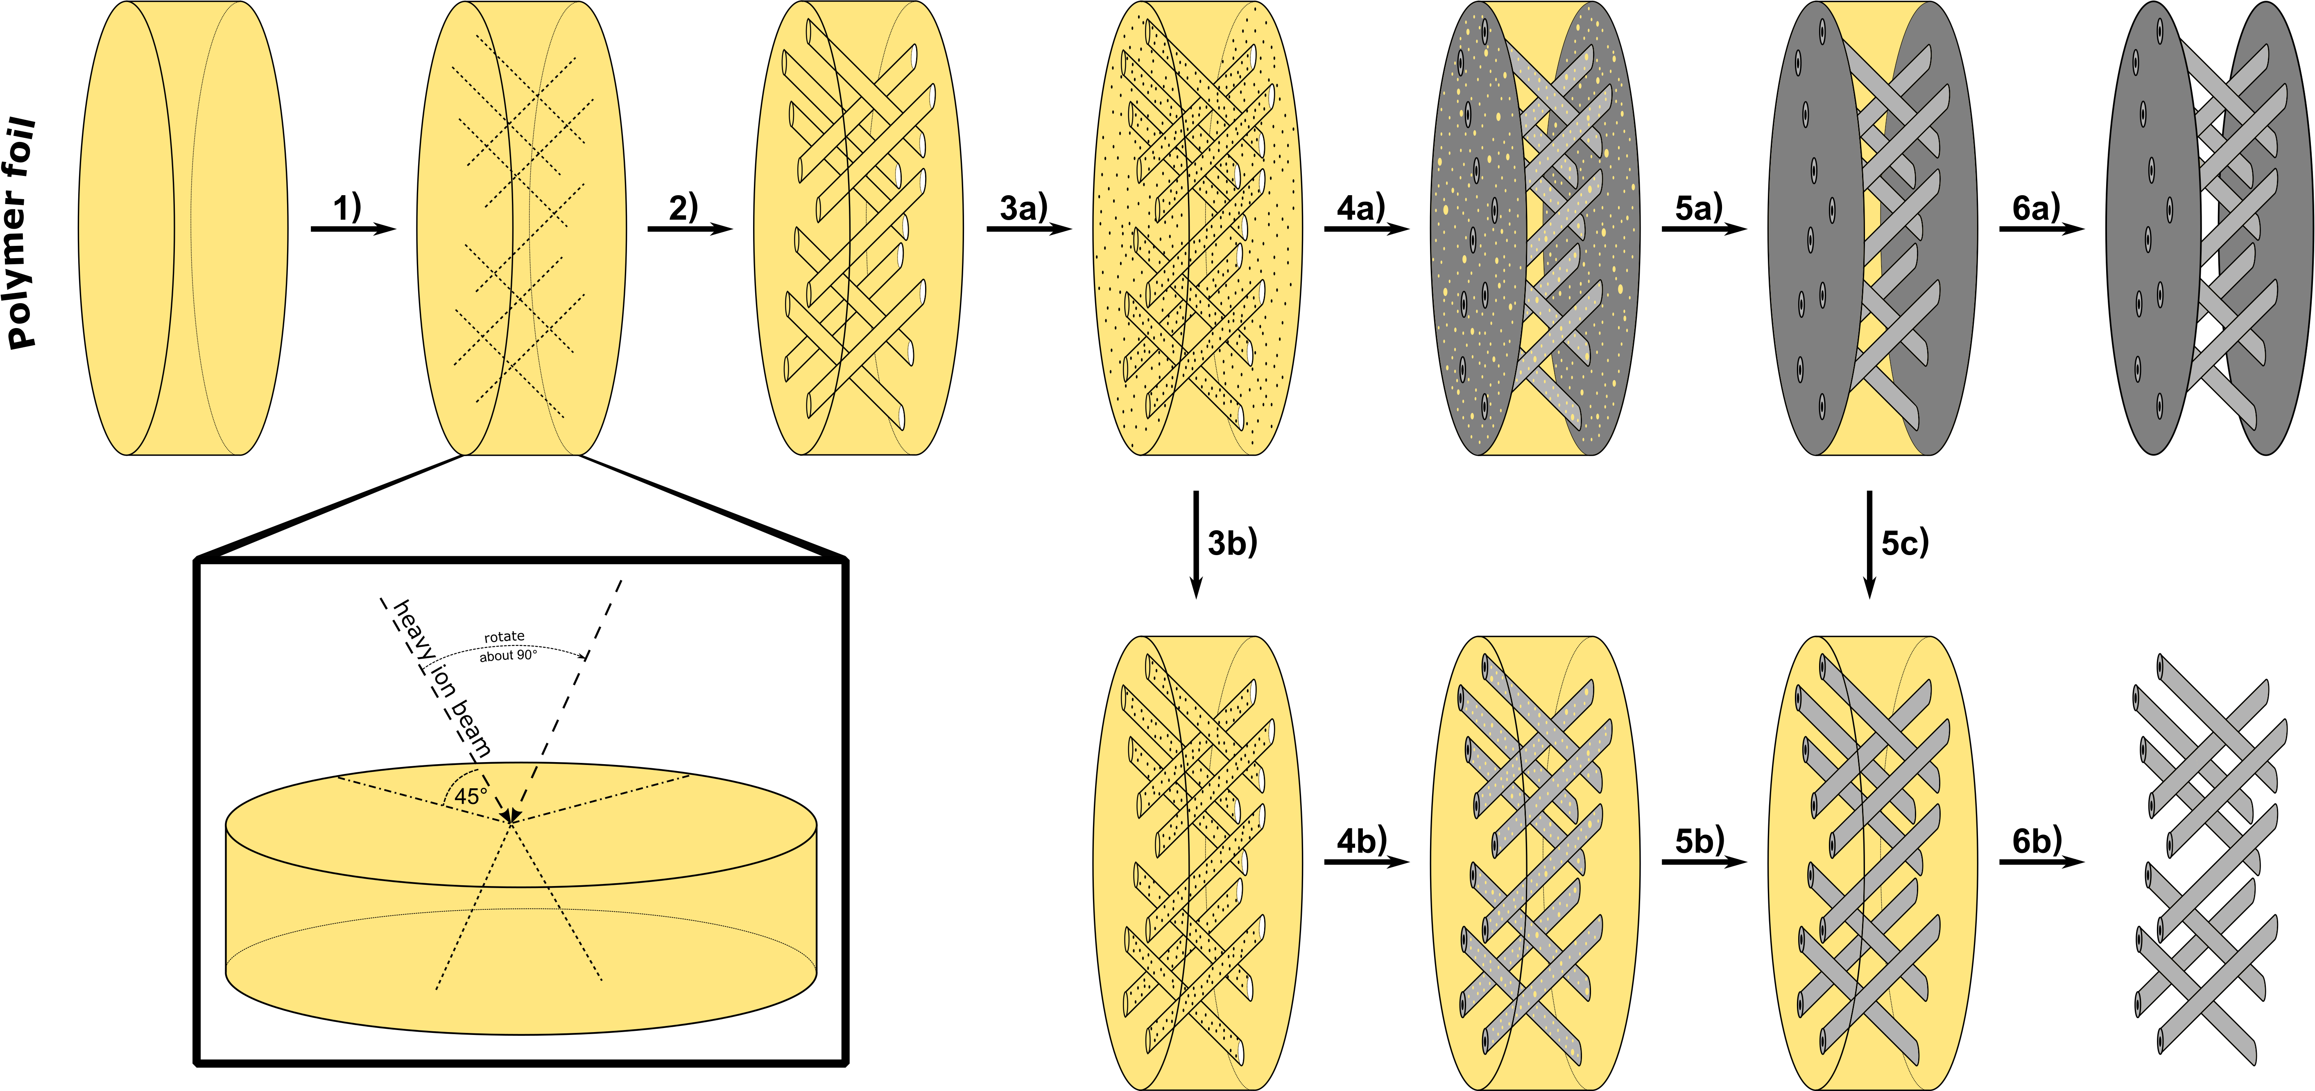
Recent Publications
- F. Muench, S. Kaserer, U. Kunz, I. Svoboda, J. Brötz, S. Lauterbach, H.-J. Kleebe, C. Roth, W. Ensinger, J. Mater. Chem. 2011, 21, 6286–6291.
- M. Rauber, I. Alber, S, Mueller, R. Neumann, O. Picht, C. Roth, A. Schoekel, M. E. Toimil-Molares, W. Ensinger, Nano Lett. 2011, 11, 2304–2310.
- S. Schaefer, E.-M. Felix, F. Muench, M. Antoni, C. Lohaus, J. Brötz, U. Kunz, I. Gärtner, W. Ensinger, J. Brötz, et al., RSC Adv. 2016, 6, 70033–70039.
- M. Antoni, F. Muench, U. Kunz, J. Brötz, W. Donner, W. Ensinger, J. Mater. Sci. 2017, 52, 7754–7767.
5. F. Muench, E.-M. Felix, M. Rauber, S. Schaefer, M. Antoni, U. Kunz, H.-J. Kleebe, C. Trautmann, W. Ensinger, Electrochim. Acta 2016, 202, 47–54.

Biography
Torsten Walbert has his expertise in template-assisted electroless metal plating. After he received his Master’s degree in chemistry from Technische Universität Darmstadt, he decided to change disciplines within the university and started a PhD in the field of materials science. Therein, he works on the template-assisted fabrication of complex metal nanostructures for the application as catalyst in fuel cells or as electrode in battery systems. He presented his work at scientific conferences in Lisbon (SMMIB) as well as Lausanne (Junior Euromat) where he received the award for best poster presentation in the area of functional materials. This template-assisted approach represents a highly flexible and promising method, enabling the independent modification of numerous material parameters.
Email: walbert@ma.tu-darmstadt.de
Contact no: +496151 1621994
Track name: Nanomaterials- production, synthesis and processing

