Hybrid nanoparticles as theranostic tool: photo-thermal treatment and MRI imaging

Nina Kostevšek¹, Samo Hudoklin², Mateja Erdani Kreft², Igor Serša¹, Sašo Šturm¹, Kristina Žužek Rožman¹

¹ Jožef Stefan Institute, Ljubljana, Slovenia
² Institute of Cell Biology, Faculty of medicine, University of Ljubljana, Slovenia

Abstract
We have produced an innovative, theranostic material based on FePt/SiO₂/Au hybrid nanoparticles (NPs) for both, photo-thermal therapy and magnetic resonance imaging (MRI). Furthermore, a new synthesis approach, i.e., Au double seeding, for the preparation of the Au nanoshells around the FePt/SiO₂ cores, is proposed. The photo-thermal and the MRI response were first demonstrated on an aqueous suspension of hybrid FePt/SiO₂/Au NPs. The cytotoxicity together with the internalization mechanism and the intracellular fate of the hybrid NPs were evaluated in vitro on normal (NPU) and a half-differentiated cancerous cell line (RT4). The control samples as well as the normal cell line incubated with the NPs showed no significant temperature increase during the in vitro photo-thermal treatment (ΔT < 0.8 °C) and thus the cell viability remained high (~90%). On the contrary, due to the high NPs uptake by the cancerous RT4 cell line, significant heating of the sample was observed (ΔT = 4 °C) and, consequently, after the laser irradiation cell viability dropped significantly to ∼60%. These results further confirm that the hybrid FePt/SiO₂/Au NPs developed in the scope of this work were not only efficient but also highly selective photo-thermal agents. Furthermore, the improvement in the contrast and the easier distinction between the healthy and the cancerous tissues were clearly demonstrated with the in vitro MRI experiments, proving that hybrid NPs have an excellent potential to be used as the contrast agent.

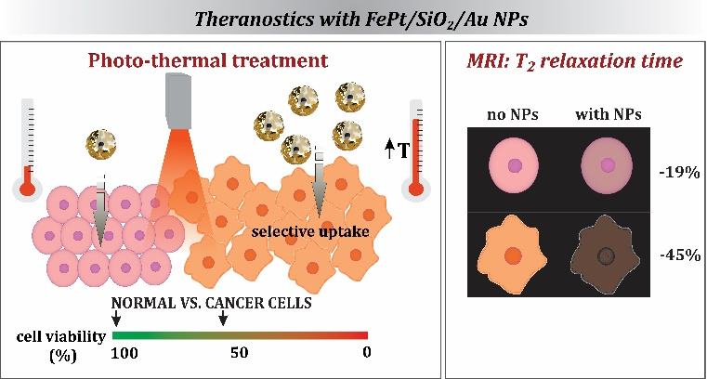

Recent Publications
- Kostevšek N et al. (2015) Multimodal hybrid FePt/SiO2/Au nanoparticles for nanomedical applications: combining photothermal stimulation and manipulation with an external magnetic field. J. Phys. Chem. C 119:16374-16382.
- Kostevšek N et al. (2015) “Single- and "multi-core" FePt nanoparticles: from controlled synthesis via zwitterionic and silica biofunctionalization to MRI applications. J. Nanopart. Res. 17: 464.
- Kostevšek N et al. (2016) The One-Step Synthesis and Surface Functionalization of Dumbbell-Like Gold-Iron Oxide Nanoparticles. A Chitosan-Based Nanotheranostic System. Chem. Comm. 52: 378-381.
- E. Borroni et al. (2017) Tumor targeting by lentiviral vectors combined with magnetic nanoparticles in mice template Acta biomaterialia, 59: 303-316.
- Kostevšek N et al. (2017) Hybrid FePt/SiO₂/Au nanoparticles as theranostic tool: in vitro photo-thermal treatment and MRI imaging, Nanoscale (submitted).

 Biography
Nina Kostevšek has her expertise in preparation of multifunctional nanomaterials based on magnetic (FePt, different ferrites) and optically active components (Au) for bioapplications such as magnetic resonance imaging, magnetic hyperthermia, photo-thermal theraphy and sensing. Her research involves as well formation of smart drug nanocarriers made of SiO₂, biopolymers (chitosan, gelatine, etc.) and thermo-responsive liposomes. Reliable characterization is of vital importance for the optimization of new materials, therefore she uses advanced “state of the art” techniques such as liquid cell transmission electron microscopy for visualization of nucleation and growth of nanoparticles in their “natural” aqueous environment.
Email: nina.kostevsek@ijs.si

