Effects of Activation Reagents on the Physical and Electrochemical Properties of Activated Carbon Electrodes for Symmetric Supercapacitors

Lu-Yin Lin, National Taipei University of Technology, Associate Professor, Taiwan
Yi-Han Chiu, Siao-Ting Hong, Yu-Shun Sung, Shang-Mao Tao, Yu-Shiang Chen, Wei-Lun Hong, Yu-Jui Hsiao, Bing-Chang Xiao, Shuo-Yang Xu, National Taipei University of Technology, Graduated Student, Taiwan
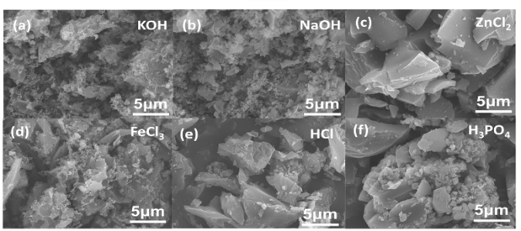

Abstract
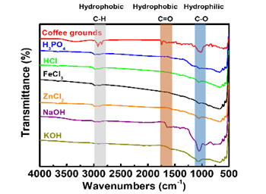
Carbon materials with large surface area, high porosity and high electrical conductivity are widely applied as the active material for the electrical double layer capacitor (EDLC). The activated carbon (AC) is largely used in commercialized Supercapacitor (SC) among the carbon materials, since the ingredient is relatively cheaper and the producing process is relatively simple for producing AC. To attain better energy storage ability, the surface area for AC is of the great importance since the ions in the electrolyte needs to adsorb and desorb from the active surface of AC during the charging/discharging process for storing charges. The activating agent plays very significant roles on refining the structure of carbon materials, but the investigation of the real function for the activating agent is limited. The effects for the kind of activating agents on the structure of AC and the interaction between AC and the electrolyte are almost neglected. This work utilized six kinds of alkane, acid and neutral activating agents including KOH, NaOH, HCl, H₃PO₄, ZnCl₂ and FeCl₃ to activate waste coffee grounds for producing AC. These carbon nanoparticles are aggregated together to form numerous textural porosities which facilitate the access of electrolyte into the interior structure (Figure 1).The intensity for peaks in FTIR curves is all reduced for the AC, the reduction of the intensity for the hydrophilic functional groups is smaller than the reduction of the intensity for the hydrophobic groups (Figure 2). The KOH-activated AC electrode showed a highest CF value of 139.32 F/g corresponding to the areal capacitance of 1.07 F/cm² among all the AC electrodes prepared using different activating agents (Figure 3). In the study, the process provides an economic and effective method to prepare active materials of high-performance from biomass. When the power outage or emergency, it can apply to health care equipment.
Figure 1 The SEM images for different activation carbons activated using (a) KOH, (b) NaOH, (c) ZnCl₂, (d) FeCl₃, (e) HCl, (f) H₃PO₄.

Image
Figure 3 (a) Specific capacitance (F/g) and (b) areal capacitance (F/cm²) measured using GC/D curves at 10 mA/cm² for AC electrodes activated using various activating agents.

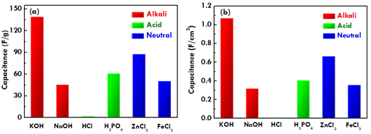
Figure 2 The FTIR spectra for the activated carbons activated using H₃PO₄, HCl, FeCl₃, ZnCl₂, NaOH and KOH.

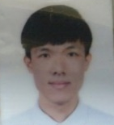 Biography
Yi-Han Chiu has completed his degree of Bachelor at the age of 22 years from the Department of Chemical Engineering in National Yunlin University of Technology. Now he is studying a master’s degree in the National Taipei University of Technology, under the supervisor of Professor Lu-Yin Lin. His research is focus on the electrode materials of supercapacitors, just like using renewable resources to make the electrode of activated carbon.
Email: t105738075@ntut.org.tw

