Microwave synthesis of Near Infrared Type II water-soluble Lead Sulfide Quantum Dots For in vivo Bioimaging
Jun Chen, PhD, Department of Orthopedic Sports Medicine, Huashan Hospital, Fudan University, Shanghai 200040, China
Shiyi Chen, PhD Department of Orthopedic Sports Medicine, Huashan Hospital, Fudan University, Shanghai 200040, China

Abstract (300 word limit)

Ribonuclease-A (RNase-A) encapsulated PbS quantum dots (RNase-A@PbS Qdots) which emit in the second near-infrared biological window (NIR-II, ca. 1000−1400 nm) are rapidly synthesized under microwave heating. Photoluminescence (PL) spectra of the Qdots can be tuned across the entire NIR-II range by simply controlling synthesis temperature. The size and morphology of the Qdots are examined by transmission electron microscopy (TEM), atomic force microscopy (AFM), and dynamic light scattering (DLS). Quantum yield(QY) measurement confirms that the prepared Qdots are one of the brightest water-soluble NIR-II emitters for in vivo imaging. Their high QY(∼17.3%) and peak emission at ∼1300 nm ensure deep optical penetration to muscle tissues (up to 1.5 cm) and excellent imaging contrast at an extremely low threshold dose of ∼5.2 pmol (∼1 μg) per mouse. Importantly, this protein coated Qdot displays no signs of toxicity toward model neuron, normal, and cancer cells in vitro. In addition, the animal’s metabolism results in thorough elimination of intravenously injected Qdots from the body within several days via the reticuloendothelial system (RES), which minimizes potential long-term toxicity in vivo from possible release of lead content. With a combination of attractive properties of high brightness, robust photostability, and excellent biocompatibility, this new NIR-II emitting Qdot is highly promising in accurate disease screening and diagnostic applications.

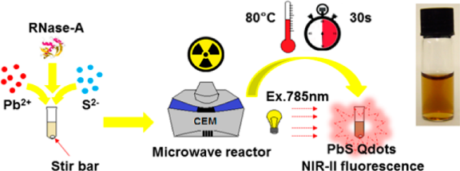

Scheme 1. Illustration of LG-PbS QDs recycled synthesis.
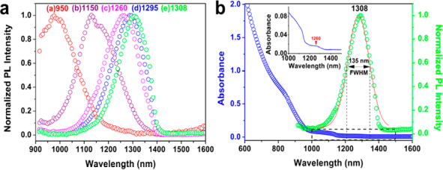
Figure 1. (a) Photoluminescence (PL) and (b) UV/vis/NIR absorption spectra of color-tunable RNase-A@PbS Qdots

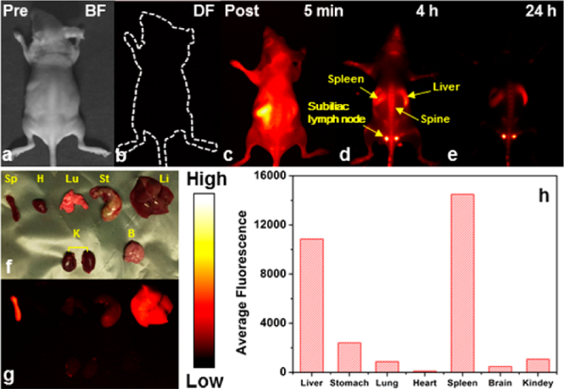
Figure 2. RNase-A@PbS Qdots for in vivo NIR-II fluorescence imaging.
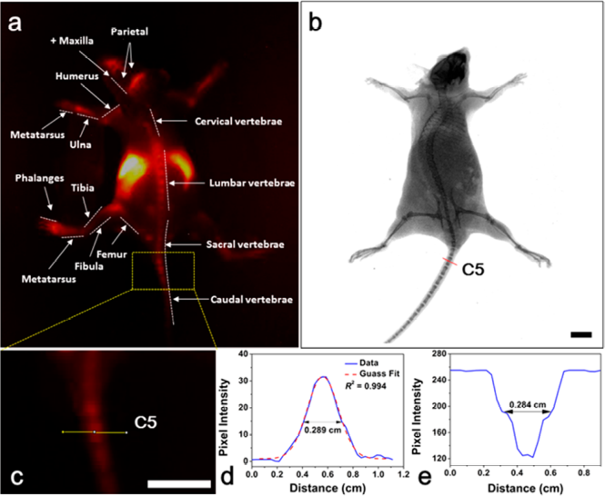
Figure 3. (a) NIR-II fluorescence image of a living nude mouse at 1 h postinjection for mapping major bone structures (identified with arrows). (b) X-ray image. (c) A zoom-in image of the selected area in part a. (d) A cross-sectional intensity profile measured along the yellow line in part c is fitted to a Gaussian function. (e) A cross-sectional intensity profile measured along the red line in part b. Scale bars represent 1 cm.
Recent publications
- Y. Kong, J. Chen, H. Fang, G. Heath, Y. Wo, W. Wang, Y. Li, Y. Guo, S. D. Evans, S. Chen and D. Zhou, Chem. Mater., 2016, 28, 3041-3050.
- J. Chen, Y. Kong, Y. Wo, H. Fang, Y. Li, T. Zhang, Y. Dong, Y. Ge, Z. Wu, D. Zhou and S. Chen, J. Mater. Chem. B, 2016, 4, 6271-6278.
- J. Chen, Y. Kong, W. Wang, h. Fang, Y. Wo, D. Zhou, Z. Wu, Y. Li and S. Chen, Chem. Commun., 2016, 52, 4025-4028.

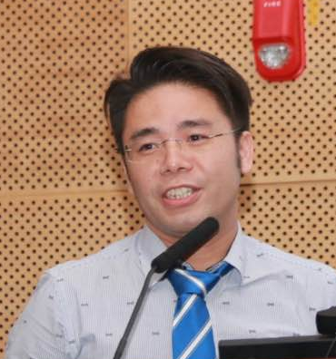 Biography
Dr Jun Chen
He is currently the assistant Professor of Huashan Hospital, Fudan University, China. He obtained the doctor degree of biomedical engineering from Shanghai Jiao Tong University in 2013, he has had studied in the Central of Bioscience in University of Nottingham as an exchange student from April to Dec, 2013. He moved to Huashan Hospital, Fudan Unversity for two years as a postdoctor, and then leads a multidiscipline research group on nanomateirals and biomedicine. Until now, He has had published more than 20 articles in high impact factor international journals such as Chem. Mater., Biomaterials, Nanoscale, J. Mater. Chem. B, and Chem. Commun., etc, and also has 7 Chinese patents of invention. His research interests including tissue engineering, nanotechology, molecular imaging and multifunctional materials for biomedical application.
Email: biochenjun@fudan.edu.cn

Notes/Comments:

