Impact of Bacillus in fermented soybean foods on human health

Trishala G, Harini Keerthana S, Kumar P, Elavarashi E*
Department of Biotechnology, Sri Ramachandra Faculty of Biomedical Sciences & Technology, Sri Ramachandra Institute of Higher Education and Research, (SRIHER), Deemed to be University, Chennai, India.

Purpose: Fermented soybean Foods (FSF) is popularly consumed in the South-East Asian countries. Bacillus species, a predominant microorganism present in these foods have demonstrated beneficial and deleterious impacts on human health. These microorganisms produce bioactive compounds during fermentation that have beneficial impacts in improving human health. However, the health risks associated with FSF: food pathogens, biogenic amines (BAs) production, and late onset anaphylaxis remain a concern. The purpose of this review is to present an in-depth analysis of positive and negative impacts as a result of consumption of FSF along with the measures to alleviate health risks for human consumption. Methods: This review was composed by scrutinizing contemporary literature of peer-reviewed publications related to Bacillus and FSF. Based on the results from academic journals, this review paper was categorised into: FSF, role of Bacillus species in these foods, process of fermentation, beneficial and adverse influence of these foods along with methods to improve food safety. Special emphasis was given to the potential benefits of bioactive compounds released during fermentation of soybean by Bacillus species. Results: The nutritional and functional properties of FSF are well-appreciated, due to the release of peptides and mucilage, which have shown health benefits: in managing cardiac disease, gastric disease, cancer, allergies, hepatic disease, obesity, immune disorders and especially microbial infections due to the presence of probiotic property, which is a potential alternative to antibiotics. Efficient interventions were established to mitigate pitfalls like the techniques to reduce BAs, food pathogens and by using a defined starter culture to improve the safety and quality of these foods. Conclusion: Despite some of the detrimental effects produced by these foods, potential health benefits have been observed. Therefore, soybean foods fermented by Bacillus can be a promising food by integrating effective measures for maintaining safety and quality for human consumption. Further, in vivo analysis on the activity and dietary interventions of bioactive compounds among animal models and human volunteers are yet to be achieved which is essential to commercialize them for safe consumption by humans, especially immunocompromised patients.

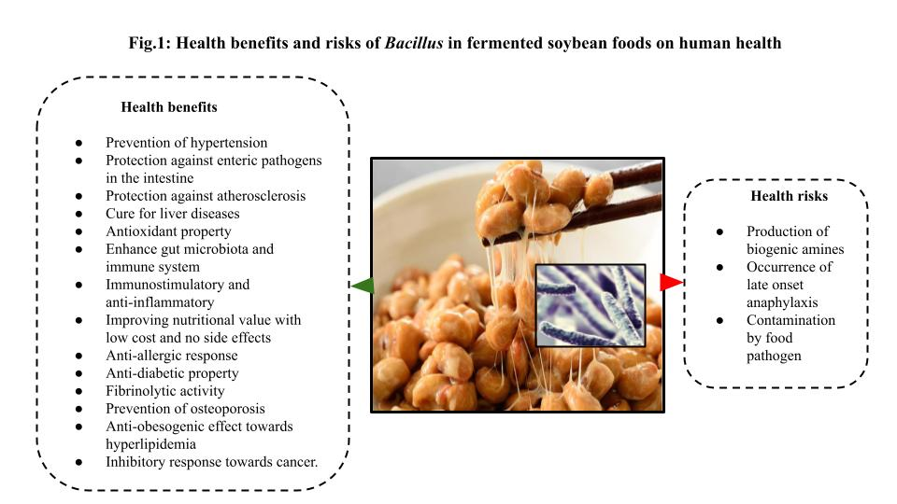

Biography:
Elavarashi E, is a recipient of SRU Chancellor Fellowship Grant for full-time PhD programme in April 2009 at Sri Ramachandra Institute of Higher Education and Research (SRIHER), Chennai, India. She has done PhD in Microbiology on ‘Phenotypic and genotypic characterization of dermatophytes from clinical specimens using novel markers’. Now her current research interest is to isolate potent probiotic Bacillus strains from various sources like fermented soybean foods and soil. She has worked on Bacillus since 2019, isolated Bacillus isolates from various sources and evaluated extracellular enzyme activity, biofilm formation and antimicrobial activity of Bacillus spp. against pathogens. Recently, she has analysed the complete genome of Bacillus and is yet to be published.

Publication:
1. Trishala Gopikrishna, Harini Keerthana S, Kumar P, Elavarashi E. Impact of Bacillus in fermented soybean foods on human health. Annals of Microbiology 2021; 71, https://doi.org/10.1186/s13213-021-01641-9.
2. Ramaraj V, Vijayaraman RS, Elavarashi E, Rangarajan S, Kindo AJ. Molecular strain typing of clinical isolates, Trichophyton rubrum using non-transcribed spacer (NTS) region as a molecular marker. Journal of Clinical and Diagnostic Research 2017; 11, 10.7860/JCDR/2017/21994.9843.
3. Elavarashi E, Kindo AJ, Sudha R. Enzymatic and non-enzymatic virulence activities of dermatophytes on solid media. Journal of Clinical and Diagnostic Research 2017; 11, 10.7860/JCDR/2017/23147.9410.
4. Elavarashi E, Kindo AJ, Kalyani J, Sudha R. Application of PCR fingerprinting using (GACA)₄ primer in the rapid discrimination of dermatophytes. Indian Journal of Medical Microbiology 2014; 32, 10.4103/0255-0857.136548.
5. Elavarashi E, Kindo AJ, Kalyani J. Optimization of PCR-RFLP directly from the skin and nails in cases of dermatophytosis, targeting the ITS and the 18S ribosomal DNA regions. Journal of Clinical and Diagnostic Research 2013; 7, 10.7860/JCDR/2013/5363.2873.

Comments: The abstract given here is from my recent review article published in Annals of Microbiology.

Presenting author details
Full name: Elavarashi Elangovan
Contact Number: 9962965584
Mail Id: elavarashi@sriramachandra.edu.in
Category: Oral presentation

