Handcraft covalent organic nanostructures molecule by molecule and bond by bond
Qigang Zhong, Postdoc, Institute of Applied Physics, Justus-Liebig University Giessen (JLU), Germany

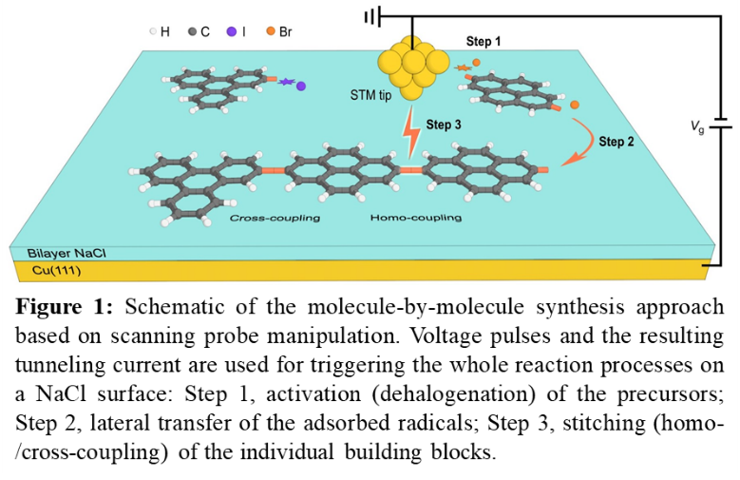
Abstract
Nanotechnology is essentially the development of materials and devices with special properties by modulating the composition, size, and structure of matter at the nanoscale (typically 1–100 nm). Ideally, matter at that size can be precisely designed and constructed from the bottom up via assembling and linking molecular building blocks one at a time. There are two prerequisites for the microscopic manipulation of intermolecular reactions: first, to selectively address and move single molecules a ‘finger’ of similar size is required, preferably with only one atom at the ‘fingertip’; second, an atomically flat ‘palm’ is needed to align two molecules in close vicinity for the formation of chemical bonds between them. However, human hands seem too large and clumsy for this task. The invention of the scanning probe microscope (1981) and its widespread application in surface science finally brought a solution to this problem. Although preliminary success has been achieved before under 0D and 1D confined conditions, freely matching and connecting different molecules on a 2D surface remains challenging. In our recent work, we used the tip of a scanning probe microscope and the crystalline sodium chloride surface as the ‘finger’ and the ‘palm’, respectively, to control the activation and movement of individual molecules as well as their combination (coupling reactions) with single-bond precision. This method has enabled homo- and cross-coupling and oligomerization with unprecedented high selectivity (including chemo-, site-, regio-, and 2D stereo-selectivity). By varying the manipulation parameters, more complex linkages than C–C single bonds, such as C–I–C bonds and carbon five-membered rings are accessible. Our method can be widely used to fabricate low-dimensional carbon-based nanostructures and single-molecule devices, to study the relationship between molecular structures and their electronic properties, and to explore the reaction mechanism of intermolecular coupling of reactive chemical entities.

Image

Recent Publications
- Zhong Q, Ihle A, et al. (2021) Constructing covalent organic nanoarchitectures molecule by molecule via scanning ‎probe manipulation. Nature Chemistry DOI: 10.1038/s41557-021-00773-4.
- Zhong Q, Ebeling D, et al. (2018) Symmetry breakdown of 4,4''-diamino-p-terphenyl on a Cu(111) surface by lattice mismatch. Nature Communications 9: 3277.
- Zhong Q, Hu Y, et al. (2019) Benzo-fused periacenes or double helicenes? Different cyclodehydrogenation pathways on surface and in solution. Journal of the American Chemical Society 141: 7399-7406.
- Zhong Q, Li X, et al. (2020) Noncontact atomic force microscopy: Bond imaging and beyond. Surface Science Reports 75: 100509.
- Tschakert J, Zhong Q, et al. (2020) Surface-controlled reversal of the selectivity of halogen bonds. Nature Communications 11: 5630.
- Ebeling D, Zhong Q, et al. (2019) Adsorption structure of mono- and diradicals on a Cu(111) surface: Chemoselective dehalogenation of 4-bromo-3''-iodo-p-terphenyl. ACS Nano 13: 324-336.

 Biography
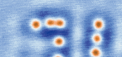
Qigang Zhong is a postdoc in the Institute of Applied Physics at JLU Germany. He received his Ph.D. in Physics at Soochow University China in 2019. His research is focused on surface physics and chemistry, with respect to the adsorption behaviors and reaction mechanisms of organic molecules on 2D surfaces and the on-surface synthesis of low-dimensional organic nanostructures. He uses scanning tunneling microscopy and non-contact atomic force microscopy under low-temperature and ultrahigh-vacuum conditions to investigate the structural, physical and chemical properties of molecules at the atomic and single-bond level. He is also experienced with atomic and molecular manipulation for creating covalent/non-covalent nanostructures from the bottom up.
Email: qigang.zhong@ap.physik.uni-giessen.de

Notes/Comments:

Presenting author details
Full name: Qigang Zhong
Contact number: +49 1628489674
Mail id: AG Schirmeisen, Heinrich-Buff-Ring 16, 35392 Giessen, Germany
Category: Oral presentation

