Preparation and anti-Pneumococcal activity of nano azithromycin-Eudragit RS100 formulation using electro-spinning method

Farzaneh Lotfipour, Khosro Adibkia, Golrokh Khorasani and Shahriar Payab
Hematology & Oncology Research Center, Faculty of Pharmacy, Tabriz University of Medical Sciences, Tabriz, Iran

Abstract
Propose: Bacterial pneumonia is a common lung infection caused by different types of bacteria. Azithromycin (AZI), an azalide antibiotic, is widely used to manage pneumococcal infections. Studies have shown that antibiotics in nanocarriers may lead to increased antibacterial activity and reduced toxicity. The aim of this work was to valuate in vitro antibacterial performance azithromycin-Eudragit RS100 nano-formulations against Streptococcus pneumoniae and Staphylococcus aureus. Methods: AZI-Eudragit RS100 nanoparticles were prepared via electrospinning technique and the in vitro antibacterial performance against S. pneumoniae and S. aureus were assessed using agar dilution method.
Results: Nanofibers in the sizes about 100-300 nm in diameter and micro scale in length and nanobeads in the range of 100-500 nm were achieved. The Minimum Inhibitory Concentrations (MIC) showed an enhancement in the antimicrobial effect of AZI-Eudragit RS100 nanofibers (40 μg/ml) compare to untreated AZI solution (>160 μg/ml) against S. pneumonia. The MIC value for AZI-Eudragit RS100 nanofibers against S. aureus was >128 μg/ml, same as that of the untreated AZI solution. Conclusion: The enhanced efficiency of AZI in nanofibers could be related to the more adsorption opportunity of nanofibers to S. pneumonia capsulated cell wall which provides an antibiotic depot on the bacterial surface compared to S. aureus. AZI-Eudragit RS100 nanofibers with enhanced antimicrobial effect against S. pneumonia can be considered as a candidate for in vivo evaluations in antibiotic therapy of Pneumococcal infections.

Image
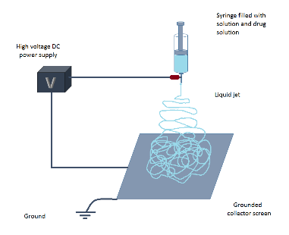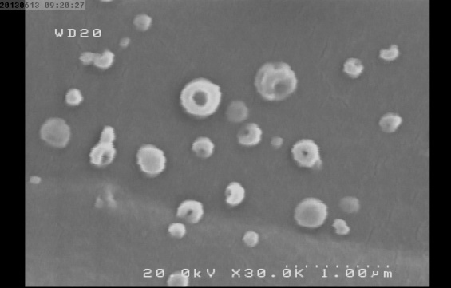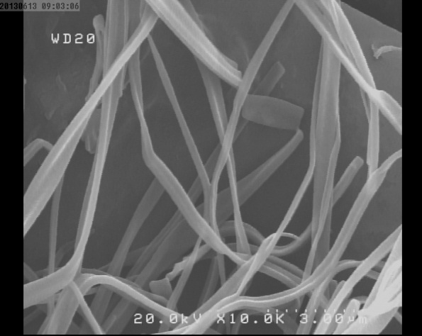
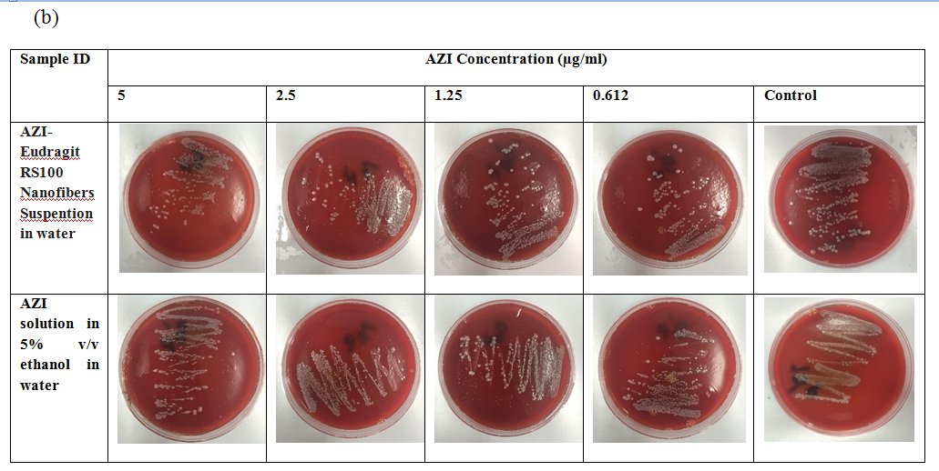

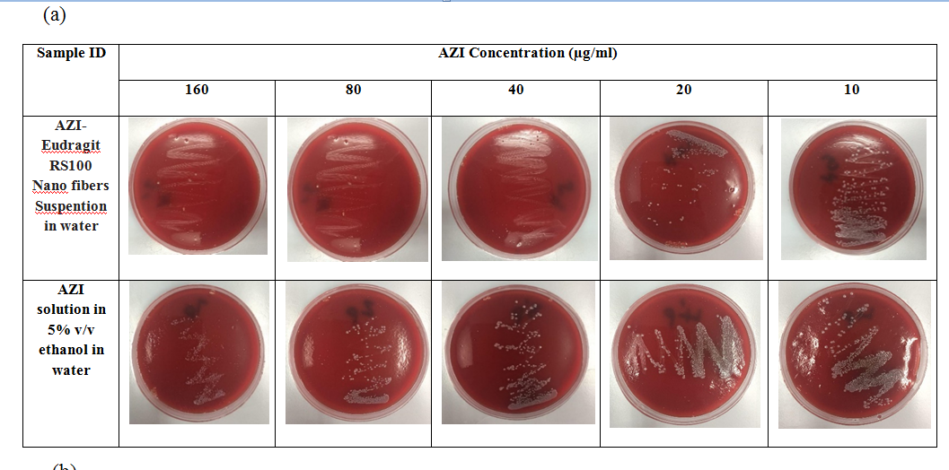

Fig 3. (a and b). Haemophillus agar plates containing AZI-Eudragit RS100 nanofibers as well as untreated AZI solution with streak cultures of S. pneumonia.
Recent Publications (minimum 5)
- Antimicrobial activity of the metals and metal oxide nanoparticles, (2014) SM Dizaj, F Lotfipour, M Barzegar-Jalali, MH Zarrintan, K Adibkia, Materials Science and Engineering: C 44, 278-284
- Natural antimicrobial peptides from bacteria: characteristics and potential applications to fight against antibiotic resistance, (2010) M Hassan, M Kjos, IF Nes, DB Diep, F Lotfipour, Journal of applied microbiology 113 (4), 723-736
- Nanoparticles for antimicrobial purposes in Endodontics: A systematic review of in vitro studies, (2016) M Samiei, A Farjami, SM Dizaj, F Lotfipour, Materials Science and Engineering: C 58, 1269-1278
- Magnetic nanoparticles for antimicrobial drug delivery, (2012) L Azhar, F Lotfipour, Die Pharmazie-An International Journal of Pharmaceutical Sciences 67 (10): 817-821
- Gelatin-based delivery systems for cancer gene therapy, (2009) SH Nezhadi, PFM Choong, F Lotfipour, CR Dass, Journal of drug targeting 17 (10), 731-738

Fig. 1. Schematic view of electrospinning process,
Fig 2. SEM images for AZI-Eudragit RS100 electrospuns.


Biography
PharmD: School of Pharmacy, Tabriz University of Medical Sciences, Iran, 1999
Research Fellow: Ottawa Health Research Institute, University of Ottawa, Ottawa, ON, Canada, 2004-2005
PhD: School of Pharmacy, Tabriz University of Medical Sciences, Iran, 2006
Farzaneh Lotfipour has her expertise in Pharmaceutical Microbiology. Her Research field included Development of novel drug delivery systems for antibiotics and gene delivery purposes; Development of novel microbial quality control methods for Pharmaceutical Products; Bioassay of antibiotics, antifungal and vitamins; Evaluation of the bioactivity of herbal and natural products. She has built her expert domain after years of experience in research, evaluation, teaching and consulting both in industries and education institutions.
Farzanrh Lotfipour, PharmD, PhD
Professor of Pharmaceutical Microbiology
Tel: +98 (41) 33392580
Session Name/Number
Category: (Oral presentation/Poster presentation)
Email: farzaneh.lotfipour@gmail.com

Notes/Comments:

