Nanolipidic Carriers Containing Curcumin: Preparation and Physicochemical Characterization
Aggeliki Liakopoulou, PhD Candidate, Laboratory of Pharmaceutical Technology, Dept of Pharmacy, Health Sciences School, University of Patras, 265 04, Rio, Greece
Konstantinos Avgoustakis, Professor Dr, Laboratory of Pharmaceutical Technology, Dept of Pharmacy, Health Sciences School, University of Patras, 265 04, Rio, Greece
Sophia Hatziantoniou, Assist. Professor Dr, Laboratory of Pharmaceutical Technology, Dept of Pharmacy, Health Sciences School, University of Patras, 265 04, Rio, Greece

Abstract (300 word limit)
Statement of the Problem: Nanoemulsions (NE), solid lipid nanoparticles (SLN) and nanostructured lipid carriers (NLC) are colloidal carriers for bioactive compounds. They are applied in therapeutic, diagnostic and cosmetic formulations. Curcumin (cur) is a polyphenol found in the rhizomes of the plant Curcuma longa L., and is traditionally used in the treatment of many diseases because of its multiple properties. The high lipophilicity of the molecule renders it difficult to incorporate in an acceptable final formulation. The above drawback as well as the intense color and reduced chemical stability of the molecule in light and air is attempted to be overcome by the use of nanotechnology. The aim of this work is to investigate the possibility of using the benefits of nanotechnology in the efficient topical delivery of curcumin formulated as nanoemulsions, solid lipid nanoparticles and nanostructured lipid carriers. Matterials & Methods: Three types of nanocarriers containing curcumin (NE-cur, SLN-cur & NLC-cur) and their corresponding control samples (NE-control, SLN-control & NLC-control) were prepared using triglycerides (Solid TG or Liquid TG or Solid-Liquid TG combination) and phosphatydylcholine (Egg PC or Soy PC) was also used as lipid phase. The particle size and their colloidal stability over time was assessed by Dynamic Light Scattering (DLS), after centrifugation or storage at 4ºC. The incorporation efficiency of curcumin in different nanocarriers was determined by size exclusion chromatography (SEC) and UV-Vis spectroscopy Their film forming capacity was examined by scanning electron microscopy. Findings: NEs, SLNs and NLCs of high curcumin content were successfully prepared and physicochemicaly characterized. Their stability was monitored over a period of 90 days. The high percentage of the incorporated curcumin and the uniformity of the particle distribution as well as the retaining of these characteristics overtime are factors indicating that the nanostructured lipid carriers and solid lipid nanoparticles are more suitable carriers for curcumin in comparison to lipid nanoemulsions.

Image
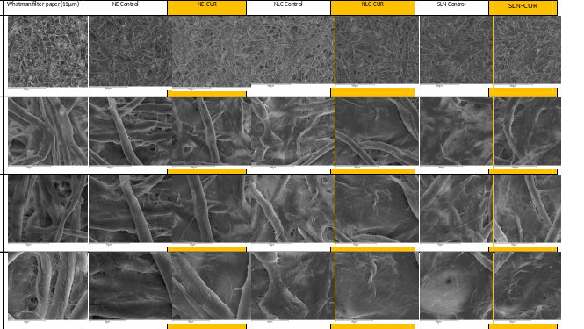
Figure 1: Film forming capacity of different nanocarriers as monitored by Scanning Electron Micoscopy
Recent Publications (minimum 5)
- Hatziantoniou S, Demetzos C. Method of Simultaneous Analysis of Liposome Components Using HPTLC/FID. Methods Mol Biol. 2017;1522:49-54.
- Kardara M, Hatziantoniou S, Sfika A, Vassiliou AG, Mourelatou E, Muagkou C, Armaganidis A, Roussos C, Orfanos SE, Kotanidou A, Maniatis NA. Caveolar uptake and endothelial-protective effects of nanostructured lipid carriers in acid aspiration murine acute lung injury. Pharm Res. 2013 Jul;30(7):1836-47.
- Deli G, Hatziantoniou S, Nikas Y, Demetzos C. Solid lipid nanoparticles and nanoemulsions containing ceramides: preparation and physicochemical characterization. J Liposome Res. 2009;19(3):180-8.
- Hatziantoniou S, Deli G, Nikas Y, Demetzos C, Papaioannou GT. Scanning electron microscopy study on nanoemulsions and solid lipid nanoparticles containing high amounts of ceramides. Micron. 2007;38(8):819-23.
- Hatziantoniou S, Nezis IP, Margaritis LH, Demetzos C. Visualisation of liposomes prepared from skin and stratum corneum lipids by transmission electron microscopy. Micron. 2007;38(8):777-81.

Biography (150 word limit)
Sophia Hatziantoniou is an Assistant Professor at the Department of Pharmacy of the Patras. University. Design and study of nanocarriers as transporters of biologically active molecules. Her research interests are focused on:
- Incorporation of drug molecules in nanosystems (liposomes, nanoemulsions, solid state lipid nanoparticles (SLN), polymeric systems, dendrimers), to improve the pharmacokinetic properties, bioavailability and pharmacological response in target tissues (tumors, lung , skin).
- Formulation of novel carriers of bioactive molecules into final products and study their characteristics (size distribution, zeta-potential, particle surface morphology, content of actives and excipients, active bioavailability, stability).
- Study of the interaction of bioactive molecules with model lipid membranes mainly by Thermal Analysis in order to design new formulations, as well as to predict their interaction with biological membranes.
- Development of cosmetics and topical pharmaceutical product. Safety assessment and evaluation of their efficacy using non-invasive biomechanical methods for claim substantiation.
Sophia Hatziantoniou
Tel: 00302610 962319
Session Name/Number
Category: (Poster presentation)
Email: sohatzi@upatras.gr

Notes/Comments:

