NEW GASTROPROTECTIVE ACTIVITY OF METHANOLIC EXTRACTS OF HYOSCYAMUS ALBUS (SOLANACEAE) AND UMBILICUS RUPESTRIS LEAVES (CRASSULACEAE) AGAINST GASTRIC MUCOSAL INJURY INDUCED BY ETHANOL IN RATS

MASSINISSA YAHIA *^{1,} MOULOUD YAHIA¹, AFAF BENHOUDA ¹, SOUHILA BENBIA ¹ , HACHANI KHADRAOUI ²

¹ Biotechnology’s Laboratory of the Bioactive Molecules and the Cellular Physiopathology, Faculty of Biological Sciences , Department of Biology and Living organisms, University of BATNA-2-, ALGERIA
² Loboratory of Anapathology CHU of BATNA, ALGERIA

Correspondence should be addressed to Massinissa YAHIA, masipsa@hotmail.com

Abstract
The present study was performed to evaluate the anti-ulcer activity of methanolic extract of Hyoscyamus albus and Umbilicus rupestris against ethanol-induced gastric ulcer. Experimental groups were orally pre-treated with and 100, and 200 mg/kg b.w of methanolic extracts HAMeOH and URMeOH. Ulcer control group were pre-treated just with absolute ethanol and reference group was orally pre-treated with omeprazole (20 mg/kg b.w). After one hour of pretreatment, all rats were received the absolute ethanol to generate gastric mucosal injury. And after one hour, our rats were anesthetized and sacrificed and the ulcer areas of the gastric walls were determined. Grossing evaluation has revealed that the negative control rats exhibited severe mucosal injury, whereas, pre-treatment with U. rupestris leaf extract and H.albus has resulted an significantly anti gastric mucosal injury and flattening of the mucosal folds. Histological studies of the gastric wall that the pre-treated with URMeOH and HAMeOH leaf extract was pronounced as gastric protection along followed by reduction or inhibition of leucocytes in the infiltration of the submucosa.

Key Words : Antiulcer activity, Hyoscyamus albus , Umbilicus rupestris, ethanol, methanolic extract

- Introduction
Umbilicus rupestris (Salisb.) Dandy is a perennial plant, belongs to the family of Crassulaceae. It presents on the rocks, the old walls and in mountains; only in North Africa. Leaves of this plant are used in traditional medicine against the ignitions of skin, wounds, burns, disinfectant, parasiticidal. Infused (leaves) of this plant is used like an ophthalmic disinfectant [Benhouda et al., 2015]. H.albus is a plant which belongsfor Solanaceae family, it used in traditional medicine as a nervous sedative and para sympatholytic [Jouzier ,2005]. Natural products are very important in pharmaceutical industry and also in search of new potential sources of bioactive molecules [Schmeda-Hirschmann et al., 2005].

Omeprazole is drug highly selective for the proton pump and catalyzed conversion into active form within the acid forming space [Nagaya et al., 1991]. We used in our study, omeprazole was used as the reference anti-ulcer drug.
The ulcer can caused by a lot of caused non stroidiens inflammatory, stress or alcohol .
They researchers found that ethanol is the simple method that the method of absolute ethanol is the most simple used to induce gastric ulcer. Ethanol induce the liberation of free radical species and [Nordmann, 1994].

Therefore, the present study was to evaluate the antiulcerogenic property of the methanolic extract of Hyoscyamus albus and Umbilicus rupestris against ethanol-induced gastric mucosal injury in experimental rats.
2. Materials and Methods
2.1. Collection of the plant
The leaves of Hyoscyamus albus nd Umbilicus rupestris were harvested in March 2015 from the Wilaya of Batna region Tibhirine Algeria. Botanical species identification was realised by Dr. B. OUDJHIH, Botanical Laboratory, Department of agronomy, University of EL-Hadj Lakhdar – Batna.
40 days in a dry and aerial place for the extraction of active compounds
2.2. Extraction by organic solvents
1 Kg of powdered leaves was extracted with 5 L of petroleum ether for three times. Then, the marc was dried and extracted with 5 L of chloroform for three times and with 5 L of methanol for three times and the supernatants were filtered separately using cotton and Whatman filter paper. The solvents were then evaporated under reduced pressure (204 mbar) and controlled temperature (30°C) using a vacuum rotary evaporator (Buchi Rotavapor).
2.3. Phytochemical screening
The phytochemical screening of HAMeOH and URMeOH was realised by using the method of 8 Phytochemical constituents which is : phenolic compounds, terpenoids , saponins , alkaloids , steroids and tannins were analysed qualitatively.
2.4.Animals
Wistar rats weighted (140-170 g) provided by the Pasteur Institute – Algiers. These rats were allowed at favorable conditions before and during the experiment: Temperature (23 ±2) ° C, relative humidity 50 -55 % with 12 hours light / 12 hours night cycle respectively. The food and water were given ad libitum.
2.5. Evaluation of Antiulcer activity
The study of this activity, we have uses the method of Garg et al. , (1993) . The rats males was divided into six groups of six rats. These rates were deprived 48 hours before the experiment but with accesses of water two hours before the experiment and received by gavage the following treatments: Group I: received distilled water with (5 ml/kg p c) and is useful like a witness, Group II: received distilled water (5 ml/kg b.w.) and served as a control, Groups III and IV: received HAMeOH with the two concentrations (100 and 200 mg/Kg b.w.) respectively, Groups V and VI: received URMeOH (100 and 200 mg/Kg b.w.) respectively with a volume of (10 ml/Kg PC), Group VII: received the omeprazole (20 mg/kg PC) (5ml / kg b.w.) as standard. 30 min after pretraitement, the ulcer was induced by oral administration of absolute ethanol (5 ml/kg b.w.) except control group. The rats were dessicated 60 min after ethanol administration and each stomach was open along the great curve, and were washed with water physiological [ Paiva et al. , 1998 ].

2.6. Evaluation of the gastric lesions
Ulcers found in the gastric mucous membrane appearing in the form of bands
ellongate of hemorragic lesions parallel to the long axis of the stomach. Surface d’ulcere gastric was calculated according to the method of Kauffman and Grossman (1978) with some modification. The length (mm) and the width (mm) of the ulcer on the mucous membrane gastric were measured by the method of squaring under a binocular magnifying glass (of x1.8). The surface of each lesion of ulcer was measured by counting the number of small squares, 1 X 1 mm, covering the length and the width of each band of the ulcer. The sum of surfaces of all the lesions for each stomach was applied for calculation surface of ulcer (UA) when the sum of small squares is multiplied with magnification 1,8 [ Abdulla 2010 ].
2.7.Mesure of gastric volume of juice
The gastric volume of juice has ete measurement has l’aide d’une syringe. 2.8. Percentage inhibition
The inhibition percentage of the ulcers was determined according to the formulate below: [ Njar et al. , 1995; Malairajan et al. , 2007 ]
Inhibition (%) = [ (UA controls UA traited )/UA control ] x100 UA controls: ulcerous surface of the group controls. Treated
UA: ulcerous surface of the treated group.

2.9. Measure of total acidity
1 ml of gastric juice was diluted 10 times with distilled water and subjected a titration has by NaOH has 0.01 NR with adding few drops of phenolphthalein drops until pink color [ Dashputre and Naikwade, 2011 ].
Total acidity is calculated according to there following formula.
Total acidity = (volume of NaOH X Normality X 100 mEq/L/100g) / 0.1
2.10. Histopathology
Stomach Samples have fixed in phormol 10% for histopathological study with using hematoxyline -eosine.
3. Results
The HAMeOH extract reduced the surface of ulcer in a significant way (P< 0.05) with an inhibition of 63 % and 95.90 % for (100 and 200 mg/kg b.w.) respectively. Still URMeOH could inhibit in a significant way (P < 0.05) the ulcer with an inhibition (48.98% and 65.94%) for the concentrations (100 and 200 mg/kg b.w.) respectively.
The omeprazole which was used like a standard of reference educed in a significant way (P≤0.05) the ulcer with an effect (60.23%) (Fig.01).

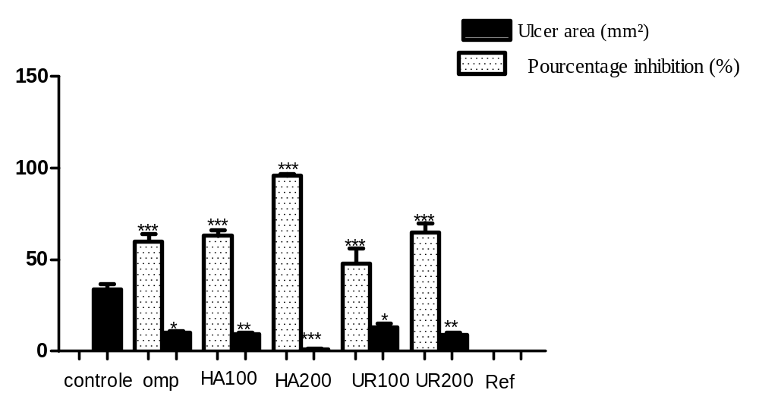

Omp = Omeprazole HA= Hyoscyamus albus UR =Umbilicus rupestris

Figure 01. Effects of HAMeOH and URMeOH on surface of ulcer (mm²) and percentage of inhibition. The results are compared to control * P≤0.05, ** P ≤0.001, *** P≤0.0001.

In the group controls, of the serious wounds were observed on the level of the gastric mucous membrane. The ethanol produced one necrosis hemorrhagic visible gastric mucous membrane. It caused disturbances of the epithelium of surface and necrotic lesions which penetrated deeply in the mucous membrane and a papilloma keratosis (Fig.02). However, in animals treated with the extracts, the whole of the signs observed at control group were gone in a significant way especially with the extract HAMeOH 200 mg/Kg b.w.(Fig.03, 04,05 and 06).

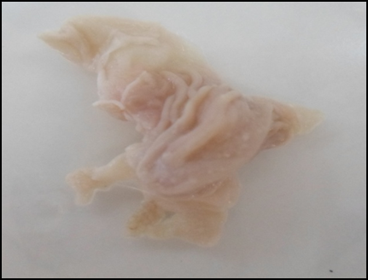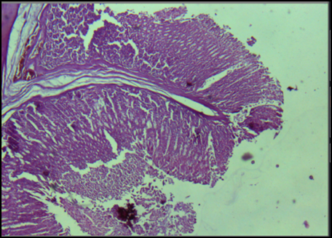
H\E
Figure 02. Macroscopic aspect and the histological study fixed by hematoxyline -eosine of the gastric mucous membrane in the pretreated rats with distilled water.
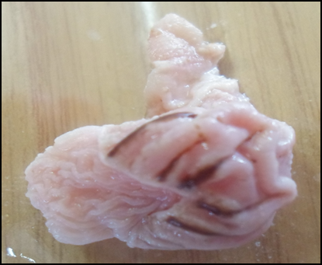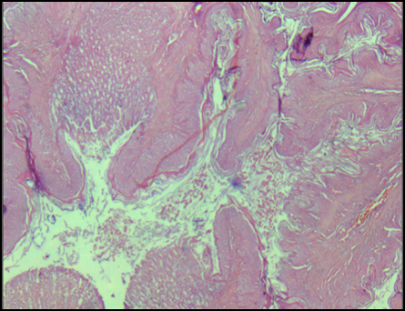
PK
Figure 03. Macroscopic aspect and the histological study fixed by hematoxyline -eosine of the gastric mucous membrane in the pretreated rats with the ethanol (control), presence of keratosic papiollome.
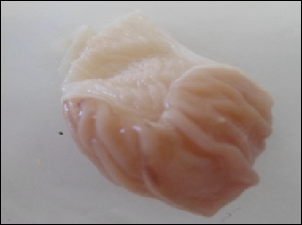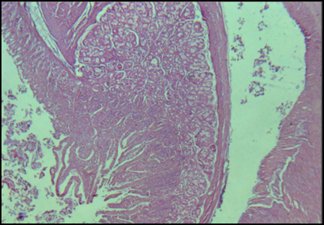
H\E
Figure 04. Macroscopic aspect and the histological study fixed by hematoxyline -eosine of the gastric mucous membrane in the pretreated rats with omeprazole.
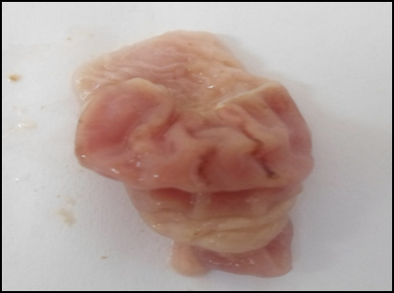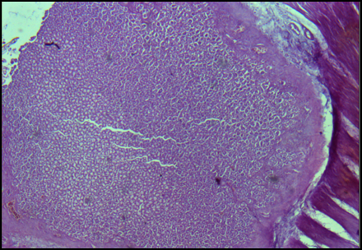
H\E
Figure 05. Macroscopic aspect and the histological study fixed by hematoxyline -eosine of the gastric mucous membrane in the pretreated rats with HAMeOH (100mg/kg b.w.).

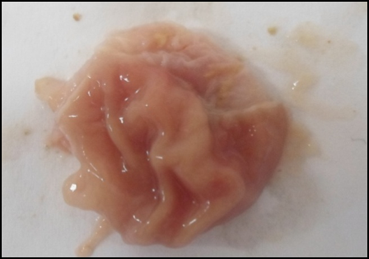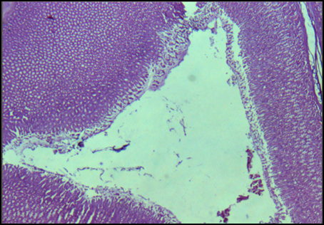
H\E
Figure 06. Macroscopic aspect and the histological study fixed by hematoxyline -eosine of the gastric mucous membrane in the pretreated rats with HAMeOH (200mg/kg b.w.).

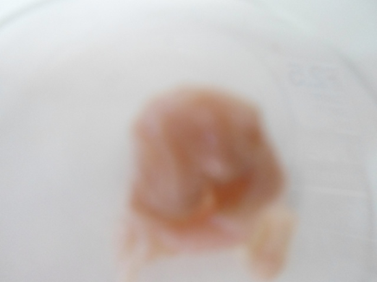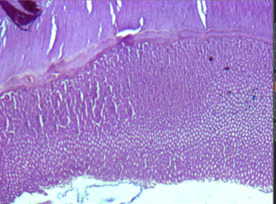
H\E
Figure 07. Macroscopic aspect and the histological study of the gastric mucous membrane in the pretreated rats with URMeOH (200mg/kg b.w.).
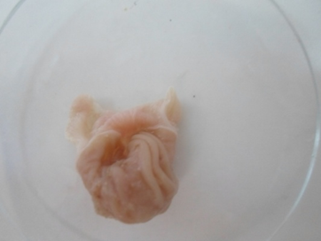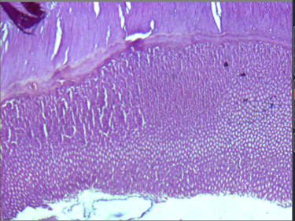
H\E
Figure 08. Macroscopic aspect and the histological study fixed by hematoxyline -eosine of the gastric mucous membrane in the pretreated rats with URMeOH (100 mg/kg b.w.).
According to results of measurement of the gastric juice volume , we noted that there is a significant reduction (P ≤0.05) in the gastric volume of juice in the rats treated by HAMeOH (200 mg/kg b.w.) and by the omeprazole compared to control and any difference between the rats treated with URMeOH compared to control (Fig.09). Moreover, we noted that there is a highly significant increase (P < 0.0001) in the value of the pH in the rats treated with HAMeOH (100 and 200 mg/kg b.w.) with values of (5.035±0.035) and (5.240±0.240) respectively compared to the control which presents a pH (3.525±0.1768). Still a highly significant increase (P < 0.0001) in the values of pH at the groups treated with URMeOH (100, 200 mg/kg b.w.) and the omeprazole compared to control with values of (5.355±0.417), (5.475±0.332) and (6.94±0.332) respectively was noted (Fig.09).
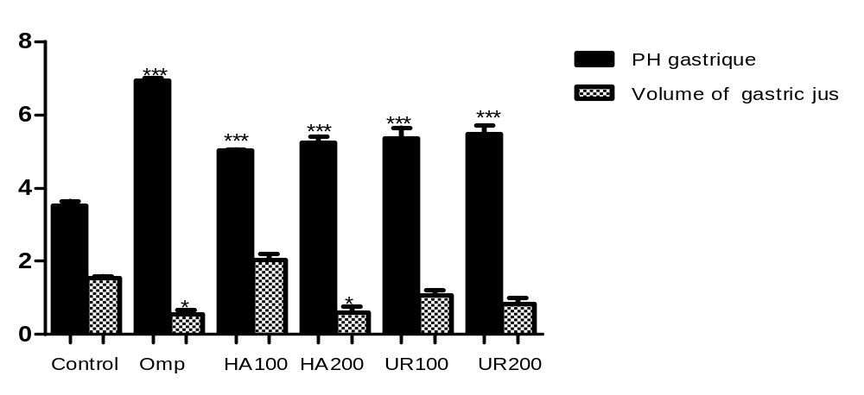
Figure 09. Effect of HAMeOH et URMeOH on pH gastric and the juice gastric volume.
The results are compared to control *P≤ 0.05, ** P≤0.001, *** P≤0.0001.
For total acidity, the omeprazole showed a significant reduction (P ≤ 0.05) compared to control. And this reduction was noticed in a significant way (P ≤ 0.05) also at the group treated with HAMeOH 100 mg/Kg and 200 mg/Kg (Fig.10).
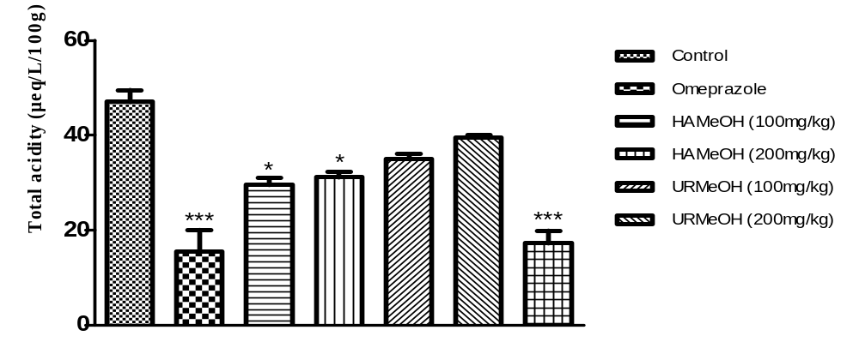
Figure 10. Effect of HAMeOH et URMeOH on totale acidity (µ eq/L/100g).

The gastrin is the only hormone able to control the secretion of acid per the increase in the mass of the parietal cells and stimulation of the form of the acid pump H + K + - ATPase. Although the parietal cells express the protein H +, K + ATPase [ Koh et al. , 1997; Friis-Hansen et al. , 1998 ].
Thus, it appears that the mode of action of the HAMeOH extract is similar to that of the omeprazole, which bind very specifically to only one sub-unit of H +, K +-ATPase on the secretary surface of the parietal cell and the inactive one, and it makes it possible to reduce the secretion of acid whatever the source of stimulation of secretion. The omeprazole is effective in the treatment of UGD and the backward flow gastro-oesophagian after its use is with length or short-term [ Ode and Asuzu, 2011 ].
Discussion
Gastroduodenal ulcer (UGD) described a state in which the is a discontinuity in all the thickness of gastric and the mucous membrane which persists because of the of the acid and pepsin in the gastric juice [ Madhu et al. , 2012 ]. The gastroduodenal ulcers are caused by an imbalance between the defensive mechanisms (defensive mucosal barrier, secretion of bicarbonate, PG) and the aggressive mechanisms (acid, pepsin and Helicobacter pylori of the mucous membrane [ Tipnis and Bajaj, 2003; Raju et al. , 2009 Madhu et al. , 2012 ]. The ethanol produces necrotic lesions by its direct action on the stomach what reduces the factors of defense like secretion of bicarbonate and the production of mucus [ Marhuenda et al. , 1993 ]. The ethanol can reach the mucous membrane by the rupture of the mucus-bicarbonate barrier and the rupture of the cells in the wall of the blood vessels. These effects are probably due to the some biological phenomena’s like the peroxidation of the membranes, the formation of the free radicals, intracellular effort oxidizing, the change of the permeability and depolarization of the mitochondrial membrane before cellular death [ Sannomiya and Al, 2005 ].

Many drugs including the inhibitors of the pump with protons, the prostaglandin analogues, histamine antagonists and the cyto-protective agents are available for the treatment of the gastro-duodenal ulcer. But the majority of these drugs produce several adverse effects including toxicity and can even deteriorate the biochemical mechanisms of the body especially after the chronic use [ Ariyphisi and al., 1986 ]. Currently, the natural products are generally used to avoid the chronic use of the drugs. Several natural products were announced like having an anti-ulcer genic activity by their effect of defense of mucous membrane [ Sairam and al., 2001 ].
The anti-ulcer effect of the methanolic extracts of H albus and U rupestris is with their wealth’s of secondary metabolites such as: flavonoids, saponins and the tannins which were announced known by their anti-ulcerogenic and anti-gastric activity [ Nwafor et al. , 1996 ]. Many work reported that the flavonoids and the tannins play a significant role in the reduction of the ulcer and the protection of the gastric cells [ Martin et al. , 1993 ]. The flavonoids are antioxidants and powerful trappers of the free radicals which prevent ulceration and the cellular oxidative lesions [ Led-Rio et al. , 1992; Salah et al. , 1995 ]. In fact major, the compounds are known by their antiulcer effects by inhibition of the lesions of the gastric mucous membrane [ Martin et al. , 1993 ]. It was also reported that the flavonoïds ensures a protection against gastric cancer [ Havsteen et al. , 2002 ].
According to Havsteen et al. , (2005), the antiulcer effect of the flavonoids is due to the inhibition of the regulation of phosphorylation of proteins.
The inhibition of protein phosphatase which reverses the action of the protein p kinase.
References

[1] Ariyphisi I., Toshiharu A., Sugimura F., Abe M., Matsuo Y., Honda T., (1986). Recurrence during maintenance therapy with histamine H2 receptors antagonist in cases of gastric ulcers. Nikon University J Medical., 28:69-74.

[2] Kauffman J.G. et Grossman M., (1978). Prostaglandin and cimetidine inhibit the formation of ulcers produced by parenteral salicylates. Gastroenterol., 75 (6): 1099-1102.

[3] Madhu C., Hindu K., Sudeepthi C.D., Maneela P., Venkat R.K., Bhagya S.B.(2012).Anti Ulcer Activity of Aqueous Extract of Aegle marmelos Leaves on Rats, Asian J. Pharm. Res. 2(4):132-135.

[4] Malairajan P., Gopalakrishnan G., Narasimhan S., Veni K.J.K., and Kavimani S .(2007).Antiulcer activity of crude alcoholic extract of Toona ciliata Roemer (heartwood). Journal of Ethnopharmacology, 110: 348-351.

[5] Marhuenda E., Martin M. J., and Alarcon C. De La Lastra (1993).Antiulcerogenic activity of aescine in different experimental models, Phytotherapy Research, 7(1):13–16.

[6] Martin M.J ., Motiva V ., de la Lastra A.C.(1993).Quercetin andnaringenin ; Effect on the leaf aqueous extract on ulcer formation and gastric secretion in rats. Journal of Ethnopharmacology (54) : 139-153.

[7] Njar V., Adesanwo J., Raji Y. (1995). Methyl Angolenate: Antiulcer Agent from the Stem Bark of Entandrophragma angolense. Planta Medica., 61: 91-91.
[8] Nwaforn P.A., Effrain, K.D., Jack, T.W. (1996). Gastroprotective effects of aqueous extract of Khaya senegalensis bark on indomethacin-induced ulceration in rats. West African Journal of Pharmacology and Drug research, 12:46-50.

[9] Ode O. J. et Asuzu, O. V.,(2011).Investigation of cassia singueana leaf extract for antiulcer effects using ethanol-induced gastric ulcer model in rats. International Journal of Plant, Animal and Environmental Sciences, 1:1–7.

[10] Oluwole F. S., J. A. Ayo, B. O. Omolaso, B. O. Emikpe, and J. K. Adesanwo, (2008).Methanolic extract of Tetracera potatoria, an antiulcer agent increases gastric mucus secretion and endogenous antioxidants.Nigerian Journal of Physiological Sciences, 23(2): 79–83.

[11] Paiva L., Rao V., Gramosa N., Silveira E. (1998). Gastroprotective effect of Copaifera langsdorffii oleo-resin on experimental gastric ulcer models in rats. J. Ethnopharmacol., 62: 73- 78.

[12] Parmar N.S. et Parmar S.(1998).Anti-ulcer potential of flavonoids. Indian J Physiology and Pharmacology, 42: 343-51.

[13] Raju D ., Ilango K ., Chitra V ., Ashish K .,(2009). Evaluation of Anti-ulcer activity of methanolic extract of Terminaliachebula fruits in experimental rats. J. Pharm. Sci. & Res., 1(3): 101-107.

[14] Sairam K., Rao C.V., Goel R.K. (2001). Effect of Centella asiatica linn on physical and chemical factors induced gastric ulceration and secretion. Indian J Exp. Biol, 39:137-142.

[15] Sannomiya M., Fonseca V. B., Da Silva M. A.(2005). Flavonoids and antiulcerogenic activity from Byrsonima crassa leaves extracts. Journal of Ethnopharmacology, 97:1, 1–6.

[16] Benhouda A and Yahia M (2015). Toxicity and anti-inflammatory effects of methanolic extract of umbilicus rupestris l. leave (crassulaceae), Int J Pharm Bio Sci 6(1): (P) 395 – 408.
[17] Benhouda A., Yahia M., Benhouda D., Bousnane N.E., Benbia S., Hannachi
N.E., Ghecham A (2014). Antimicrobial and Antioxidant activities of various extracts of Hyoscyamus albus L. and Umbilicus rupestris L. leaves. Algerian J. Nat. Products, 2:14-17.
[18] Jouzier E.(2005). Solanacees medicinales et philatelie Bull. Soc Pharm Bordeaux;144.

[19] Nagaya H, Inatomi N, Nohara A, Satoh H (1991). Effects of the enantiomers of lansoprazole (AG-1749) on (H++ K+)-ATPase activityin canine gastric microsomes and acid formation in isolated canine parietal cells. Biochem. Pharmacol., 42: 1875-1878
[20] Schmeda-Hirschmann G. and E. Yesilada, “Traditional medicine and gastroprotective crude drugs,” Journal of Ethnopharmacology, vol. 100, no. 1-2, pp. 61–66, 2005. Nordmann R (1994). Alcohol and antioxidant systems. Alcohol Alcohol., 29: 513.

