Synthesis of ZnO Nanoparticles Using Different pH Values

Jyostna Chauhan^{*1}, Varsha R Mehto² and Neeraj Malviya²
¹HOD SONT, Rajiv GandhiTechnical University, Bhopal (M.P.)
²Rajiv GandhiTechnical University, Bhopal (M.P.)
*Corresponding author: jyotsnachauhan2006@gmail.com

Abstract
ZnO nanoparticles have been prepared via simple precipitation technique.The size of ZnO nanoparticles was tuned by using different concentration of sodium hydroxide.The as grown nanoparticles were characterized using X-ray diffraction (XRD), UV-Vis absorption spectroscopy, PLspectroscopy and FTIR analysis. XRD results confirmed the tuning of size of ZnO nanoparticles with decreasing the concentration of sodium hydroxide. Absorption results show the blue shift in the peak position with decreasing the size of ZnO nanoparticles. PL spectra indicate the marked improvement in luminescence intensity with decreasing the size.

1. Introduction

There are different methods for the synthesis ofpure and doped ZnO nanoparticles such as sol-gel, electrochemical deposition, spray pyrolysis, thermal oxidation,reactive evaporation, vapour phase epitaxy, chemical depositionetc. [1-3]. Among them chemical precipitation technique has attracted special attention due to itssimplicityand low cost.ZnO NPs have been used in various applications such as ultraviolet (UV), light-emitting diodes (LEDs), blue luminescent devices, UV lasers, photoelectron devices, sensors, drug delivery, nanomedicine etc.[4-6].Ozgur et al also reported that ZnO nanoparticles can also be used as the astringent for wounds healing, anti-hemorrhoids, eczema and excoriation in the human medicine [7].Botha et al. synthesize blue emitting ZnO nanoparticles for fluorescent applications [8]. Chia et al reported the reducing ZnO nanoparticles toxicity through silica coating [9]. Saravanan et. al prepared the conducting PANI stimulated ZnO system for visible light photocatalytic degradation of coloured dyes [10].
In this work, we have reported the synthesis and characterization of zinc oxide nanoparticles by using chemical precipitation method.The prepared samples were characterized by using XRD, UV-Vis absorption spectroscopy, PL spectroscopy and FTIR analysis.Structural properties, crystallite size, and optical properties of ZnO nanostructures were investigated, and an attempt was made to correlate the optical properties of ZnO with the crystallite size.

2. Materials
The materials used in this study wereAR grade zinc acetate,ethanol and sodium hydroxide. The synthesis were carried out in room temperature

2.1 Synthesis of ZnO nanoparticles
To synthesize ZnO nanoparticleszinc acetate 0.025M and sodium hydroxide 0.7M were added together under continuous vigorous stirring at room temperature. Four nanocrystalline samples S1, S2, S3 and S4were prepared by varying the concentration of sodium hydroxide 0.7M,0.5M0.3Mand0.1M respectively. Flow chart of the reaction is shown in Figure 1.

Figure 1. Synthesis of ZnO Nanoparticle (precipitation method)

After 1 hour of stirring the resulting precipitated white solid products were washed with ethanol, filtered and then dried at room temperature.

3. Results and Discussion
3.1 X-ray diffraction (XRD) characterization analysis
XRD is an efficient analytical technique used to identify the structural properties ofcrystalline materials. The X- ray diffraction data were recorded by using CuKα radiation (1.5406 A°).The XRD pattern of a typical ZnO sample exhibits prominent broad peaks at 2θ values of 31.77°, 34.42°,36.35°,47.53°, 56.60° 62.86°and 66.37°which could be indicated as scattering from the (100),(002), (101), (102),(110), (103) and(112) hexagonal phase of ZnO respectively, suggesting that the nanoparticles are in hexagonal form. No peaks attributable to other phases were observed. The broadening of the diffraction peak provides information about crystallite size. As the width increases, the particle size decreases and vice versa [11]. Figure 2 (a), (b) (c) and (d)gives the X-ray diffraction pattern for samples S1, S2, S3and S4. Study of standard data JCPDS (36-1451) confirmed that the synthesized materials are hexagonal ZnO phase (wurtzite Structure [12] ). The summary of XRD data is given in table 1.
The average grain size was calculated with the help of Scherrer equation(Eq. 1). The calculated size of ZnO nanoparticles were found 11.93, 8.54, 7.38 and 5.14 nm for sample S1, S2, S3 and S4 respectively.

D=0.9 λ/ß Cos θ (1)
Where D is particle size λ is the wavelength of the incident ray, θ is the Bragg‟s angle and ß is the full width at half maxima.

Table 1 XRD data analysis for sample S1, S2, S3 and S4
Sample Name | NaOH  Concentration | 2θ |  | d value(Å) |  | Intensity |  | FWHM | Miller Indies |  |  | Particle size  (nm)
Sample Name | NaOH  Concentration | St. | Ob. | St. | Ob. | St. | Ob. |  | h | k | l | 11.93
S1 | 0.7M | 36.35 | 36.18 | 2.47 | 2.47 | 100 | 100 | 0.70 | 1 | 0 | 1 | 11.93
S1 | 0.7M | 47.53 | 47.41 | 1.91 | 1.91 | 23 | 36 | 0.70 | 1 | 0 | 2 | 11.93
S1 | 0.7M | 56.60 | 56.50 | 1.62 | 1.62 | 32 | 43 | 0.70 | 1 | 1 | 0 | 11.93
S1 | 0.7M | 62.86 | 62.70 | 1.47 | 1.47 | 29 | 35 | 0.70 | 1 | 0 | 3 | 11.93
S1 | 0.7M | 66.37 | 67.83 | 1.37 | 1.38 | 23 | 27 | 0.70 | 1 | 1 | 2 | 11.93
S2 | 0.5M | 31.77 | 31.66 | 2.81 | 2.82 | 57 | 71 | 0.98 | 1 | 0 | 0 | 8.55
S2 | 0.5M | 34.42 | 34.33 | 2.60 | 2.60 | 44 | 89 | 0.98 | 0 | 0 | 2 | 8.55
S2 | 0.5M | 36.35 | 36.12 | 2.47 | 2.48 | 100 | 100 | 0.98 | 1 | 0 | 1 | 8.55
S2 | 0.5M | 47.53 | 47.47 | 1.91 | 1.91 | 23 | 37 | 0.98 | 1 | 0 | 2 | 8.55
S2 | 0.5M | 56.60 | 56.59 | 1.62 | 1.62 | 32 | 40 | 0.98 | 1 | 1 | 0 | 8.55
S2 | 0.5M | 62.86 | 62.75 | 1.47 | 1.47 | 29 | 38 | 0.98 | 1 | 0 | 3 | 8.55
S2 | 0.5M | 66.37 | 67.95 | 1.37 | 1.37 | 23 | 31 | 0.98 | 1 | 1 | 2 | 8.55
S3 | 0.3M | 31.77 | 31.96 | 2.81 | 2.80 | 57 | 80 | 1.13 | 1 | 0 | 0 | 7.38
S3 | 0.3M | 34.42 | 34.40 | 2.60 | 2.60 | 44 | 86 | 1.13 | 0 | 0 | 2 | 7.38
S3 | 0.3M | 36.35 | 36.16 | 2.47 | 2.48 | 100 | 100 | 1.13 | 1 | 0 | 1 | 7.38
S3 | 0.3M | 47.53 | 47.22 | 1.91 | 1.92 | 23 | 41 | 1.13 | 1 | 0 | 2 | 7.38
S3 | 0.3M | 56.60 | 56.75 | 1.62 | 1.62 | 32 | 39 | 1.13 | 1 | 1 | 0 | 7.38
S3 | 0.3M | 62.86 | 62.72 | 1.47 | 1.47 | 29 | 36 | 1.13 | 1 | 0 | 3 | 7.38
S3 | 0.3M | 66.37 | 68.03 | 1.37 | 1.37 | 23 | 30 | 1.13 | 1 | 1 | 2 | 7.38
S4 | 0.1M | 31.77 | 31.81 | 2.81 | 2.81 | 57 | 69 | 1.62 | 1 | 0 | 0 | 5.15
S4 | 0.1M | 34.42 | 34.34 | 2.60 | 2.60 | 44 | 74 | 1.62 | 0 | 0 | 2 | 5.15
S4 | 0.1M | 36.35 | 35.87 | 2.47 | 2.50 | 100 | 100 | 1.62 | 1 | 0 | 1 | 5.15
S4 | 0.1M | 47.53 | 47.25 | 1.91 | 1.92 | 23 | 45 | 1.62 | 1 | 0 | 2 | 5.15
S4 | 0.1M | 56.60 | 56.43 | 1.62 | 1.62 | 32 | 46 | 1.62 | 1 | 1 | 0 | 5.15
S4 | 0.1M | 62.86 | 62.83 | 1.47 | 1.47 | 29 | 43 |  | 1 | 0 | 3 | 5.15
S4 | 0.1M | 66.37 | 67.79 | 1.37 | 1.38 | 23 | 40 |  | 1 | 1 | 2 | 5.15

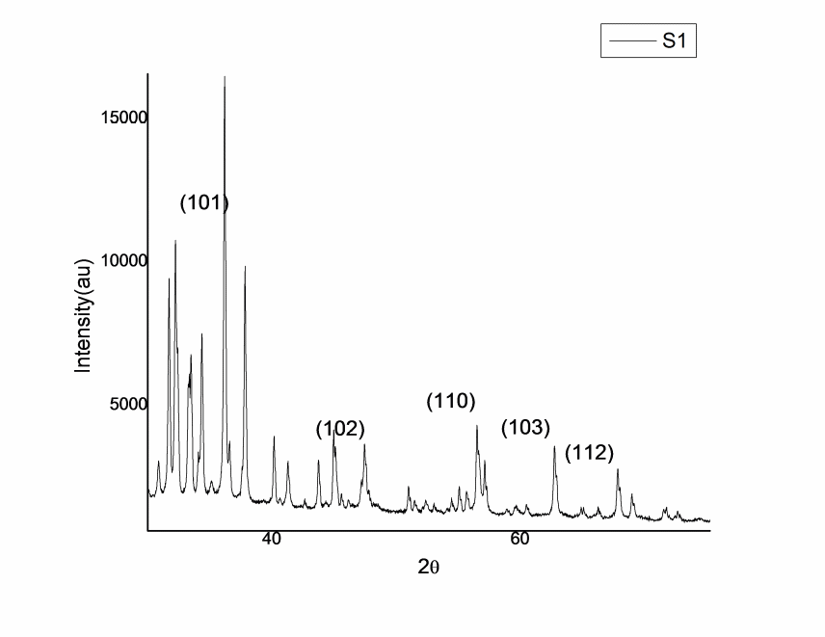
Figure 2 (a) XRD pattern of Sample S1 of ZnO nanoparticles.
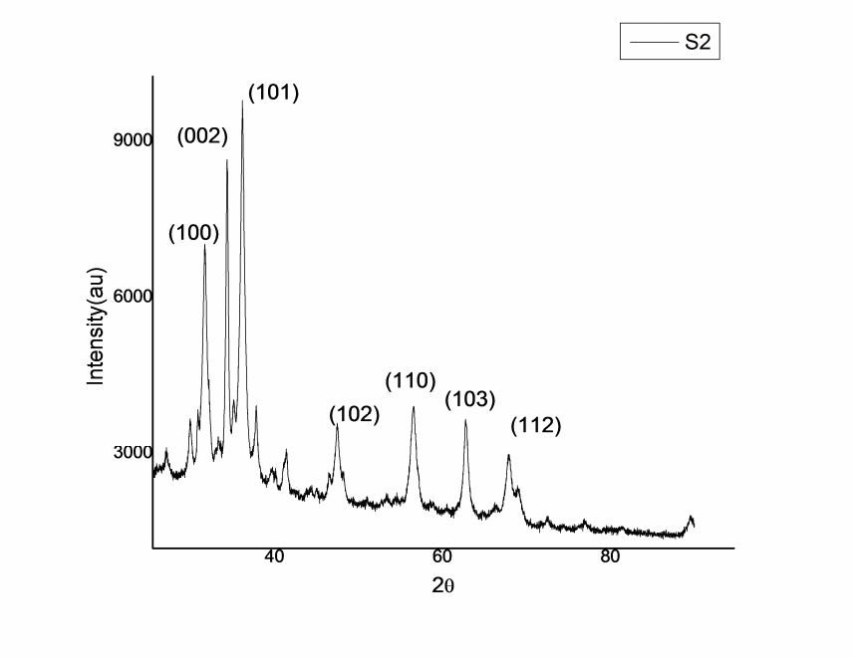

Figure 2 (b) XRD pattern of Sample S2 of ZnO nanoparticles.

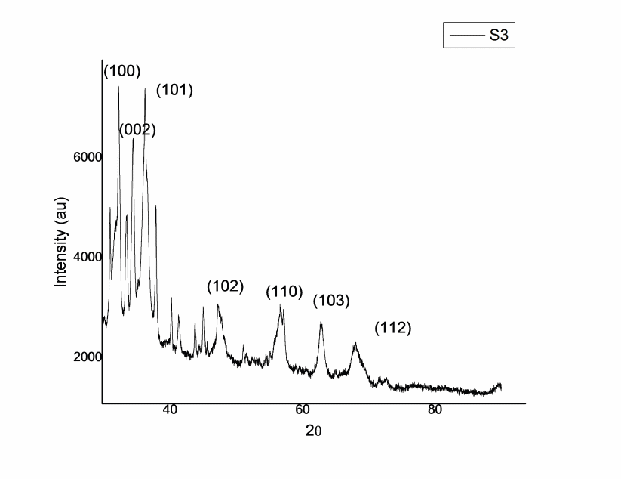 Figure 2 (c) XRD pattern of Sample S3 of ZnO nanoparticles

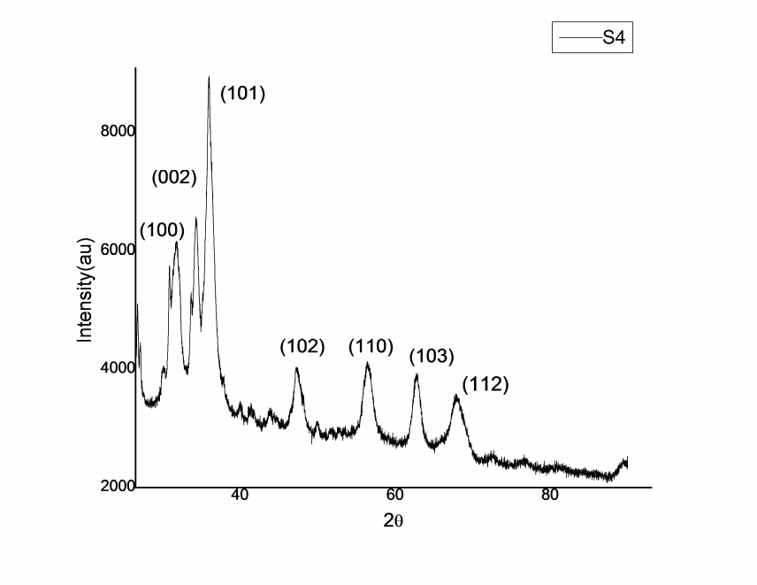Figure 2 (d) XRD pattern of Sample S4 of ZnO nanoparticles

3.2 Photoluminescence characterization analysis
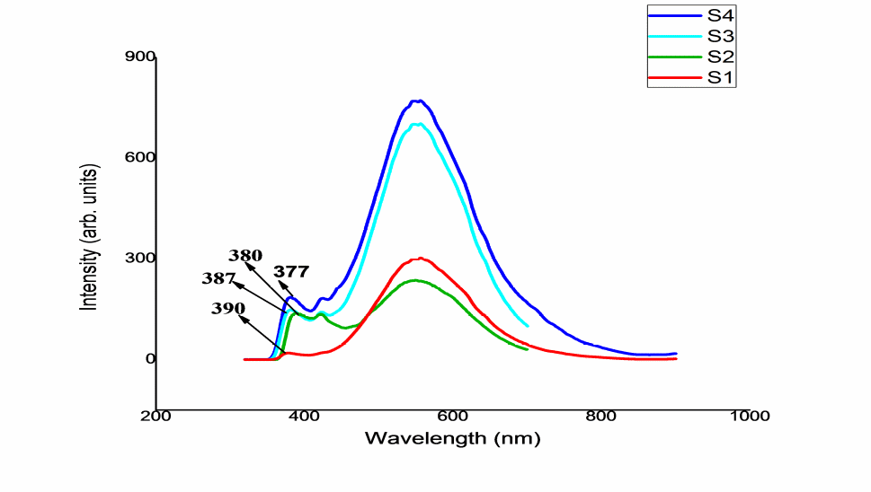Photoluminescence spectroscopy is a valuable tool to study the optical properties of semiconducting materials. The room temperature PL spectra of ZnO nanoparticle samples were recorded (Figure3, Figure caption is missing). The spectra were recorded usingexcitation wavelength of 300 nm. The spectra have broad emission peak (near band edge) at 390nm, 387nm, 380nm and 377nm for sample S1, S2, S3 and S4 respectively.
Figure3. PL pattern of sample of ZnO nanoparticles with different pH

The PL emission peaks are blue shifted with decreasing the size of ZnO nanoparticles, that is due to the size quantization effect [11].However, surface states have also been identified as a possible cause of the visible emission in the ZnO nanomaterials [12]. It is known that the PL emission is caused by the recombination of excited electrons and holes, and the lower PL intensity may indicate the lower recombination rate of electrons and holes under lightirradiation. The PL intensity is highest as prepared sample S4 indicating the highest recombination of electrons and holes. It is reasonable that there are some defects in the ZnO nanostructures at the surface and subsurface due to their fast reaction formation process and large surface-to volume ratio [13].The strong green emission band at ~553 nm is due to the defects on the surfaces of nanoparticles. Pandey et al report different types of defects states in visible emission spectra of ZnO nanoparticles are singly or doubly charged Zn vacancies (VZn), neutral or singly charged oxygen vacancies (VO), singly charged or neutral interstitial Zn (Zni), interstitial O (Oi) and substitution O at Zn position (OZn).[14, 15, 12,].Table 2 represents the summary of PL data analysis.

Table 2 Summery of PL Results
Sample Name | Particle Size | Concentration of NaOH (M) | PL Peak Position(nm)
S1 | 11.93 | 0.7 | 390
S2 | 8.55 | 0.5 | 387
S3 | 7.38 | 0.3 | 380
S4 | 5.15 | 0.1 | 377

3.3 UV- Visible spectroscopy
UV-vis spectroscopy has many different applications in organic and biological chemistry. The effect of different volume ratios ofZnAc:NaOHon the optical properties of ZnO nanoparticles were investigated. The absorbance spectra of ZnO nanoparticles were measured in the wavelength range from 200 to 800 nm.

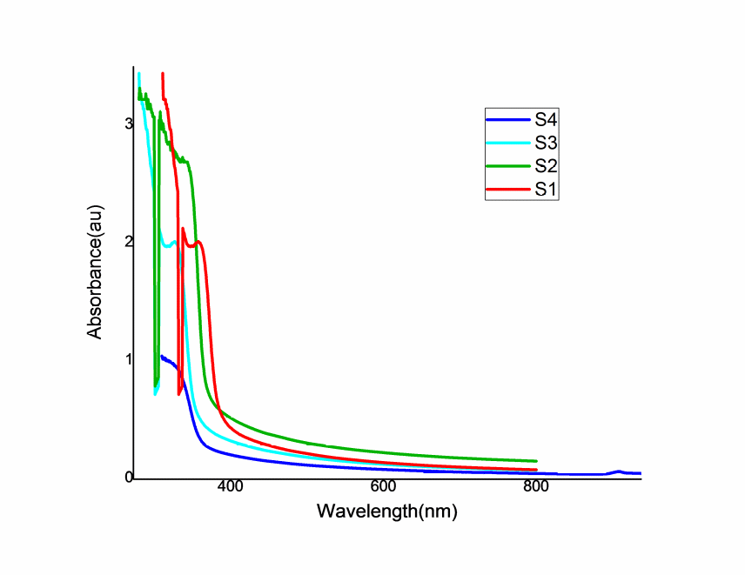

Figure 4 UV-Vis Spectra of ZnO nanoparticle with different pH values 11, 9.2, 8.5 and 7 for sample S1, S2, S3 and S4 respectively.

Table 3 Summery of UV-VIS absorption
Sample Name | Particle Size((nm) | Concentration of NaOH | Absorption peak Position(nm)
S1 | 11.93 | 0.7M | 383
S2 | 8.54 | 0.5M | 368
S3 | 7.38 | 0.3M | 366
S4 | 5.14 | 0.1M | 352

Figure 4 depicts the UV-vis absorbance spectra for the sampleS1, S2 S3 and S4. Clearly, the absorption edge is seen to shift to the lower wavelengths with decreasingthe concentration of NaOH or decreasingthe pH value, indicating changes in particle sizes.The absorbance onset was found 383, 368, 366 and 352 nm for sample S1, S2, S3 and S4 respectively, Table 3 shows the summary of absorbance data analysis.Measurement of optical absorption spectrum in band gap semiconductors bearsimportance both theoretical as well as practical aspects. Near to band gap absorptionof photons, absorption coefficient a steeply increases with increasing the photon energy.The spectral absorption coefficient has been evaluated as

Where k is the spectral extinction coefficient and λ is the wavelength of the absorbedphoton. The optical band gap of ZnO nanoparticles is calculated using the Tauc relation
$$α=\frac{4πk}{λ}$$
Where k is the spectral extinction coefficient and l is the wavelength of the absorbedphoton. The optical band gap (Eg) of the sample can be estimated from the expression for transition
$$αE=A(E-E_{g})²$$

Where $E={hc}/λ$ is the photon energy A is a constant, n is an index which assumes thevalues n=1/2 for allowed direct transition, n=3/2 for direct forbidden transition, n=2 forallowed indirect transition and n=3 for indirect forbidden transition.
Where, α is the absorption coefficient, A is a constant, is the energy of incidentphotons and exponents n whose value depends upon the type the transition which may havevalues 1/2, 2, 3/2 and 3 corresponding to the allowed direct, allowed indirect, forbiddendirect and forbidden indirect transitions respectively. Allowed direct bandgap of ZnO nanoparticles is calculated to be 3.5 eV. The increase in the band gap of the ZnO nanoparticles with the decrease in particlesize may be due to a quantum confinement effect. We have also reported the calculation of band gap using theoretical models[16]. The results are shown in table 4 for the sample S1, S2, S3 and S4. For maximum particle size for sample S1 the band gap is minimum. When the size decreases the value of band gap increases which is maximum for sample S4.
Table 4 Band gap calculation
Sample  Name | Wavelength (λ) at absorption peak (nm) | Experimental Band gap (eV) | Theoretical  EMA Band gap  (eV) | Theoretical  TBT Band gap  (eV)
S1 | 383 | 3.24 | 3.27 | 3.48
S2 | 368 | 3.37 | 3.39 | 3.63
S3 | 366 | 3.39 | 3.45 | 3.67
S4 | 352 | 3.52 | 3.53 | 3.71

3.4 Fourier Transform Infrared Spectroscopy(FTIR)
FTIR presented in Figures 5(a-d) were performed to study the chemical structure to deduce the nature of bonds present in the samples. In the given profile on wave number axis, the absorbance peaks around 3,400 cm⁻¹are the peaks representing the hydroxyl (-OH) groups, which show incomplete removal of organic solvent(ethanol).The next absorbance peak at wave number approximately 1,500 cm⁻¹ is due to the absorbance of organic group carbon (carbonyl carbon -C=O). The absorbance at wave number approximately 880 cm⁻¹ is due to the typical bond between zinc and oxygen (Zn-O)[15] The spectra show minimal % absorbance by the samples (less than 10%) which insinuate high purity as supported by XRD results. However, more organic solvent presence is observed indicating existence of more impurity.

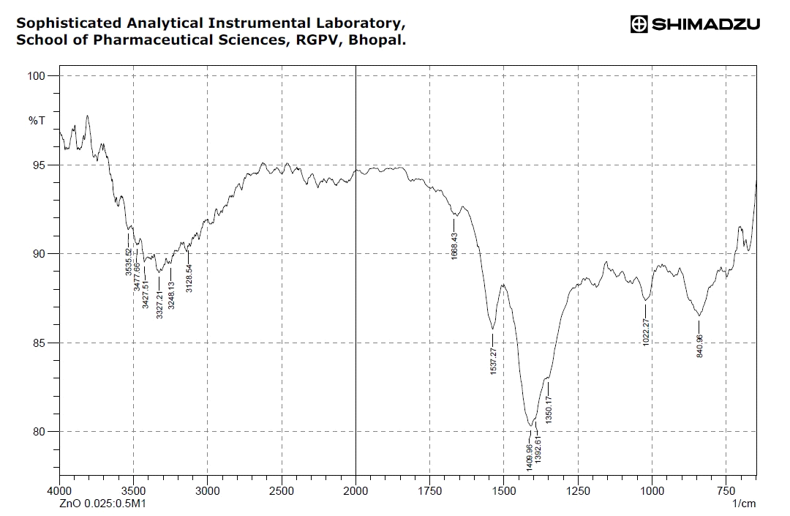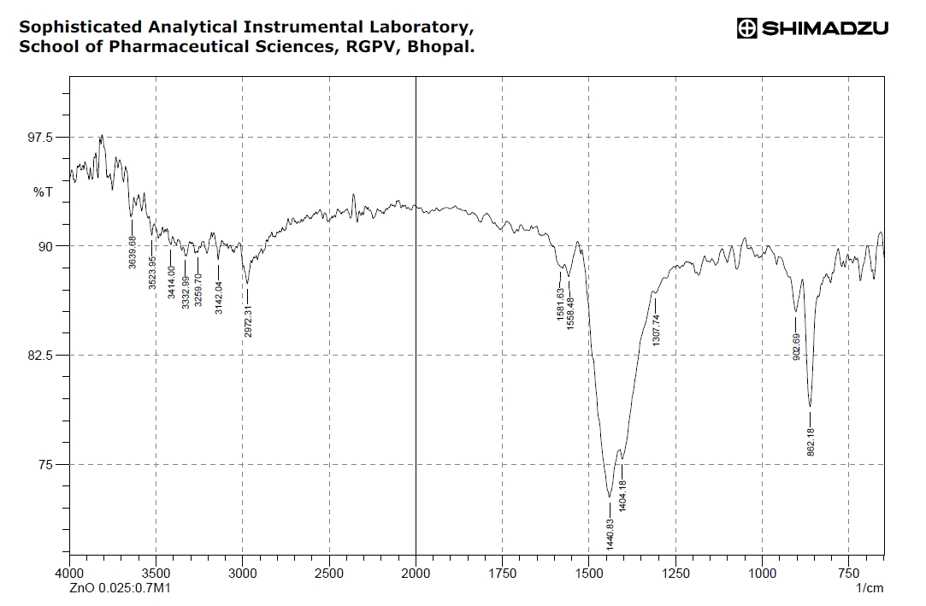
Figure 5 (a) FTIR pattern for S1

Figure 5 (b) FTIR pattern for S2

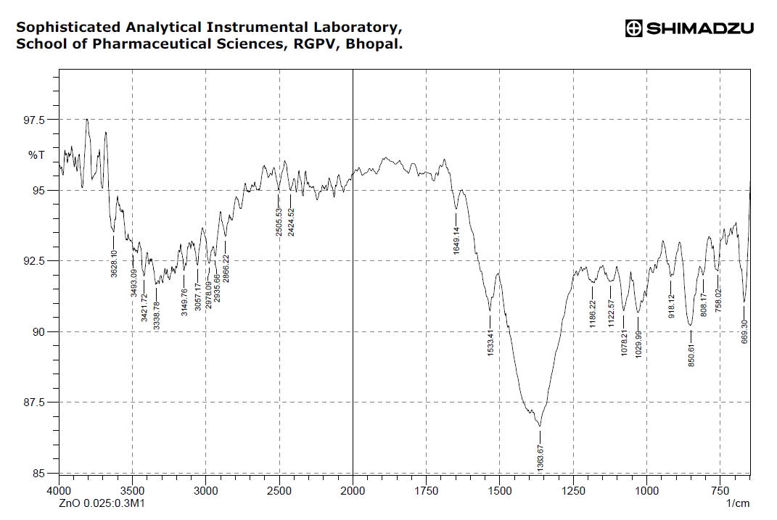

Figure 5 (c) FTIR pattern for S3

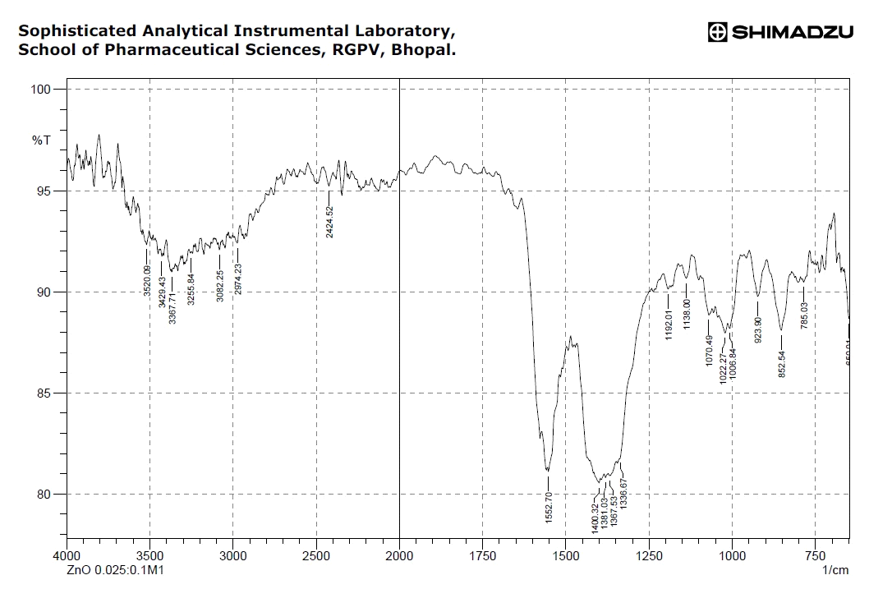
Figure 5 (d) FTIR pattern for S4

4. Conclusion
The ZnO nanoparticles were prepared by chemical precipitation method where the size of the particles tuned by varying the pH values 11, 9.2, 8.5 and 7 for sample S1, S2, S3 and S4 respectively. The XRD of these samples conformed that the required hexagonal phase is present -in our samples..
PL results show the significant enhancement in the luminescence intensity with decreasing the size of ZnO nanoparticles. The photo emission peaks are also blue shifted with decreasing the size that is due to the size quantization effect.
The UV absorbance spectra reveal that as the size of the nano crystals decreases, the band gap also increases. The rapid increase in band gap and shift in the electron transition to higher energies with decreasing the particle size, it is due to the enhancement in surface/volume ratio and accompanied increase in oscillation strength of the nano crystal induced by the quantum size effect. The functional groups present in the synthesized ZnO materials were identified by FTIR analysis.
5. References
1. Cheng XL, Zhao H, Huo LH, Gao S, Zhao JG: ZnO nanoparticulate thin film: preparation, characterization and gas-sensing properties.Sens. Actuators B. 2004, 102: 248–252. 10.1016/j.

2.Lee SY, Shim ES, Kang HS, Pang SS: Fabrication of ZnO thin film diode using laser annealing.Thin Solid Films. 2005, 437: 31–34.

3.Wang ZL, Kong XY, Ding Y, Gao P, Hughes WL: Semiconducting and piezoelectric oxide nanostructures induced by polar surfaces.Adv. Funct. Mater. 2004, 14: 943–956.

4.Wang ZL: Zinc oxide nanostructures: growth properties and applications.J. Phys. Condens. Matter. 2004, 16: R829-R858.

5. Suchea M, Christoulakis S, Moschovis K, Katsarakis N, Kiriakidis G: ZnO transparent thin films for gas sensor applications.Thin Solid Films. 2006, 515: 551–554.

6. Ashour A, Kaid MA, El-Syed NZ, Ibrahim AA: Physical properties of ZnO thin films deposited by spray pyrolysis technique.Appl. Surf. Sci. 2006, 252: 7844–7848.

7. U. Ozgur; D. Hofstetter; H. Morkoc, ―ZnO Devices and Applications: A Review of Current Status and Future Prospects‖, Proceedings of the IEEE, 2010, Vol. 98, Issue: 7, pp. 1255 - 1268.

8. Leta T, HYPERLINK "http://www.sciencedirect.com/science/article/pii/S092145261630237X"JuleFrancis, B.Dejene, Kittessa T.Roro, Zelalem N.Urgessa, Johannes R.Botha, blue emitting ZnO nanoparticles for fluorescent applications Physica B: Condensed Matter HYPERLINK "http://www.sciencedirect.com/science/journal/09214526/497/supp/C"Volume 497, 15 September 2016, Pages 71-77.
9.Sing Ling Chia, David Tai Leong,Reducing ZnO nanoparticles toxicity through silica coating,Materials Science, Inorganic Chemistry, Physical Chemistry, 21 Oct 2016- Volume 2, Issue 10
10. R. Saravanan, ElisbanSacari, F. Gracia, Mohammad Mansoob Khan, E. Mosquera, Vinod Kumar Gupta, Conducting PANI stimulated ZnO system for visible light photocatalytic degradation of coloured dyes,Journal of Molecular Liquids 221 (2016) 1029–1033

11. Varsha R Mehto, Deepshikha Rathore, RK Pandey, Optical and structural properties of electrodeposited polyaniline/Q-CdS composite. Polymer Composites 35(9): 1864-1874, 2014.

12. . K. K. Nishad, J. Joseph, N. Tiwari, R. Kurchania, and R. K. Pandey,
Science of Advanced Materials

13. Neha Tiwari, Varsha R. Mehto, K. K. Nishad, R. P. Singh, and R. K. Pandey, Vertically Aligned ZnO and ZnS Quantum Dot Based Hybrid White LED, Journal of Nanoelectronics and Optoelectronics, Vol. 10, 1–7, 2015.

14. Varsha R. Mehto, Akanksha Mehto, D. K. Gupta and R. K. Pandey, Synthesis and Characterization of PANI/ZnO Nanocomposites J. Chin. Chem. Soc. Volume 63, Issue 11
November 2016 , Pages 935–946.

15. K.K. Nishad, R.K. Pandey, Materials Science and Engineering B 178 (2013) 1380– 1389

16. S N Sahu& K K Nanda,Nanostructure Semiconductor: Physics & Application,PINSA,67 15 September 2000.

