Abstract

A new constraint DFT technique for self-consistent determination of U values

Hamada, T.
National Institute for Materials Science, Tsukuba, Japan

Keywords: Strongly correlated electron systems, First principle calculation, DFT+U, Hubbard onsite interaction parameter U

- Abstract Body
First principle design of strongly correlated electron systems (SCESs) with localized d and f electrons has been a dream of material scientists and a challenge of electronic structure theory for long time. This is because SCESs are expected to exhibit unprecedented phenomena such as High T_{c} superconductivity and their electronic structure calculation is difficult. The electronic structure of SCESs can be calculated by using the density functional+U (DFT+U) method when their Us are known, where Us are Hubbard interaction parameters describing the strength of on-site interactions between their localized electrons. However, strictly speaking, the first principles determination of Us of SCESs had been impossible until recently. In this study, I solved this problem, developing a new theory of U calculation. This theory uses the DFT+U method and calculates the U of a SCES, self-consistently, to be such that it determines the electronic structure Ψ of the SCES and vice versa (see the image shown below) [1, 2]. This theory is physically-meaningful, very simple, accurate, inexpensive, theoretically-coherent, and applicable to the U determination of large and complex SCESs [2] In this talk, I will talk about this theory and its application calculations in detail. Also, I will talk about why and how I developed this theory, mentioning about problems of previous theoretical studies. I will conclude this talk, showing my expectation that the theory would enable the first principles design of several SCESs, making the dream come true.

Image:
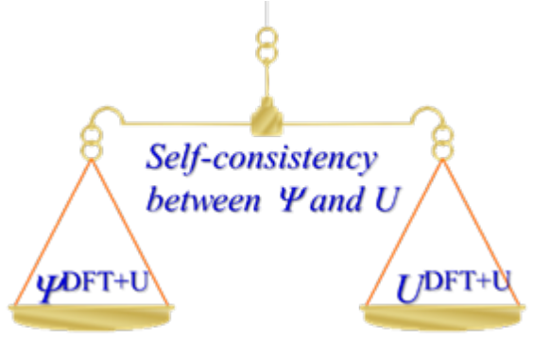

- Reference:

1 Hamada, T. and Ohno, T., 2019. A New constraint DFT technique for self-consistent determination of U values. J. Phys.: Condens. Mat., 31; 065501

- Hamada, T., Sugimasa, M., Satsu, Y. and Ohno, T.,
- 2020. First principles density functional +U
- pseudopotential study on the electronic structure of
- layered perovskite LaSr₃Fe₃O₁₀. J. Phys. Condens. Mat.,
- 32: 065503

Biography:
Dr. Tomoyuki Hamada completed his B. Sc at the age of 23 from Chiba University and his Ms. Eng. at the age of 25 from Kyoto University. He had been affiliated to Research and Development Group of Hitachi Ltd. from 1988 to 2019 as a researcher, senior researcher, manager, and chief researcher. He completed his Ph. D. at the age of 35 from Kyoto University. His theory of U calculation was recognized as “A Key Technology of Excellence” by Advances in Engineering. He is a research fellow of National Institute of Materials Science. He is a theorist and material scientist

.

Presenting author details


Full name: Tomoyuki Hamada Contact number: +81 43 306 2214 Twitter account: Linked In account:
Session name/ number:
Category: Oral presentation
Passport Number:

