Abstract Template

Title: Novel Low Cost Nanoparticles Derived From Water Industry Waste for Remediation of Chromium Contaminated Soil and Water

Elkhatib EA, Hamdeen H, and Mesalem MO
Department of Soil and Water Sciences, Alexandria University, Alexandria, 21545, Egypt.

Keywords: Sorption isotherms, Kinetics , Fractionation ,Cr species, Industrial waste water

- Abstract Body (up to 250words)
Nanomaterials are efficient pollutant adsorbents due to their large specific surface area, and multiple active sites. In this study, novel nano particles derived from water industry waste were produced and evaluated for their capabilities in remediating Cr contaminated soil and water. Equilibrium and kinetics studies of Cr sorption by nanosorbent were performed in batch system. The nano-sorbent exhibits very high adsorption potential (92 %) for Cr (VI) within the first 15 min. Based on the isothermal and kinetic investigations of the adsorption process, the Langmuir and power function models were well correlated with the obtained results. Application of nano-sorbent strongly enhanced Cr sorbed in the alkaline soil, whereas the released amount of both metals through 6 successive desorption steps dramatically decreased.Fractionation experiment data demonstrated that amending the soil with the nanosorbent produced significantly increased Cr concentration in the residual fraction and simultaneously decreased the more accessible forms of Cr. Overall, the final results confirm the strong capability of the nano-sorbent produced in reducing Cr risks in highly contaminated water and soil.
.

Image:
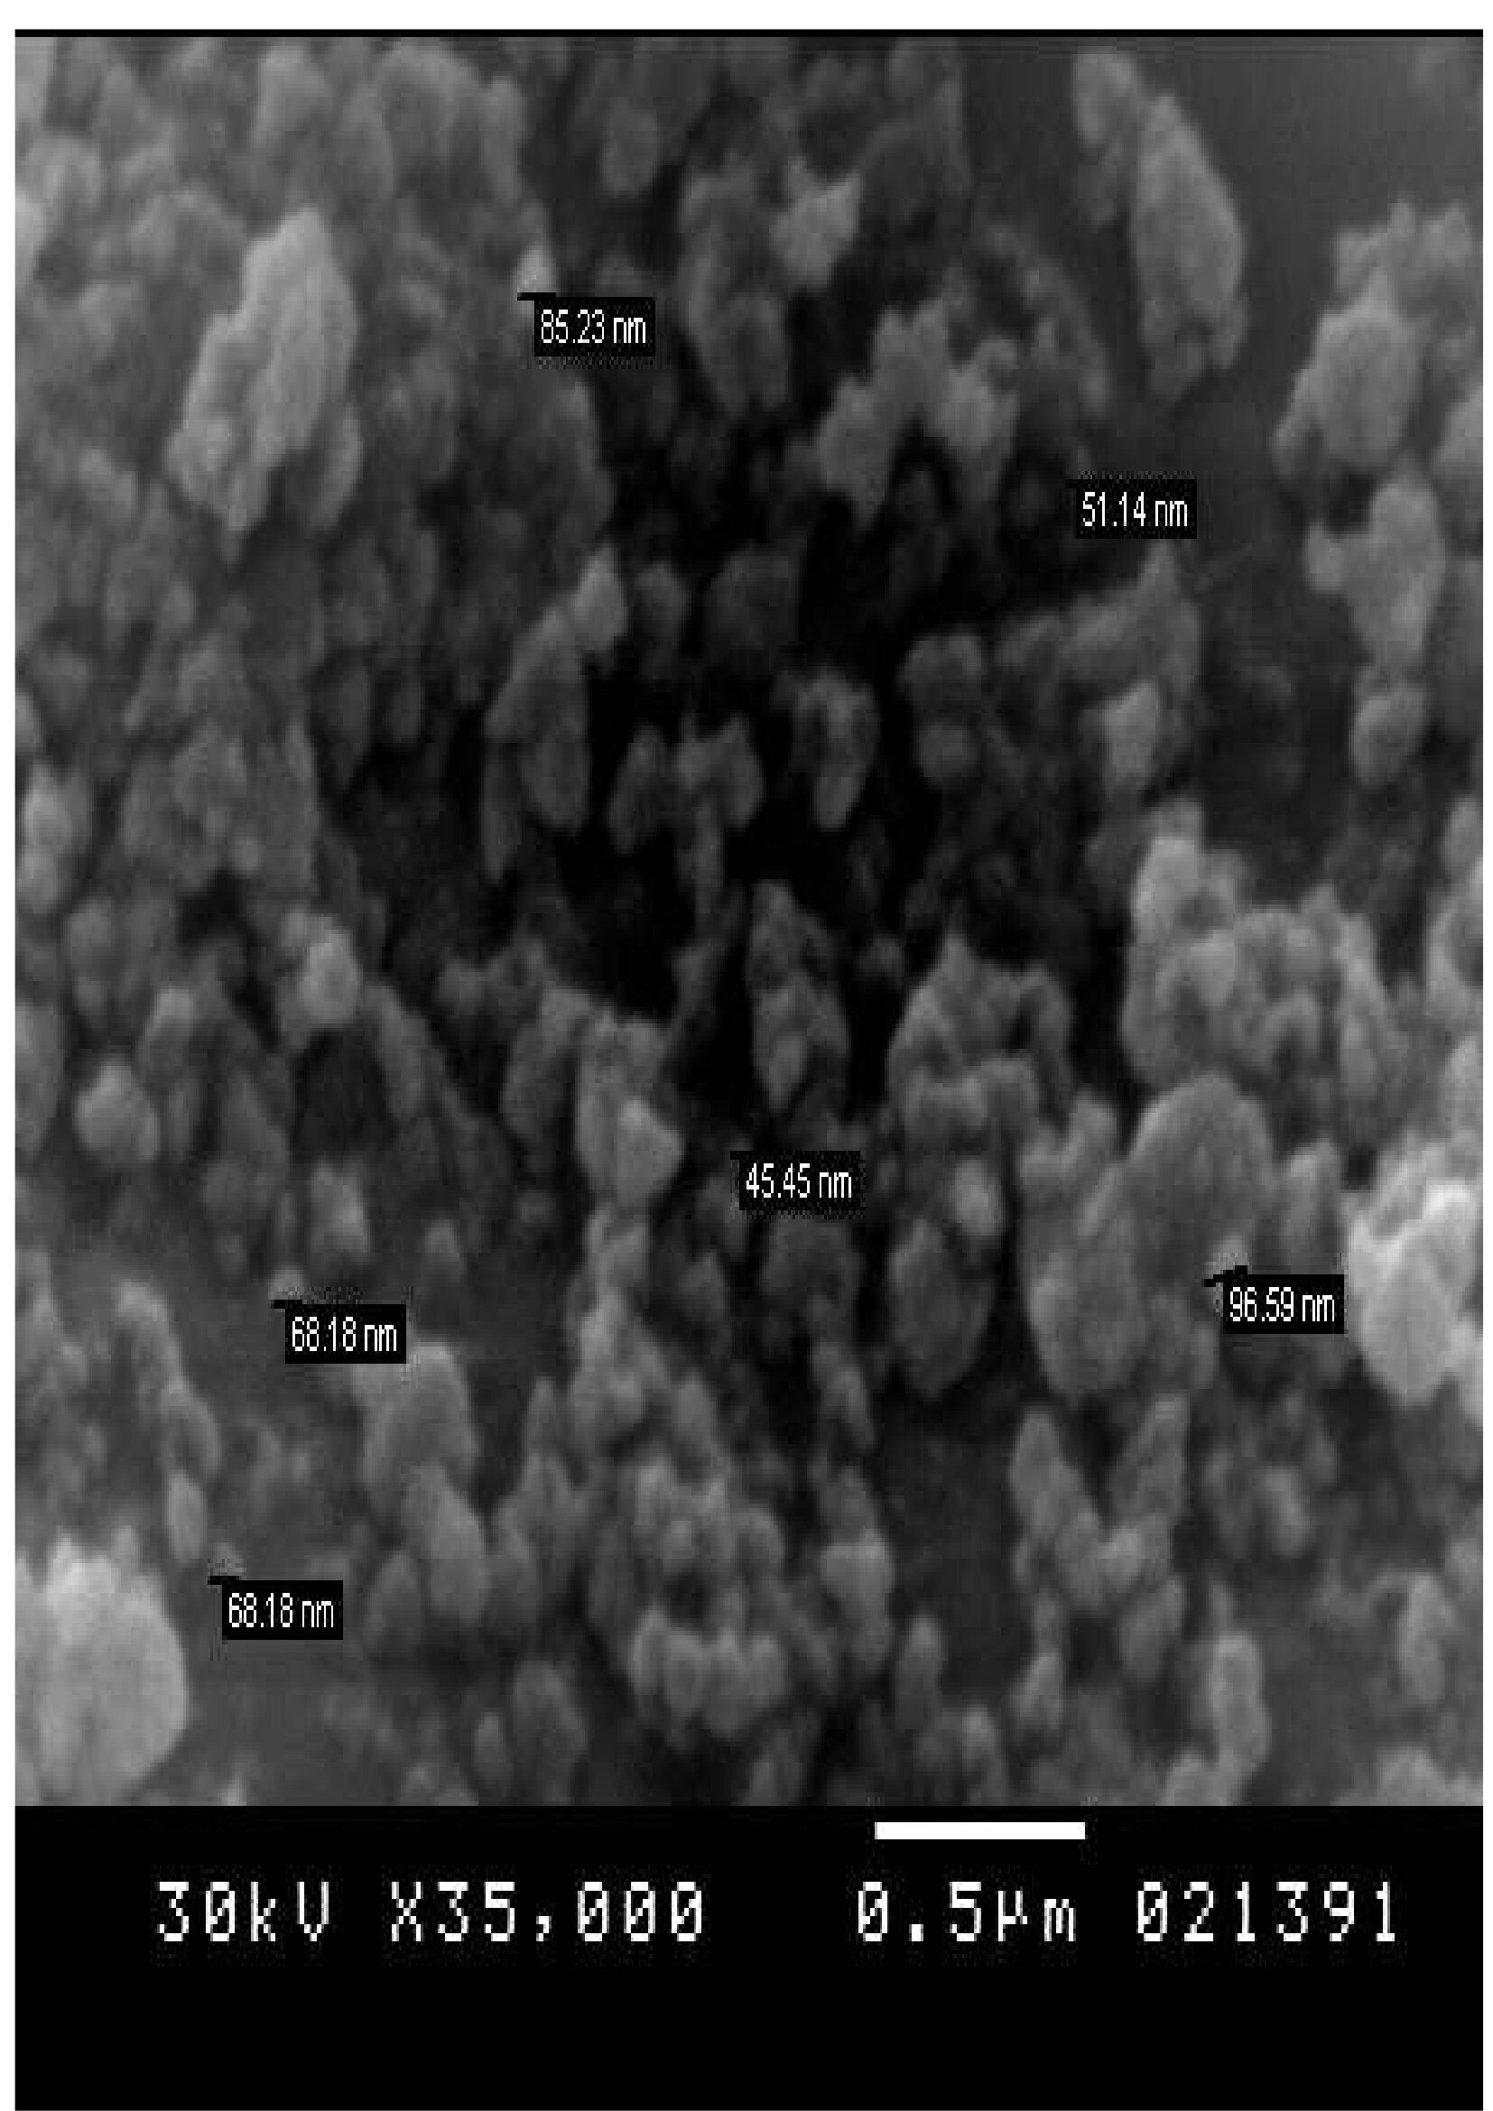
- Reference:

- Elkhatib, E.A., A.M. Mahdy, and K.A. Salama, 2015. Green synthesis of nanoparticles by milling residues of water treatment. Environmental chemistry letters, 13: 333-339.
- Elkhatib, E. and J. Hern,1988. Kinetics of phosphorus desorption from Appalachian soils. Soil science, 145(3): 222-
- Foo, K.Y. and B.H. Hameed, 2010.
Insights into the modeling of adsorption isotherm systems. Chemical engineering journal, 2010. 156: 2-10.
229.

Biography:

Dr.Elsayed Elkhatib is a Professor of Environmental Soil Chemistry at Alexandria University in Egypt; he received his PhD Degree in Soil Chemistry from West Virginia University, USA. He worked as a Postdoctoral Researcher in Appalachian Soil and Water Conservation Research Laboratory at Beckley and as a Visiting scientist at Virginia Polytechnic Institute and State University, at Blacksburg Professor Elkhatib is currently a director of the program on Developing MS in Water Research Management at Alexandria University" and is engaged in several projects on the subject of developing “green”, low-cost nanomaterials derived from bio-wastes and industrial wastes for remediation of contaminated water and soil .

Presenting authordetails

Full Name: Elsayed A.Elkhatib
Contact number: 002-1005409463
Session name/ number: Nanotechnology in energy and environment
Category: (Oral presentation)
Passport Number:A12227497

