Safer-by-design conception of TiO₂ nanoparticles coated with PEG for applications in paints
Aurelie Rosset^{a,b}, Sébastien Artousª, Anass Benayadª, Adrien Boulineauª, Isabelle Michaud-Soret^{b}, ª Université Grenoble Alpes, F-38000 Grenoble, France; CEA, Laboratoire en Nanosécurité et Nanocaractérisation, F-38000 Grenoble Cedex 9, France. ^{b} Université Grenoble Alpes, CEA, CNRS, IRIG-LCBM, Laboratoire de Chimie et Biologie des Métaux, 38000 Grenoble, France.

Abstract (300 word limit)
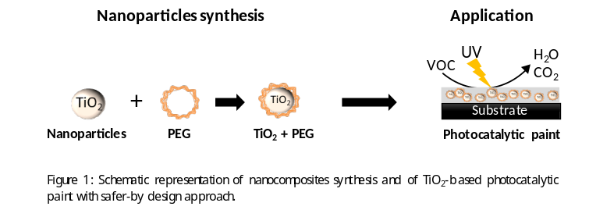
Statement of the Problem: Improving air quality is becoming an important concern for human health and environment. The TiO₂-based photocatalytic paints represent a promising alternative technology for air treatment, which aims at mineralizing gaseous pollutants, such as Volatile Organic Compounds (VOCs), into innocuous species (H₂O and CO₂). Nevertheless, the nanoparticle releases and the emerging risks related to the exposure to those species during the lifecycle of paints become of major concern. The aim of the SafeTiPaint project, supported by LabEx SERENADE, is to design a paint containing photocatalytic TiO₂ nanoparticles taking into consideration safety aspects at every step of the value chain. This project gathers partners in specific fields such as synthesis, paint formulation, use throughout the lifecycle, characterization and tox/ecotox testing. Here, we will present our strategy to TiO₂ nanoparticles synthesis. Methodology & Theoretical Orientation: The aim of our synthesis work is to modify the surface of the TiO₂ nanoparticles used by a paint manufacturer with a bio-inspired ligand in order to reduce degradation of mineral matrix-based paint while keeping a good photocatalytic activity. To achieve this goal, we coated TiO₂ nanoparticles with PEG using different [PEG]/[TiO₂] ratios ranging from 0.5 to 10 using an electro-steric stabilization. The photocatalytic activities of the composites were investigated by measuring the degradation of methylene blue in solution under UV irradiation. Findings: The size of the synthesized particles increased with [PEG]/[TiO₂] ratios up to a ratio of 5/1, which corresponds to the lowest photocatalytic activity, and decreased for higher ratios. Conclusion & Significance: This 5/1 composite is an interesting candidate to limit the matrix-based paint degradation. It will be dispersed in paint formulations in order to evaluate its role during their artificial weathering. The more photoactive 1/1 composite will also be selected for comparison purposes.

Image

Recent Publications (minimum 5)
- A. Rosset, G. Plantard, K. Djessas, V. Goetz, Correlation between gap energy and photocatalytic efficiencies of nanocatalyst under solar irradiation conditions, J. Mater. Sci. Mater. Electron. 28 (2017) 1-10.
- A. Rosset, G. Plantard, K. Djessas, Photocatalytic efficiencies of Zn_{1-x}M_{x}O compounds synthesized with a broad panel of M elements: Responses in the UV, visible and solar range, Journal of Environmental Chemical Engineering, 6, (2018) 7273-7283.

 Biography (150 word limit)
Dr. Aurelie Rosset graduated in 2013 in solar energy (University of Perpignan Via Domitia). She then received her Ph.D. in engineering sciences at the laboratory PROMES-CNRS of University of Perpignan Via Domitia in 2017 on synthesis and characterization of catalytic nanoparticles for solar photocatalysis applications. Since 2018, she working as a postdoctoral in CEA-Grenoble on towards the eco-design of a photocatalytic paint. She develop new functionalization way of TiO₂ nanoparticles by a safer-by-design approach. She works in risk assessments, management and environmental impact of nanoparticles produced during the life cycle. She is involved in SafeTiPaint project, supported by LabEx SERENADE, as project manager.
Email: aurelie.rosset@cea.fr
Phone: +3343-878-1250

Notes/Comments:

This work is a contribution to the LABEX SERENADE (n° ANR-11-LABX-0064) funded by the “Investissements d'Avenir” French Government program of the French National Research Agency (ANR) through the A*MIDEX project (N° ANR-11-IDEX-0001-02).

