Micropatterning of Multifunctional Coatings by UV-triggered Polymerization of Plant Phenolic Compounds
F. Behboodi-Sadabad¹, H. Zhang², V. Trouillet¹, A. Welle¹, N. Plumeré², P. Levkin*¹ , ¹Karlsruhe Institute of Technology, Germany. ²Ruhr-Universität Bochum, Germany

Abstract
Plant-derived phenolic compounds, rich in catechol and pyrogallol moieties, can form multifunctional nanocoatings on various substrates, following polymerization under mildly alkaline pH solutions. Despite a lot of appealing features of such coatings, the difficulty to control this polymerization spatially and temporally, limits the number of potential applications of plant polyphenols. Here we demonstrate for the first time that UV irradiation can trigger oxidative polymerization and deposition of plant-derived phenolic compounds, which opens the possibility to create 2D gradients and patterns of polyphenol nanocoatings and control this polymerization temporally. UV-Vis spectroscopy, ESI-MS, and cyclic voltammetry analyses were used to investigate the UV-induced polymerization of several plant-derived phenolic compounds including pyrogallol, tannic acid, caffeic acid, and gallic acid. Deposition of polyphenol nanocoatings on polar and non-polar substrates after UV irradiation was studied using AFM, ToF-SIMS and XPS. The ability to use UV-light to trigger polymerization and deposition of phenolic compounds opens the possibility to create polyphenol patterns and gradients within microfluidic channels, which was demonstrated by creating a pattern of polyphenol inside a fused silica capillary. The use of UV-light to accelerate polymerization of polyphenol opens the possibility for the photolithographic patterning of functional polyphenolic nanocoatings on various substrates, extending the scope of potential applications of plant polyphenols.

Image
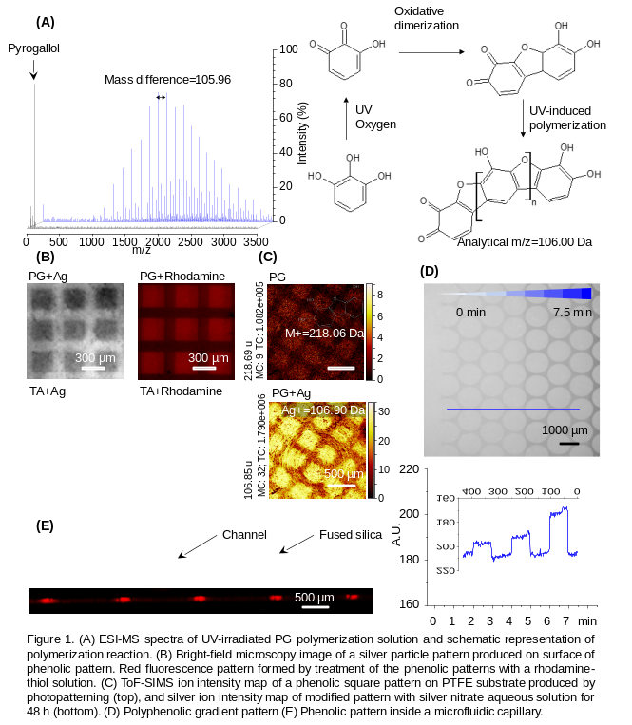
Recent Publications (minimum 5)
- A. I. Neto, K. Demir, A. A. Popova, M. B. Oliveira, J. F. Mano, P. A. Levkin (2016), Adv. Mater., 28, 7613.
- M. R. Molla, P. A. Levkin (2016), Adv. Mater., 28, 1159.
- L. Li, W. Feng, A. Welle, P. A. Levkin (2016), Angew. Chem. Int. Ed. Engl.
- L. Li, W. Feng, A. Welle, P. A. Levkin (2016), Angew. Chem. , n/a.
- W. Q. Feng, L. X. Li, X. Du, A. Welle, P. A. Levkin (2016), Adv. Mater., 28, 3202.

Biography
Farid Behboodi Sadabad has completed his Bsc and Msc from Amirkabir University of Technology. He is doing his PhD in bioinspired materials and polymer chemistry in Karlsruhe Institte of Tehnology.
Email: farid.sadaba@kit.edu

Notes/Comments:

