Design of Pd-based nanoalloy particles confined into mesoporous carbon: size, composition and confinement effects on the interactions with hydrogen

Camelia Matei Ghimbeu*, Alicia Martinez de Yuso, Jean-Marc Le Meins, PhD, Institut de Science des Matériaux de Mulhouse (UMR 7361 CNRS-UHA), Mulhouse, France

Yassine Oumellal, Claudia Zlotea, PhD, Université Paris Est, Institut de Chimie et des Matériaux Paris-Est (UMR7182-CNRS) Thiais, France

Supported metal nanoparticles (NPs) with well controlled size, dispersion and shape are of great interest in many fields of applications. They exhibit large surface to volume ratio, faster molecular diffusion pathways and synergetic effects rising from the interaction with the support. Mesoporous carbons are widely employed to support such particles affording good stabilization through nanoconfinement effects leading to small and well dispersed NPs. Supported Pd-based alloys with noble or transition metals on carbon are tremendously studied in catalysis while hydrogen storage studies are scarce.

In the present work two main strategies were developed to synthesize a series of Pd_{x}-M_{100-x} alloys NPs (where M= Co, Ni, Rh, Pt and x= 10, 25, 50, 75, 90) having different compositions, tunable particle size and location in the carbon network. The first approach is the incipient wetness impregnation of carbon host with a metallic solution, followed by hydrogen reduction at 300-500°C [1] while the second approach is a one-pot method where the metallic particles are formed in-situ during the synthesis of carbon framework at 600°C [2].

The optimization of NPs size was achieved by tuning several the metal salt type, carbon precursors, cross-linkers and thermal reduction temperature while their location was directed mainly by the type of synthesis approach, the impregnation favor the NPs location into the pores while the one-pot in the walls of carbons. For several studied systems, alloy particles were formed in the whole composition range as highlighted by the linear relationship between the lattice parameter and the composition (Fig. 1a) [1-3]. Small particles with sizes ranging between 1.5 and 50 nm were prepared (Fig.1), the incipient method allowing obtaining always smaller particle sizes than the one-pot method [1-5] (Fig. 1left). The hydrogen interactions with the nanoalloys were strongly influenced by their composition, size and confinement in the carbon network (Fig. 1b) [3-6].

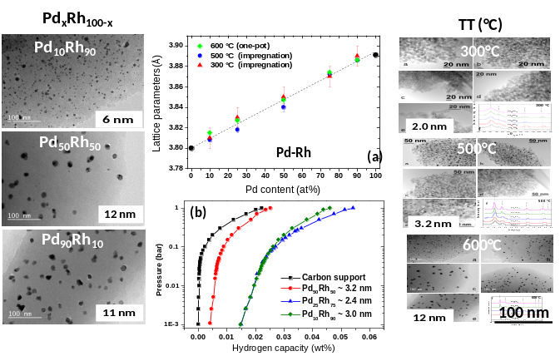Figure 1: TEM images of Pd_{x}Rh_{100-x} vs. metallic composition (left) and synthesis temperature (right) and their corresponding lattice parameters (a) and hydrogen sorption isotherms at 20°C (b).

References
- Oumellal Y, Joubert J-M, Matei Ghimbeu C, Le Meins J-M, Bourgon J, Zlotea C (2016) Synthesis and stability of Pd-Rh nanoalloys with fully tunable particle size and composition, Nano-Structures & Nano-Objects 7: 92-100.
- Matei Ghimbeu C, Puscasu A, Martinez A, Zlotea C, Oumellal Y, Latroche M, Vix-Guterl C (2016) One-pot synthesis of tailored Pd-Co nanoalloy particles confined in mesoporous carbon, Micro Mesoporous Mater 223: 79-88.
- Zlotea C, Matei Ghimbeu C, Oumellal Y, Crivello J-C, Vix-Guterl C, Latroche M (2015) Hydrogen sorption properties of Pd-Co nanoalloys embedded into mesoporous carbons, Nanoscale 7: 15469-15476.
- Oumellal Y, Matei Ghimbeu C, Martínez de Yuso A, Zlotea C (2016) Hydrogen absorption properties of carbon supported Pd-Ni nanoalloys, Intern. J. Hydrogen Energy, Under press.
- Martínez de Yuso A, Oumellal Y, Zlotea C, Vidal L, Matei Ghimbeu C (2016), Optimization of bulk immiscible Pd-Pt nanoalloys confined in mesoporous carbon via one-pot microwave approach and their interactions with hydrogen, Nanostructures & Nano-Objects, under review.
- Oumellal Y, Provost K, Matei Ghimbeu C, Martinez de Yuso A, Zlotea C (2016), Composition and size dependence of hydrogen interaction with carbon supported bulk-immiscible Pd–Rh nanoalloys, Nanotechnology 27: 465401

 Biography
Dr. Camelia Matei Ghimbeu is a researcher at Institute of Materials Science of Mulhouse (IS2M-CNRS), France. She received in 2007 her PhD from University of Metz, France and TU Delft, The Netherlands and her Habilitation in 2015 from University of Haute Alsace, France. Author of 55 articles and about 100 communications, her research interests are focused on the design of carbon hybrid materials with controlled characteristics for energy storage and environmental applications. She is animating the research axe “Carbon and Hybrid Materials” at IS2M, and she is member of French network of Electrochemical Storage of Energy (RS2E).

Email: camelia.ghimbeu@uha.fr

Notes/Comments:

