High Efficiency of Silica-Coated CdSe/ZnS quantum dots for cellular imaging by Time lapse Confocal Laser Scanning Microscopy
Heba ElSayed ElZorkany, PhD student, Nanotechnology and Advanced Materials Central Lab. (NAMCL),
Agriculture Research Center (ARC), Egypt.

Abstract

Owing to its intrinsic photophysical properties quantum dots (QDs) act as a new tool for imaging and drug delivery. In this study, biocompatible silica-coated QDs were synthesized in order to track their cellular uptake in cancer cells. Firstly, Trioctylphosphine oxide capped CdSe QDs were synthesized by organometallic routes and ZnS shell were grown on them by injection solution of diethylzinc (Zn (Et)₂) and hexamethyldislathiane ((TMS)₂S )as Zn and S precursors. CdSe/ZnS QDs were then rendered water soluble by overcoating with silica using 3-Aminopropyltriethoxysilane (APTS) as silica precursor. The toxicological effects of silica-coated CdSe/ZnS (Si-QDs) were investigated by exposing hep-G2 cells to different concentrations of Si-QDs then the mitochondrial activity was evaluated using WST-1 kit. The intracellular localization of Si-QDs in hep-G2 cells was investigated by Confocal Laser Scanning Microscopy (CLSM) equipped with CO2 incubator up to six hours. All stages of QDs formation were characterized by UV-Vis absorption, emission spectroscopy TEM, XRD, DLS and ζ-potential. Results showed that, high fluorescence QDs were synthesized with a size between 2 and 4 nm. Also, Silica coating process yielded final particle sizes of 6-18 nm which possessed strong luminescence property. The cytotoxicity test results showed that Si-QDs were nontoxic even at higher concentrations as cells remained viable when exposed to Si-QDs at the highest concentration of 100 nM. The fluorescence imaging of hep-G2 cells exposed to Si-QDs by CLSM time lapse mode for 6 hours depicted the fast internalization of Si-QDs into the cells producing good fluorescence in the cytoplasmic portion. These results confirmed the effective role of these fluorescent materials in biological labeling and imaging applications.
Image
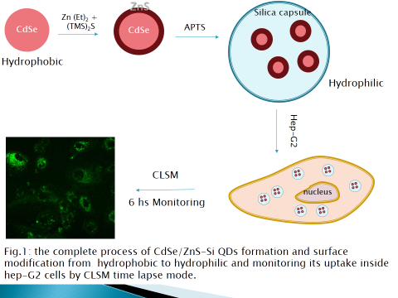
Recent Publications (minimum 5)
No already published paper found.

 Biography (150 word limit)
Heba ElZorkany received her B.Sc.in Biotechnology from Benha University at 2006. She joined the National Institution of Laser Enhanced Science, Cairo University as a post graduate student and she awarded a diploma degree in laser applications in biotechnology and photobiology in 2008. She awarded her M.Sc degree in 2013 under title “The photothermal effect of metallic nanoparticles on bacteria”.
She has enrolled in the Ph.D program at NILES, since 2014 to conduct her thesis titeled “Efficiency of biocompatible quantum dot for cellular imaging using confocal laser scanning microscope”.
She has been appointed as a researcher at Nanotechnology and Advanced Materials Central Lab. (NAMCL), Agriculture Research Center (ARC) since 2010.
Her research experiences include biotechnology, microbiology, photobiology, laser applications in biology, nanotechnology, spectroscopy, and microscopy. She is Confocal Laser Scanning Microscope (CLSM) & cell culture specialist. She has participated in several international conferences.
Email: heba.elzorkany@namcl.sci.eg, heba.elzorkany@gmail.com

Notes/Comments:

Session name: Scope of Nanomaterials
Category: Oral presentation

