Nanodiamond Clusters Decorated with Folic
Acid for Photothermal Tumor Therapy
Sung-Wook Choi, PhD, Professor
The Catholic University of Korea, Korea

Abstract
Statement of the Problem: Photothermal tumor therapy (PTT) have attracted considerable attention as minimally invasive therapeutic techniques as they have a typical tissue penetration of several centimeters in biological tissues. Nanodiamonds (NDs) have a truncated octahedral composition, have emerged as promising materials due to their spherical morphology, versatile functionality, fluorescent property, colloidal stability, and high biocompatibility. Herein, we designed ND nanoclusters decorated with folic acid (FA) as a targeting moiety and utilized the photothermal effect of NDs upon NIR laser irradiation for tumor therapy.
Methodology & Theoretical Orientation: To evaluate the photothermal property of ND nanoclusters with various ND concentrations, samples were prepared and then exposed to NIR laser ( λ = 808 nm) for 5 min. in vivo tumor specificity and therapeutic efficacy also examined by injecting ND and FA-ND nanoclusters into tumor-bearing nude mice through a tail vein.
Findings: FA-ND nanoclusters exhibited specific cellular uptake to KB cells. The viability of KB cells treated with FA-ND cluster was reduced to 5.4% (94.6% of ablation ratio) along the light of NIR laser. An in vivo studies revealed that FA-ND nanoclusters selectively accumulated in tumor tissue and effectively reduced tumor volume from 36.1 ± 5.2 mm³ to 21.4 ± 4.9 mm³ by the NIR laser-exposed.
Conclusion & Significance: We demonstrated the superior performance of FA-ND nanoclusters for selective photothermal tumor therapy. We believe that FA-ND nanoclusters have great potential for selective photothermal tumor therapy.
Image
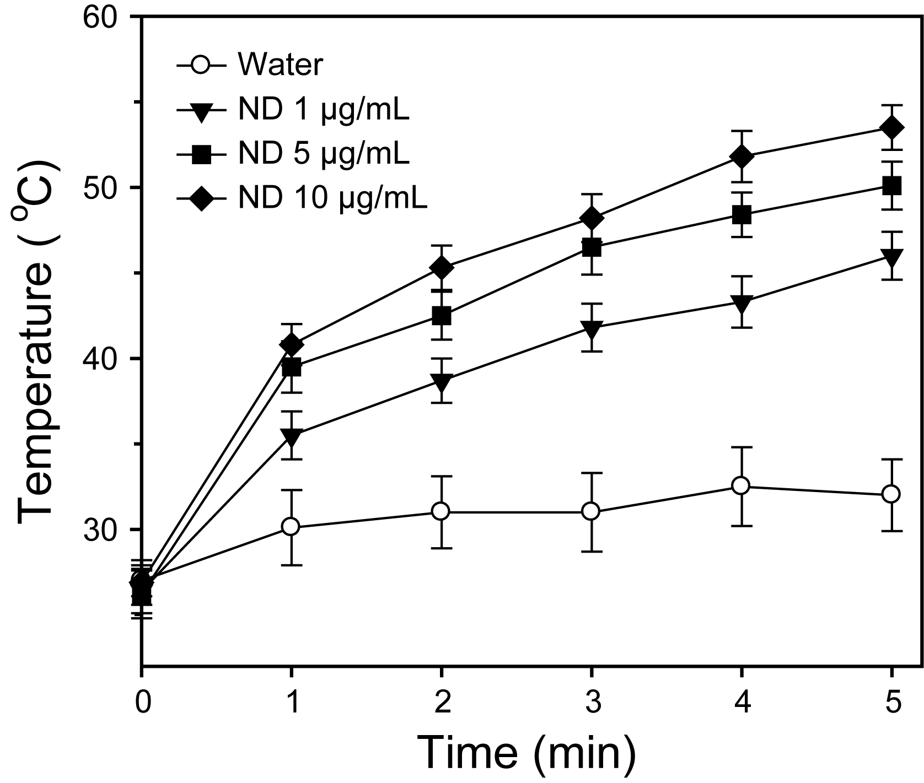
Figure 1. Variation in temperature of aqueous ND dispersions at various ND concentrations with respect to laser exposure time (2 W/cm²).

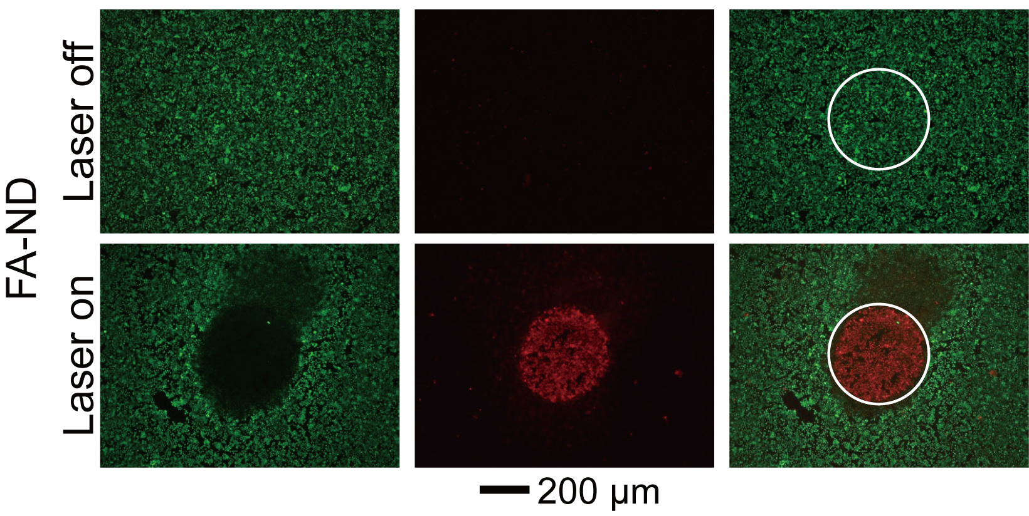
Figure 2. Fluorescence microscopy images of KB cells under laser on and off conditions. KB cells were incubated with ND and FA-ND nanoclusters for 12 h and exposed to NIR irradiation (5 min, 2 W/cm²), followed by LIVE/DEAD staining.

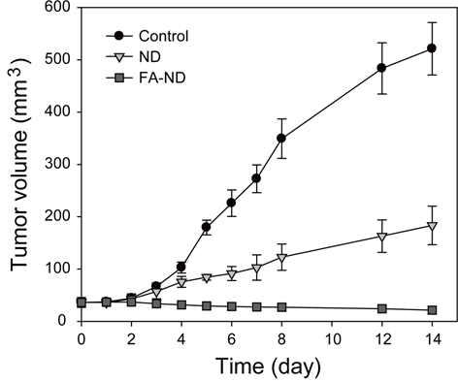
Figure 3. variation in tumor volume after intravenous PBS (control), ND, and FA-ND nanocluster injection with respect to time. Tumor tissue was exposed to NIR laser irradiation (2 W/cm²) for 5 min.


Biography (150 word limit)
Sung-Wook Choi has an expertise in design and fabrication of functional nanoparticles for specific tumor therapy. His academic interest included fluidic device, biomaterials, scaffold, tissue engineering as well as nanomedicine. Recently, he has worked on the nanodiamonds and their applications for nanodelivery and tissue engineering. The photothermal therapy using nanodiamond was first reported in his research group.

Email: choisw@catholic.ac.kr
Notes/Comments:

