Cationic lipids for gene delivery in vitro and in vivo
Yinan Zhao, Yingnan Cao, Yanyan Du, Xiaodong Xu, Defu Zhi, Dalian Minzu University, China Shubiao Zhang, PhD, Dalian Minzu University, China

Abstract

Several novel tri-peptide cationic lipids were designed and synthesized for delivering DNA and siRNA. They have tri-lysine and tri-ornithine as headgroups, carbamate group as linker and 12 and 14 carbon atom alkyl groups as tails. These tri-peptide cationic lipids were prepared into cationic liposomes for the study of the physicochemical properties and gene delivery. Their particle size, Zeta potential and DNA-binding were characterized to show that they were suitable for gene transfection. The further results indicate that these lipids can transfer DNA and siRNA very efficiently into NCI-H460 and Hep-2 tumor cells. The selected lipid, CDO14, was able to deliver combined siRNAs against c-Myc and VEGF for silencing distinct oncogenic pathways in lung tumors of mice, with little in vitro and in vivo toxicity.
Image
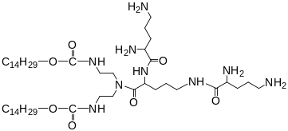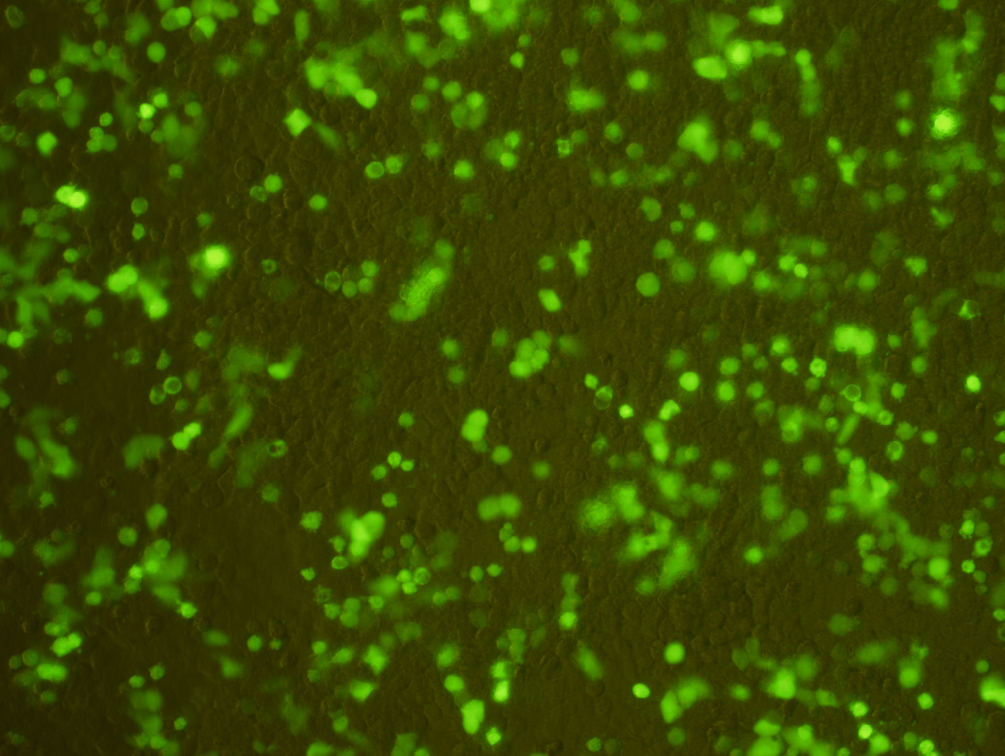
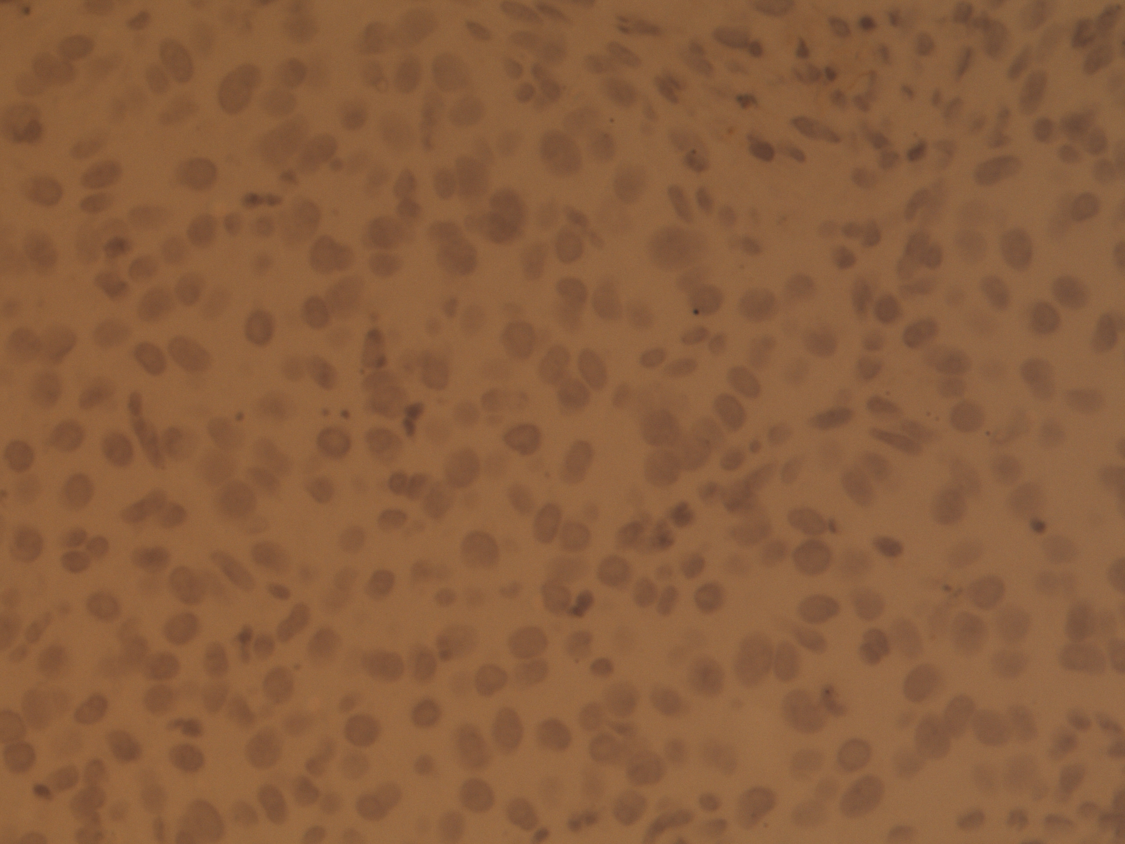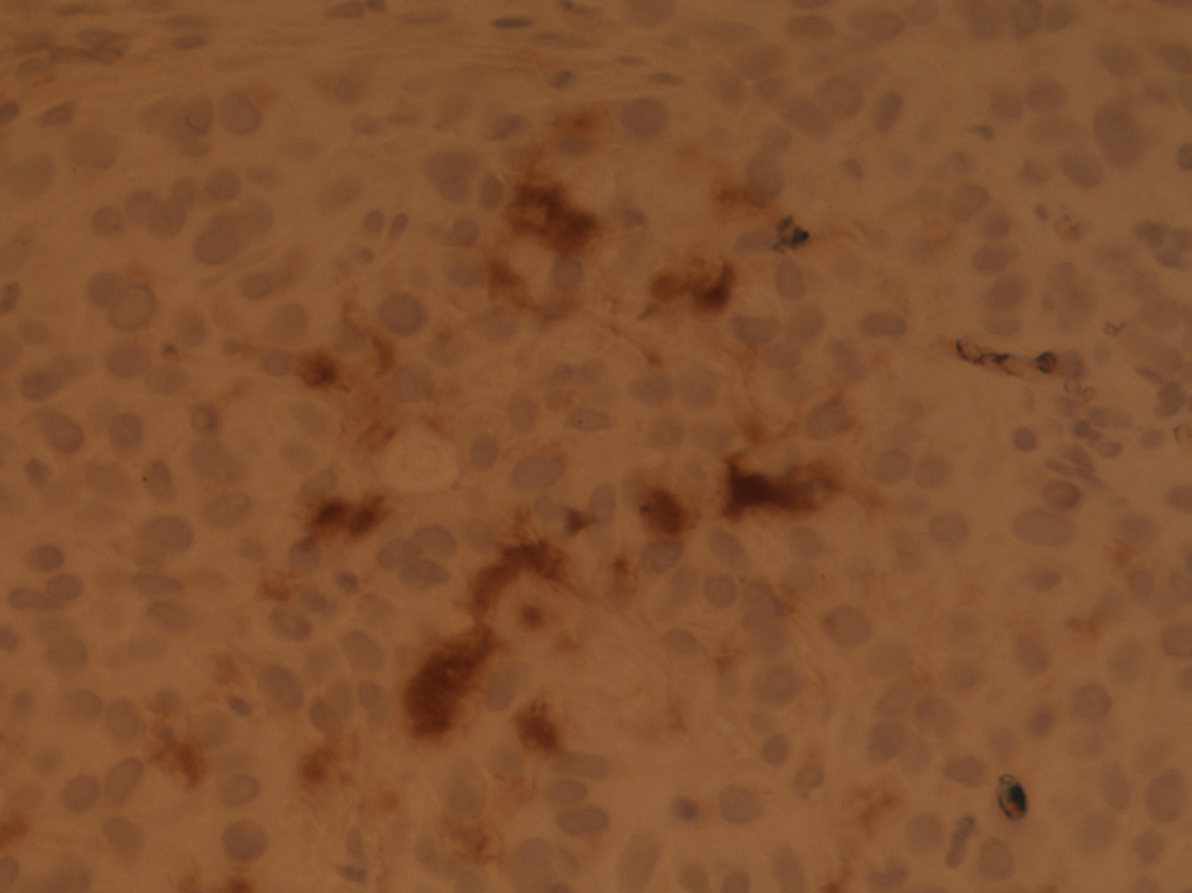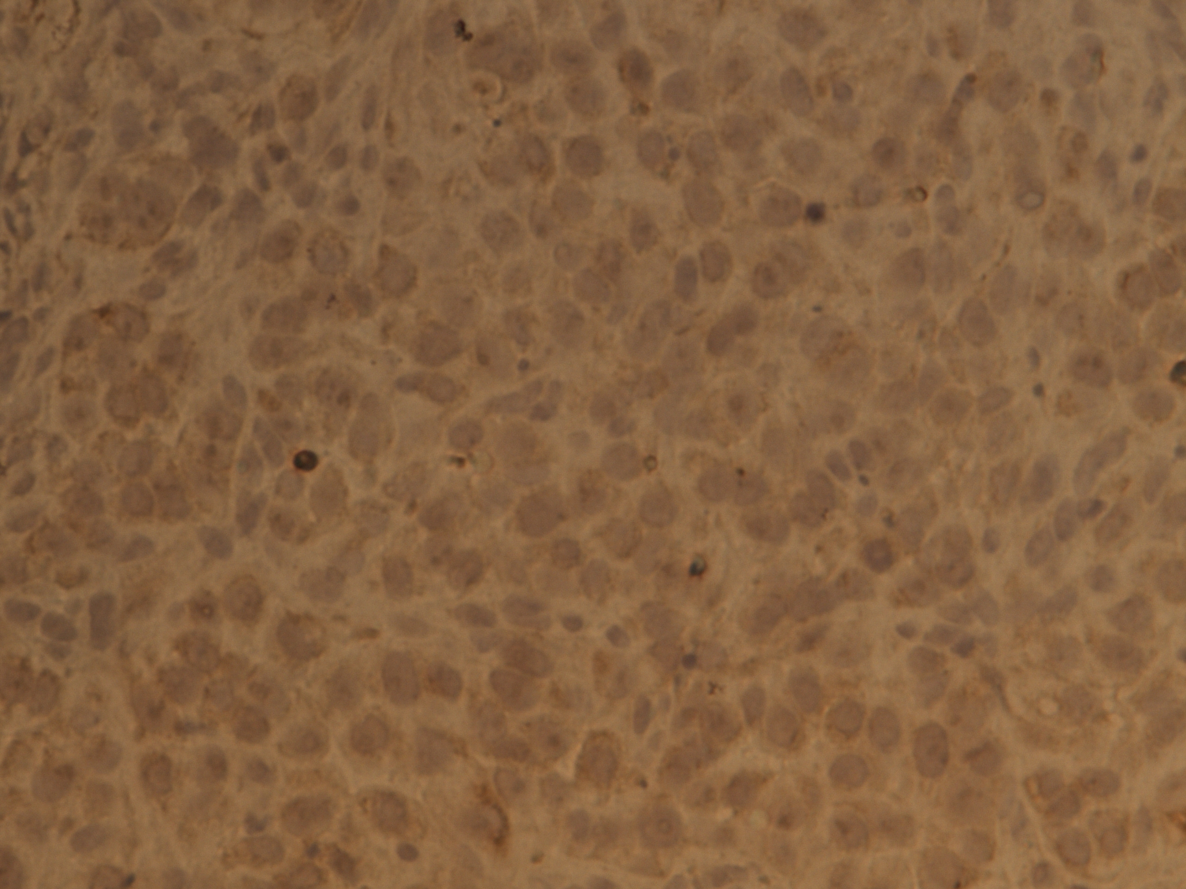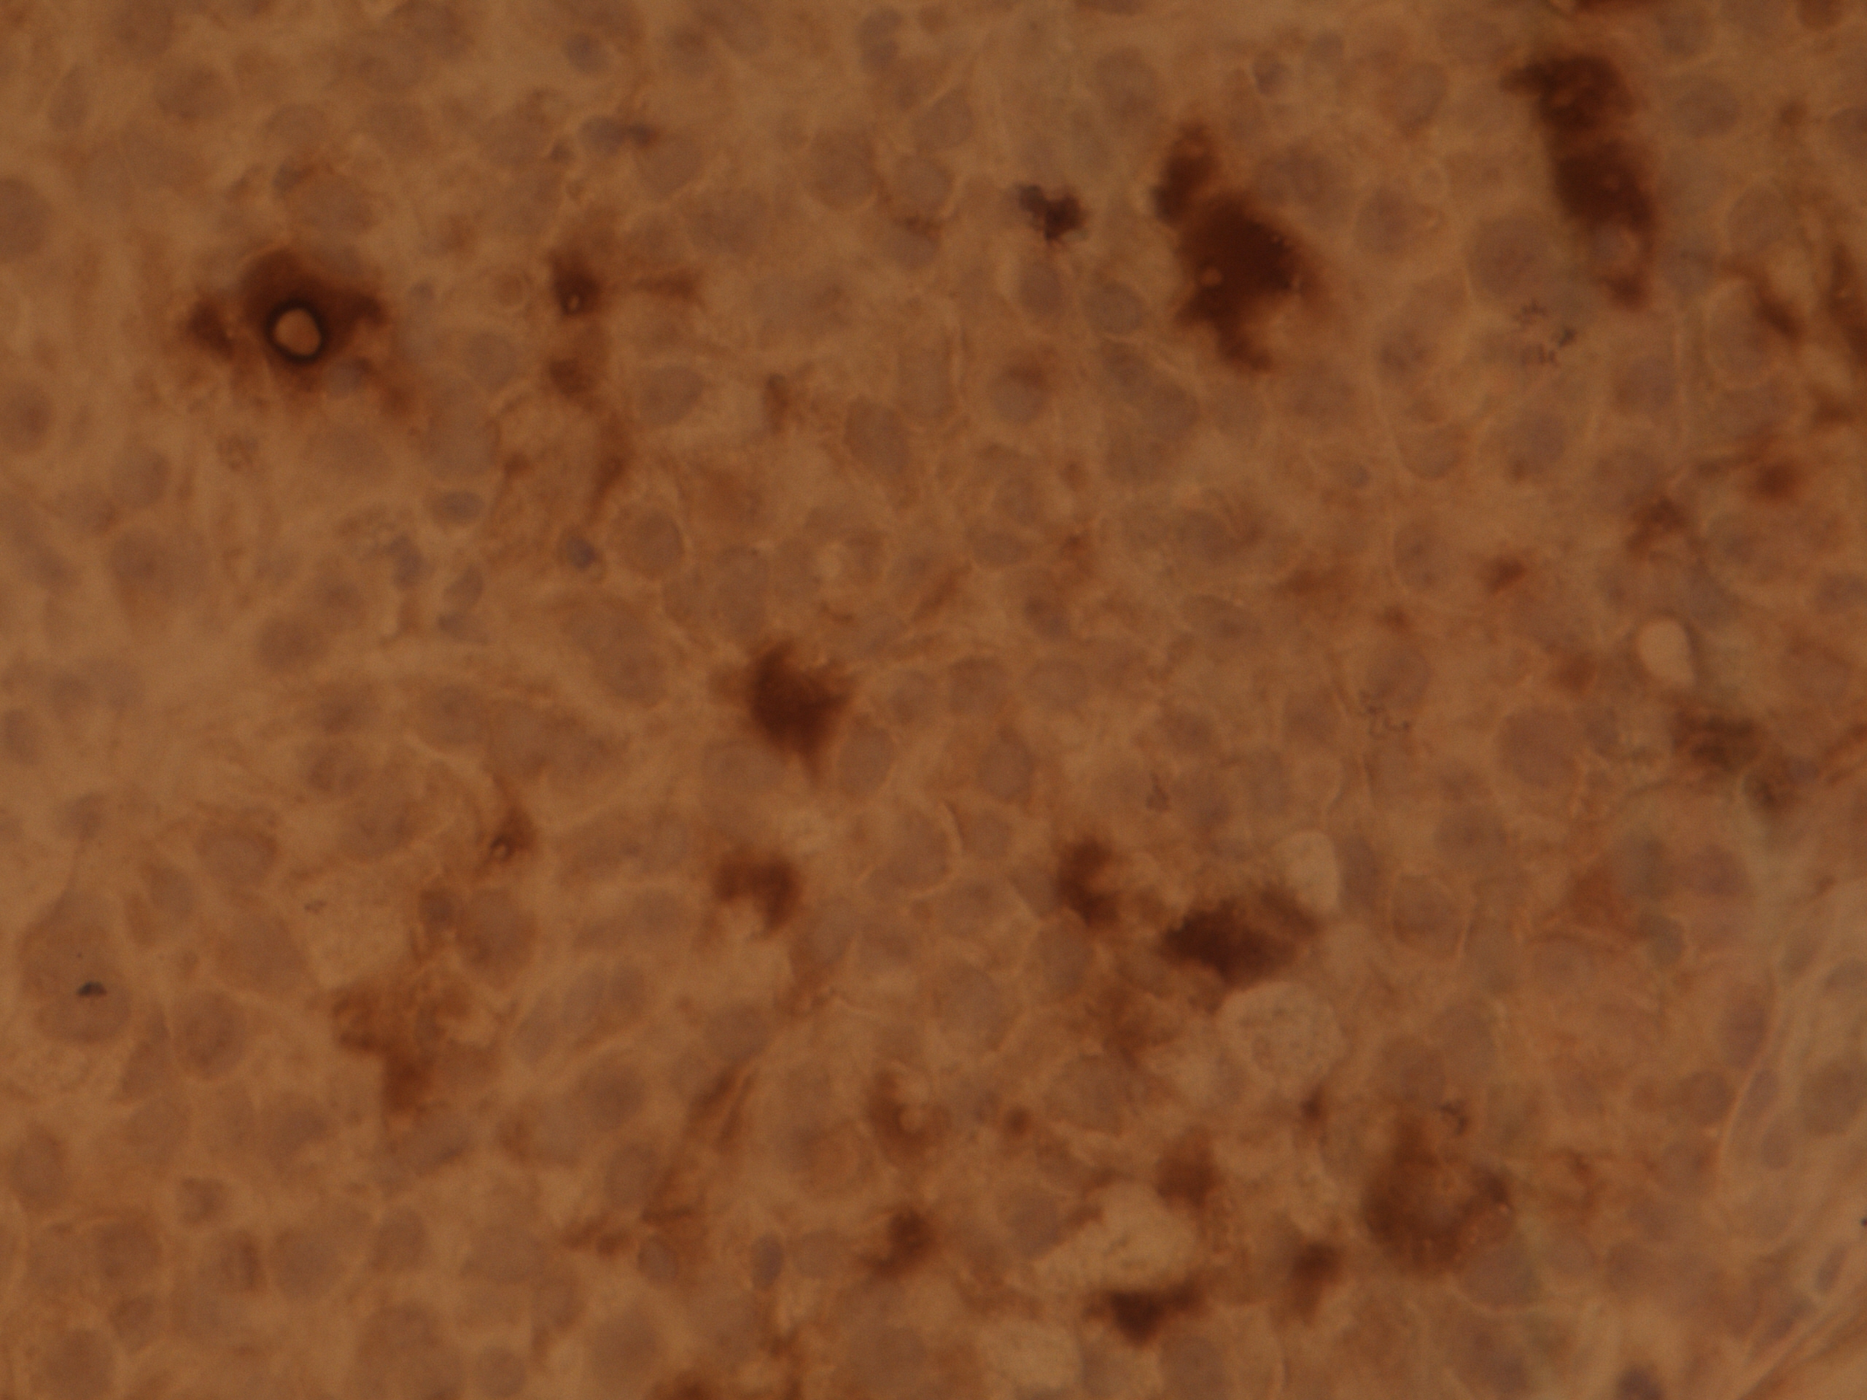
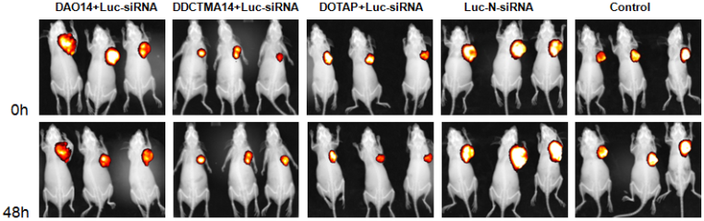
Fig. 1 The novel tri-peptide cationic lipid can efficiently transfer DNA and siRNA into tumor cells and tumors of mice with little in vitro and in vivo toxicity.


Biography
Dr. Shubiao Zhang now is a distinguished professor at Dalian Minzu University and a doctor supervisor at Dalian Institute of Chemical Physics and Dalian University of Technology. He is involved in the study about non-viral vectors for gene delivery and bio-active materials. He got many awards at the university including Young Backbone Teacher of Liaoning Province, New Century Excellent Talents of Ministry of Education, Academic Paper Award of Liaoning Province and Scientific and Technological Paper Award of Dalian City. He leads many research programmes supported by Natural Science Foundation of China, Ministry of Education, Hoffmann La-Roche Ltd. and some domestic companies. He published over 80 peer-reviewed articles, among them over 40 were indexed by SCI, 15 by EI with a total cites of over 1200 times. He is a reviewer for many high quality peer-reviewed journals such as Journal of Controlled Release, Bioconjucate Chemistry, Molecular Pharmaceutics and Interational Journal of Pharmaceutics.
Email: zsb@dlnu.edu.cn

Notes/Comments:

This research is financially supported by the National High-Tech Research and Development Program of China (863 Program, 2014AA020707), the National Natural Science Foundation of China (21503035/21606041/21776044).

