PED4 inhibitor-loaded phosphatiosomes for attenuating neutrophilic inflammation in acute lung injury
Jia-You Fang, Ph.D, Pharmaceutics Laboratory, Graduate Institute of Natural Products, Chang Gung University, Kweishan, Taoyuan, Taiwan
Cheng-Yu Lin, MS, Pharmaceutics Laboratory, Graduate Institute of Natural Products, Chang Gung University, Kweishan, Taoyuan, Taiwan
Tsong-Long Hwang, Ph.D, Cell Pharmacology Laboratory, Graduate Institute of Natural Products, Chang Gung University, Kweishan, Taoyuan, Taiwan

Abstract
Background: Cilomilast is a phosphodiesterase 4 (PDE4) inhibitor for treating inflammatory lung diseases. This agent has a narrow therapeutic index with significant adverse effects on the nervous system. This study was conducted to entrap cilomilast into PEGylated phosphatidylcholine (PC)-rich niosomes (phosphatiosomes) to improve pulmonary delivery via the strong affinity to pulmonary surfactant film. Neutrophils were used as a cell model to test the anti-inflammatory activity of phosphatiosomes. In an in vivo approach, mice were given lipopolysaccharide (LPS) to produce acute lung injury (ALI). The surface charge in phosphatiosomes that influenced the anti-inflammatory potency is discussed in this study. Results: The average diameter of the phosphatiosomes was about 100 nm. The zeta potential of anionic and cationic nanovesicles was -35 and 32 mV, respectively. Cilomilast in both its free and nanocapsulated forms inhibited superoxide anion production but not elastase release in activated neutrophils. Cationic phosphatiosomes mitigated calcium mobilization far more effectively than the free drug. In vivo biodistribution evaluated by organ imaging demonstrated a two-fold ameliorated lung uptake after dye encapsulation into the phosphatiosomes. The lung/brain distribution ratio increased from 3 to 11 after nanocarrier loading. The intravenous nanocarriers deactivated the neutrophils in ALI, resulting in the elimination of hemorrhage and alveolar wall damage. Only cationic phosphatiosomes could significantly suppress IL-1β and TNF-α in the inflamed lung tissue. Conclusions: These results suggest that phosphatiosomes should further be investigated as a potential nanocarrier for the treatment of pulmonary inflammation.

Image
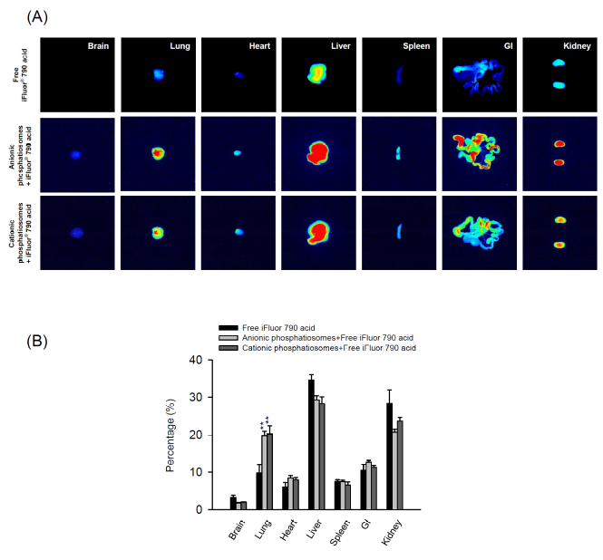
Figure 1. The bioimaging of seven peripheral organs from the mice at 2 h following an intravenous injection of iFluor® 790 loaded in a control solution and in phosphatiosomes: (A) the representative organ images and (B) the percentage of near-infrared signal in different organs. The scale of bioimaging was calibrated by the intensity of the formulations for impartial comparison. Each value represents the mean ± S.E.M. (n=5).


Biography (150 word limit)
Jia-You Fang is now a Professor in the Graduate Institute of Natural Products at Chang Gung University in Taiwan. In addition, he is an Adjunct Professor in the Graduate Institute of Health Industrial Technology, Chang Gung University of Science and Technology and Department of Anesthesiology, Chang Gung Memorial Hospital. Over the past 25 years, he and his team have made contributions to the understanding of drug delivery, pharmaceutics, pharmacokinetics, nanomedicine, and cosmetology. His contributions add up to 249 peer-review articles, more than 6000 citations and H index of 44.
Email: fajy@mail.cgu.edu.tw

