Extracellular biosynthesis of silver nanoparticles using
Rhizopus stonililifer

Khalid AbdelRahim (Botany and Microbiology Department, College of Science, King Saud University, P.O. Box 2455, Riyadh 11451, Saudi Arabia)
Sabry Younis Mahmoud, Ahmed Mohamed Ali, Khalid Salmeen Almaary a, Abd El-Zaher M.A. Mustafa a,d, Sherif Moussa Husseiny

Abstract (300 word limit)

Synthesis of silver nanoparticles (AgNPs) has become a necessary field of applied science. Biological method for synthesis of AgNPs by Rizobus stonilifer aqueous mycellical extract was used. The AgNPs were identified by UV–visible spectrometry, X-ray diffraction (XRD), Transmission electron microscopy (TEM) and Fourier transform Infrared spectrometry (FT-IR). Presence of surface plasmon band around 420 nm indicates AgNPs formation . The characteristic of the of AgNPs within the face-centered cubic (fcc) structure are indicated by the peaks of the X-ray diffraction (XRD) pattern corresponding to (111), (200) and (220) planes. Spherical, mono-dispersed and stable AgNPs with diameter around 9.47 nm were prepared and affirmed by high- resolution transmission electron microscopy (HR-TEM). Fourier Transform Infrared (FTIR) shows peaks at 1426 and 1684 cm⁻¹ that affirm presence of coat covering protein the AgNPs which is known as capping proteins. Parameters optimization showed smallest size of AgNPs ( 2.86 ± 0.3 nm ) was obtained with 10⁻² M AgNO₃ at 40 º C. Present study provides the proof that the molecules within aqueous mycellial extract of R. stonilifer facilitate synthesis of AgNPs and highlight on value-added from R. stonilifer for cost effective. Also, eco-frindely medical and nanotechnology-based industries could also be provided. Size of prepared AgNPs could be controlled by temperature and AgNO₃ concentration. Further studies are required to study effect of more parameters on size and morphology of AgNPs as this will help in control of large scale production of biogenic AgNPs.

Image

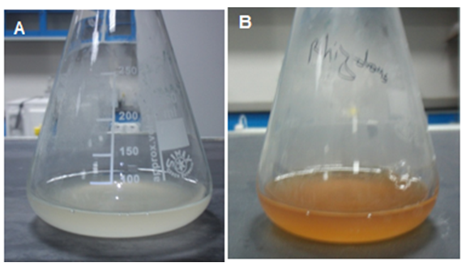
Figure 1. Visible observation of AgNPs biosynthesis. (A) ErlenMeyer flask with R. stonilifer mycellial filtrate after exposure to AgNO3 solution (1 mM) for a few minutes (no color change), and (B) ErlenMeyer flask with R. stonilifer mycellial filtrate after exposure to AgNO3 solution (1 mM) for 48 h (reddish-brown color).

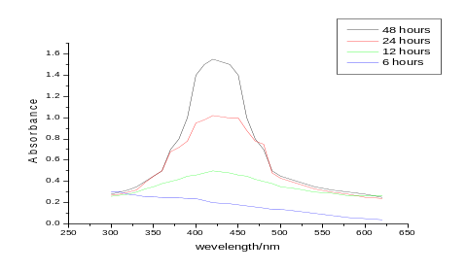
Figure 2 UV–visible absorption spectra of produced AgNPs using Rhizopus stonililifer mycelium extract at different incubation times.
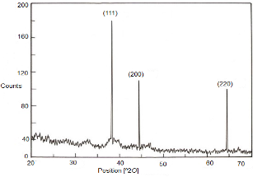  Figure 3. X-ray diffraction pattern of the AgNPs. | 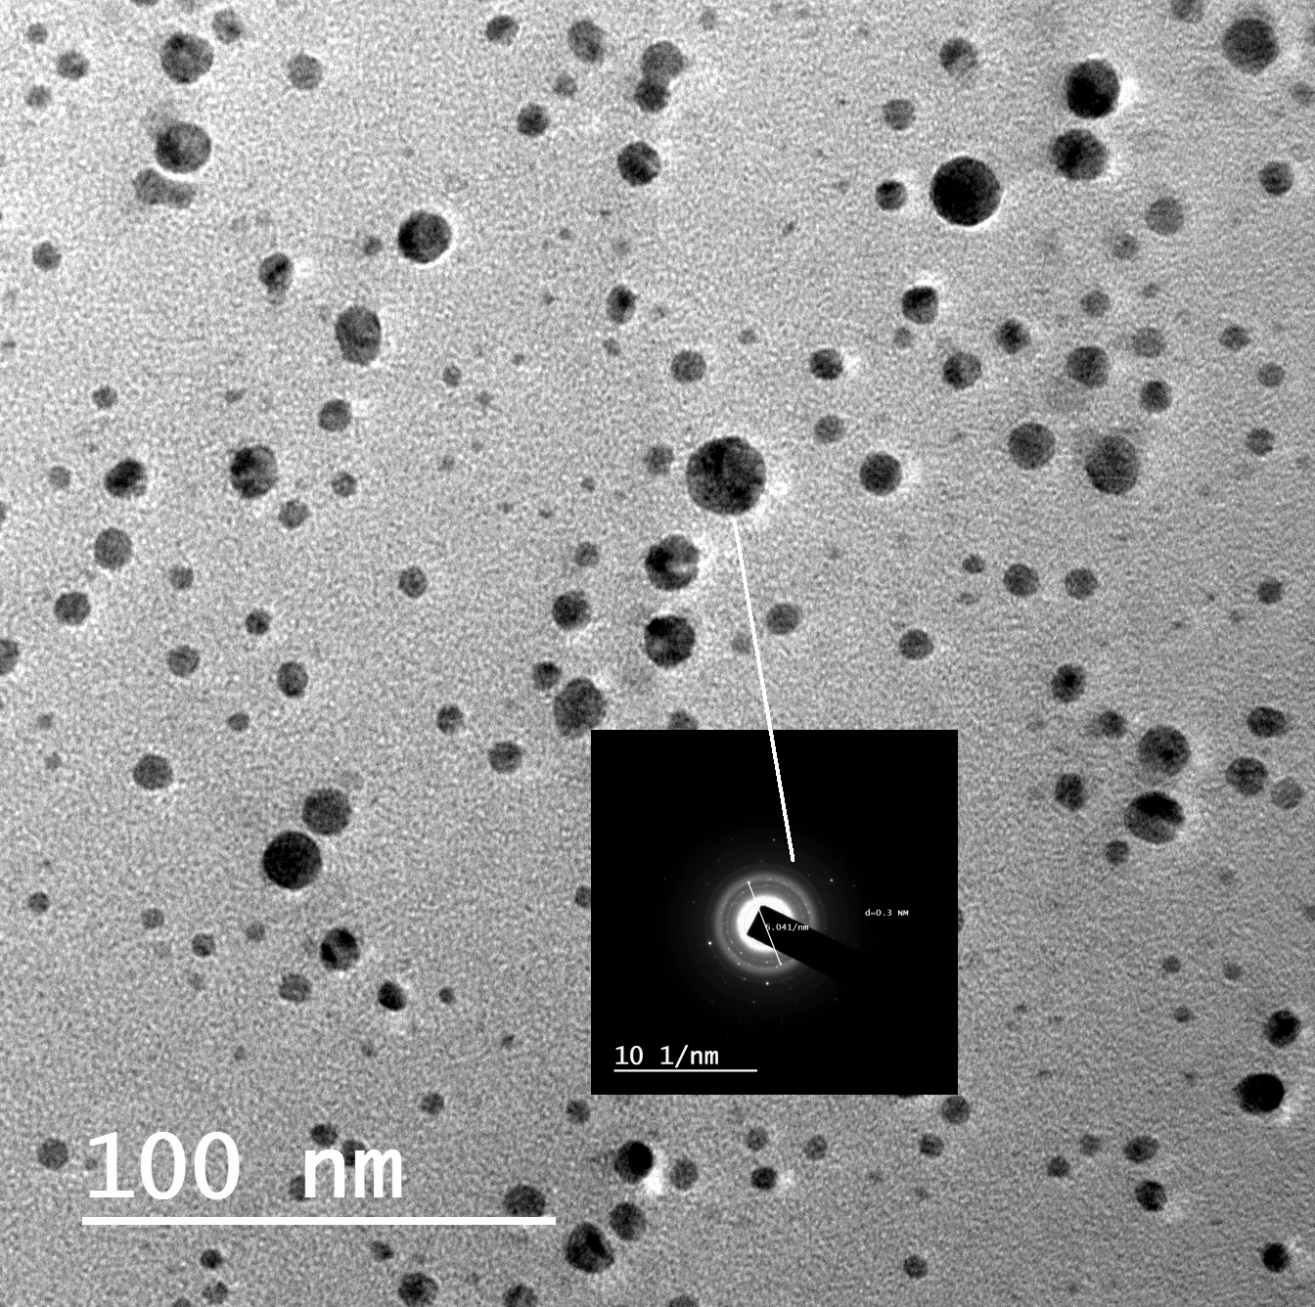  Figure 4. HRTEM pictures of the mono distributed spherical AgNPs (x=100 nm) (inserted picture: selected area electron diffraction pattern).


Biography (150 word limit)
Khalid AbdelRahim interested in antibiotics resistance problems. He is trying to help in overcoming this problem by awareness towards antibiotics usage, new drug by using nanotechnology.
Email: kabdelraheem@ksu.edu.se

