Title: Evaluation of wound healing effect of hydrogen peroxide responsive vanillyl alcohol-containing polymer in vivo
Berwin Singh S.V¹, Dileep R.T¹ and Dongwon Lee¹.
¹Department of BIN Fusion Convergence Technology,
Chonbuk National University, Baekje-daero 567, Jeonju,
Chonbuk, 561-756, Republic of Korea.

Abstract
Statement of the Problem: Vanillyl alcohol (VA), a phenolic derived bioactive principle present in Gastrodia elata is known for its antioxidant, angiogenic and anti-inflammatory properties. VA incorporated polymer poly (vanillyl alcohol-co-oxalate) (PVAX) has been evaluated for its ability in inflammatory conditions. However, no attempts have been made to explore the hydrogen peroxide (H₂O₂) scavenging capability in the excision wound. Methodology & Theoretical Orientation: In this study, we have demonstrated the use exogenous reactive oxygen species detoxifying PVAX nanoformulation mediated H₂O₂ scavenging in vivo model. The unique capability of the polyoxalate containing polymer PVAX is that in the physiological condition it retains its integrity, yet, in a pathophysiological condition like a wound site due to the higher level of H₂O_{2,} it starts to degrade and release VA at the wound. Findings: Amplex red assay of excisional wound shows that in comparision with VA, PVAX nanoformulation treated group exhibited dose-dependent reduction of H₂O₂ levels. H&E and collagen staining studies gives a clear picture of proliferation, formation of epidermal layer and fibroblast remodeling. Western blotting results have confirmed that nanoformulation scavenges excessive H₂O₂ thereby decrease protein expression of reactive oxygen species detoxifying enzyme Nrf-2 and HO-1 significantly. Conclusion & Significance: PVAX nanoformulation scavenge excessively H₂O₂ at the wound site, resulting in reduction wound size reduction accompanied by reepithelization and collagen deposition. Smart polymeric nanoparticles containing small molecules in the polymer backbone could be more versatile effective nanoparticles or scafold materials that sould transform regenerative medicine.
Image
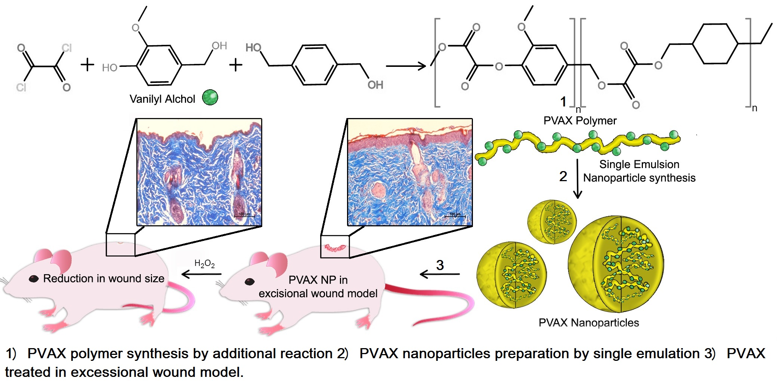

 Biography
Berwin Singh S.V is a Ph.D. student at the Chonbuk National University in South Korea working under the supervision of Prof. Dongwon Lee. He received his Masters in Bio Medical Science from the Bharathidhasan University, India, then He was trained in Bio Medical technology (M.Phil) at the Sri Chitra Instititute of Medical Science, India. His current research is focused on smart polymer synthesis-physiochemical characterization, developing and evaluation of nano-carriers in vitro and in vivo.

Email: berwinsingh1989@jbnu.ac.kr

Notes/Comments:

