Title: Chemiluminescence mediated light free photodynamic therapy
Berwin Singh S.V¹, Dileep R.T¹ and Dongwon Lee¹.
¹Department of BIN Fusion Convergence Technology,
Chonbuk National University, Baekje-daero 567, Jeonju,
Chonbuk, 561-756, Republic of Korea.

Abstract (300 word limit)
Statement of the Problem: Photodynamic therapy (PDT) is a treatment modality that employs an extrinsic photosensitive dye that could mediate a photochemical reaction involving conversion of molecular oxygen from triplet state to singlet in the presence of photons of suitable wavelength. However, penetration of the photons to the tumor interstitium is a major concern that limits PDT in majority of the biomedical application. At present, several researchers have developed “self-illuminating” PDT systems, in which photosensitizers are excited by chemiluminescent resonance energy transfer (CRET) or bioluminescent resonance energy transfer (BRET). In this work, we had demonstrated use of hydroxybenzyl alcohol-incorporating copolyoxalate peroxalate ester loaded protoporphyrin nanoselfassembly (CDNP) that could mediate chemiluminasencedynamic therapy (CDT). Methodology & Theoretical Orientation: CDNP react with HPOX to generate 1,2-dioxethanedione as an intermediate of high energy. Highly unstable 1,2-dioxethanedione rapidly decomposes and releases energy which could activate PPIX to generate ¹O₂ that ultimately kill the cancer cells: we termed this POCL dependent event as CDT. Findings: We successfully developed CDNP with average diameter of 200 nm. Morphological assessment, flow cytometric analysis, western blotting and confocal fluorescence micrographs indicates CDNP co-treatment with CA exhibited significant cytotoxicity in SW620 cells (human colorectal adenocarcinoma). Conclusion & Significance: we have validated that CDNP could induce ¹O₂ in the presence of H₂O₂ without any external photon to exert highly potent anticancer activity. This work provides for the first time, a proof of concept for laser-free PDT as a novel anticancer therapeutic system. We anticipate that CDT could provide solutions to the challenges in PDT and hold great potential as a promising cancer treatment modality.

Image
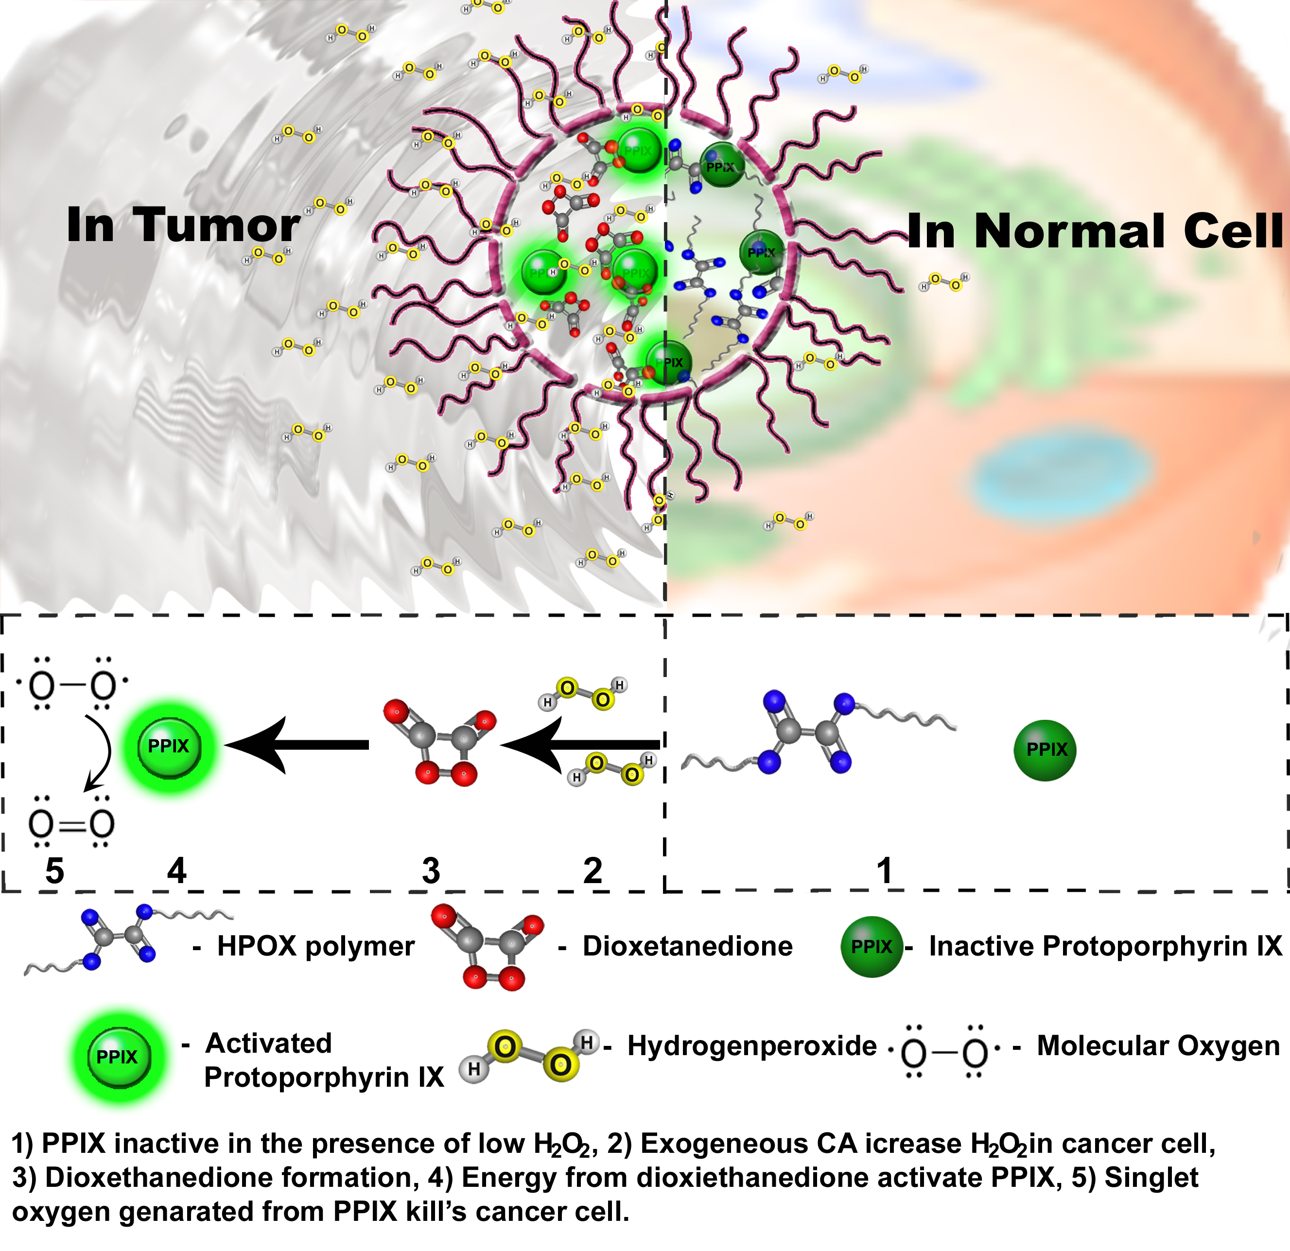

 Biography
Berwin Singh S.V is a Ph.D. student at the Chonbuk National University in South Korea working under the supervision of Prof. Dongwon Lee. He received his Masters in Bio Medical Science from the Bharathidhasan University, India, then He was trained in Bio Medical technology (M.Phil) at the Sri Chitra Instititute of Medical Science, India. His current research is focused on smart polymer synthesis-physiochemical characterization, developing and evaluation of nano-carriers in vitro and in vivo.

Email: berwinsingh1989@jbnu.ac.kr

Notes/Comments:

