Fe_{3-δ}O₄ nanoparticles inhibit Clostridium difficile spore germination: an in vitro and in vivo study
Dar-Bin Shieh, DDS, DMSc, Inst. Oral Medicine, NCKU and NCKUH, Tainan 70101, Taiwan
Pei-Jane Tsai, PhD, Dept. Med Lab Sci and Biotech, National Cheng Kung University, Tainan
Wei-Ting Lee, PhD, Inst. Basic Med Sci, NCKU and NCKUH, Tainan 70101, Taiwan


Chen-Sheng Yeh, PhD, Dept Chem, NCKU, Tianan, Taiwan
Shang-Rung Wu, PhD, Inst. Oral Medicine, NCKU and NCKUH, Tainan 70101, Taiwan

Abstract
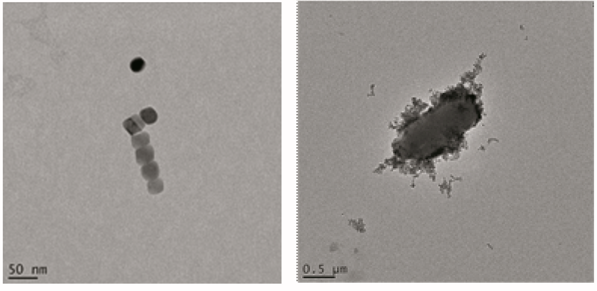
Clostridium difficile infection (CDI) has emerged to be an important cause of global healthcare-associated infection (Ananthakrishnan et al.; 2010). Resistance of CD spores to various preventive and therapeutic measures post a significant threat in CDI (Paredes-Sabja et al.; 2014). Nanomaterials have been explored for potential applications in anti-microbials with intrinsic advantages of low drug-resistance issue and high efficacy. We discovered the 22 nm octahedral Fe3-δO4 single crystal nanoparticles with a strong inhibitory effect to CD spore germination in vitro and in vivo. The nanocrytal presented excellent saturation magnetization (94 emu/g) close to the bulk due to the presence of alpha iron. Such particle showed a dose dependent inhibition of CD spores germination (62% growth inhibition at 50 μg/mL) for 20 minutes of exposure. At 500 μg/mL, the inhibition rate is close to that of sodium hypochloride. CDI animal model established in NF-κB-reporter mice using oral gavage with CD spores presented significant bowel inflammation in the MOCK compared to Fe3-δO4 nanoparticle treated group as revealed by In Vivo Imaging System. Slayer protein and a conserved hypothetical protein were released from CD spores after for 20 minutes of Fe3-δO4 nanoparticle exposure. Cryo-electron tomography clearly showed binding of the nanoparticles to CD spores’ surface followed by disruption of the spores. Pro-inflammatory cytokines including IL-1β, TNF-α, and INF-γ and inflammatory cell infiltrations were significantly suppressed after nanoparticle treatment. These results provide nano-material based strategy for CDI control and potential therapeutic mechanisms that encourage further clinical translational development.

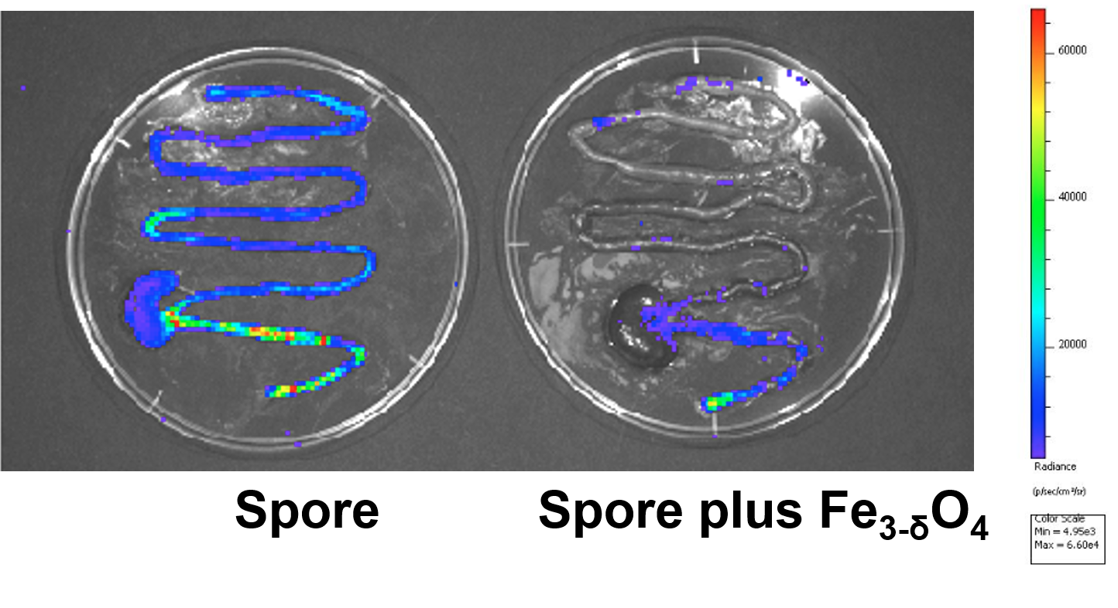
Image

Recent Publications (minimum 5)
- Ananthakrishnan AN. (2010), Clostridium difficile infection: epidemiology, risk factors and management, Nat Rev Gastroenterol Hepatol., 1, 17-26.
- Paredes-Sabja D, Shen A, Sorg JA. (2014), Clostridium difficile spore biology: sporulation, germination, and spore structural proteins, Trends Microbiol., 7, 406-416

 Biography
Professor Shieh holds the title of Distinguished Professor, Institute of Oral Medicine, College of Medicine, National Cheng Kung University (NCKU). His research Interests include nanomedicine, oral diagnosis and pathology, molecular biology, cancer biology, cryo-EM, Mitochondria. He is a recipient of many major awards, including, the Nano Elite Award, Ministry of Economics, Taiwan and the Outstanding Research Award of Taiwan National Science Council. He holds a numbers of international patents, including one on nano-carrier, complex of anticancer drug, pharmaceutical composition and complex manufacturing for treating cancer. Professor Shieh and the PI have collaborated since 2012 on the molecular and cellular basis of chemoresistance in ovarian and head- and-neck cancers, and have recently published jointly two seminal papers (PNAS and International Journal of Cancer).
Email: darbinshieh@gmail.com
Contact no: +886-910743025
Track name:

Notes/Comments:

