Synthesis, characterization and biocidal effect of copper nanoparticles


Paste your Logo here

Younus Rashid, Eng., Cairo University, Egypt
Ahmed Soliman PhD, Cairo University, Egypt
Ibrahim Ismail, PhD, Zewail City for Science and Technology, Egypt
3

Abstract (300 word limit)
A chemical reduction method was used to produce highly stable and dispersed Copper nanoparticles. In this method, copper salt (Copper (II) chloride dihydrate; CuCl2.2H2O and Copper (II) sulfate pentahydrate; CuSO4.5H2O) were used as precursor. L-ascorbic acid was used as reducing and capping agent. The effect of reaction time and molar ratios of L-ascorbic acid to copper salt on the size of copper nanoparticles were studied. The particle size and morphology of copper nanoparticles were measured by Dynamic Light Scattering (DLS) and Transmission Electron Microscopy (TEM). The results show that increasing time of reaction and increasing the molar ratio of L-ascorbic acid to copper salt decrease the size of copper nanoparticles. The size of copper nanoparticles was found less than 10 nm and spherical in shape. The copper nanoparticles colloidal solution was kept in ambient conditions for more than three months but no change was observed. The use of L-ascorbic acid has the advantage of non-toxic, low cost and environmental friendly production process. Antimicrobial tests of copper nanoparticles were carried out on different types of bacteria (Gram-negative bacteria and Gram-positive bacteria) and fungi. The prepared aqueous solutions of copper nanoparticles were diluted to different concentrations and 10 μl of each dilution was spotted on the overlay of each bacterial culture by impregnating the as-synthesized copper nanoparticles using micropipette on paper discs. The minimum inhibitory concentration (MIC) is defined as the lowest concentration of each sample at which visible inhibition of bacterial growth was induced and zone of inhibition was measured after 24 h of incubation. After completion of the MIC assay, the minimum bactericidal concentration (MBC) was also assessed. The results showed that the copper nanoparticles exhibited antimicrobial activity and that the lower the particles, the higher the biocidal effect on both bacteria and fungi.
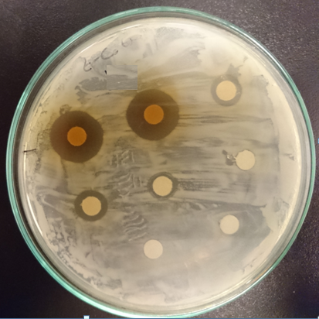  a  8  7  6  5  4  3  2  1 | 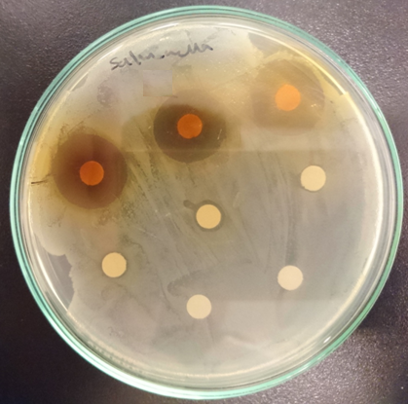  b  8  7  6  5  4  2  1
Antimicrobial activity of copper nanoparticles on bacterial Strains (a) E-coli, (b) Salmonella typhimurium with various concentrations of copper nanoparticles colloidal solution, (1) 100%, (2) 60%, (3) 40%, (4) 20%, (5) 10%, (6) 5%, (7) 2% and (8) 1%.
Image

Recent Publications (minimum 5)
- AZ Hafez, A Soliman, KA El-Metwally, IM Ismail (2017), Design analysis factors and specifications of solar dish technologies for different systems and applications, Renewable and Sustainable Energy Reviews 67:1019-1036.
- Ahmed Z Hafez, A. Soliman, K. A El-Metwally, I. M Ismail, (2017) Tilt and Azimuth Angles in Solar Energy Applications A review, Renewable & Sustainable Energy Reviews, 77: 147-168.
- O.A. Abdel Moamen , H.A. Ibrahim, N. Abdelmonem, I.M. Ismail, (2016) Thermodynamic analysis for the sorptive removal of cesium and strontium ions onto synthesized magnetic nano zeolite, Microporous & Mesoporous Materials 223: 187–195.
- O.A. Abdel Moamen, I.M. Ismail, N.M. Abdel Monem, R.O. Abdel Rahman (2015) Factorial design analysis for optimizing the removal of cesium and strontium ions on synthetic nano-sized zeolite, Journal of the Taiwan Institute of Chemical Engineers 55: 133–144.
- Ibrahim M. Ismail, Hesham Mousa, Hassan Baioumy, Hisham F. Aly (2015) Rare earth elements and origin of the fluorite mineralization from the Nuba Mountains, Sudan, Journal of African Earth Sciences (112) A: 276–286.

 Biography (150 word limit)
Ibrahim Ismail has his PhD from Tokyo Institute of Technology in 1999. He worked on material science and their applications in environment and energy fields in Tokyo Institute of Technology, Institute of Research and Innovation, Cairo University and Zewail City for Science and Technology. He published more than 70 articles, one book chapter and submitted one patent.
Email: ibrahim.ismail@zewailcity.edu.eg
Contact no: +201000401077
Track name:

Notes/Comments:

