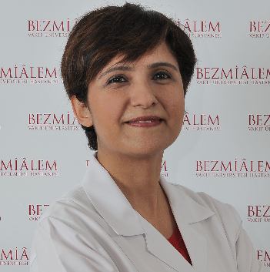


Targeted Cancer Therapy Using Nano-Micelles Made of Natural Bio-Compatible Materials
Fatemeh Bahadori

Bezmialem Vakif University, Faculty of Pharmacy, 34093, Fatih Istanbul-Turkey

During the last decades delivering biologically active molecules using nano materials (nano drug delivery systems; NDDS), have gained increasing attention in a wide range of applications from sensing and imaging to treatment of disease. The superior properties of nano materials provide numerous feasibilities such as controlling the release of drugs, targeting and imaging of cancer tumors, increasing serum half-life of bioactive molecules, passing over Blood Brain Barrier etc. Targeting cancer tumor is the area, which has attracted the greatest interest. By targeting cancer side, it is possible to obtain a better efficacy with a lower dose of the chemotherapeutic agent. However, this would be possible only if the material used in synthesis of nano-drug delivery system is both biocompatible and biodegradable.
Nano-micelles made of amphiphilic materials are superior in all above-mentioned properties compared to other NDDS. They simultaneously form in aqueous media and this provides easy production especially in industrial scale. However, their application has been associated with some stability problems and not all amphiphilic materials are non-toxic. According to our studies, natural materials show the best toxicity profile in vivo and it is possible to enhance their stability using some other natural products as well. In this presentation, we will discuss synthesis and in vitro and in vivo evaluation of micelles made of organic natural materials such as phospholipids, chitosan and glycolipids. We also will compare their cytotoxicity and genotoxicity compared to synthetic polymers.

Biography

Fatemeh Bahadori has completed her PhD at Istanbul Technical University, Department of Organic Chemistry. She has had a year of assistant ship at University of Ilinois at Chicago, The U.S.A during her course of Ph.D. studies. She is Assistant Professor at Faculty of Pharmacy, Department of Pharmaceutical Biotechnology, Bezmialem Vakif University, Istanbul-Turkey since 2014. She has published more than 15 papers in reputed journals, 2 chapters in international books and has edited a special issue with special emphasis on Nano Drug Delivery systems in an internationally indexed journal.

