SPIRIT WORD TRADING TRAVEL & TOURISM

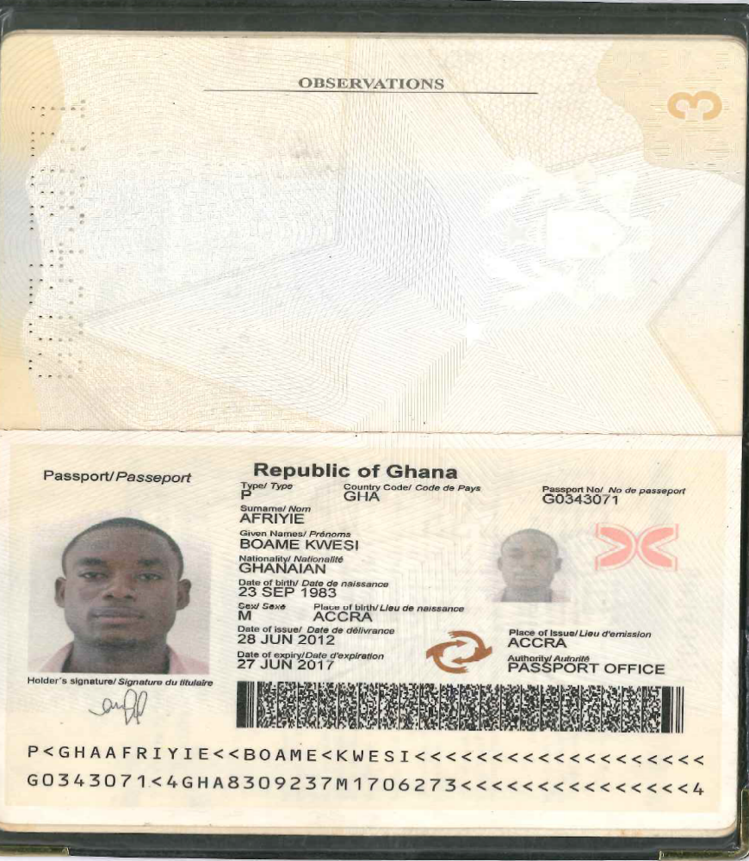
S.W.T.T.T.

Address:
23 Summer Street
Ottosdal Township
2610
North West Province. South Africa
Cell: +27 83 711 6657
: +27 73 232 9572
Fax: +27 18 571 0291

Abstract on Nano Technology

Title: Nano Technology and self replication system

Name: Mr Afriyie Boame Kwesi

Spirit Word Trading Travel & Tourism South Africa

A basic definition of Nano Technology is simply the study on how we manipulate and manufacture of extremely minute machines. These machines are so small to the point of manipulating the atoms themselves to form materials. By this Nano technology we can make a new medical capabilities that can heal and cure in cases that are now viewed as utterly hopelessly. The properties of Manufactured products depends on how those atoms are arranged like if we know about exactly know many dopant atoms are single transistor and exactly where each induvial dopant atoms is located and placed. Roughly the right number roughly the right places we make a working transistor.

Another improvement in Nano technology is self replication system, which is originated from biological system and surround us are likely to seriously mislead us about the properties and characteristics of artificial self replicating system of non biological products like diamond under programmatic control are likely to be more brittle and less adaptable in their response to change in their environment than biological systems. Thus the progress of technology around the world has already given us more precise, less expensive manufacturing technology that can make an unprecedented diversity of new products.

Biography

Afriyie Boame Kwesi has completed his masters degree in the year 2013 in Ghana at highly recognised University in Ghana known as Kwame Nkrumah University Of Science And Technology. He has a degree in BSC Masters Mechanical Engineering , he is a Christian with one child. He resides in the republic of South Africa he is the Chief Director Of Broadbent Motors, he is also the Deputy Director of Spirit Word Trading Travel & Tourism.

Date of Birth:23 September 1983

