Nanoparticle-Infused-Biodegradable-Microneedle Technology for Skin Cancer Treatment

Rachel Sullyª, Adrian Podoleanu^{b}, Erika Loizidou^{c} and Vladimir Gubalaª
ª Medway School of Pharmacy, University of Kent
^{b} School of Physical Sciences, University of Kent
^{c} Department of Natural Sciences, Middlesex University

Abstract (300 word limit)
Melanoma affects over 200,000 people in the UK alone, with survival rates of around 86%. Over the last decade melanoma skin cancer incidence rates for males and females combined increased by 50%. The current main treatments of skin-cancer are surgery to remove the affected area, as well as chemotherapy/radiotherapy and immunotherapy to kill the tumour cells. However, around 33,000 people still die within the first five years after diagnosis and treatment. The purpose of this study is to explore the possible development of a new nanomedicine technology that uses anti-cancer drug doped-nanoparticles (Figure a) to kill tumour cells. Nanoparticles¹ are held in solution which can lead to aggregation, making them undesirable as drug delivery systems. The proposed solution to this is to formulate the nanoparticles into a microneedle array made from methylcellulose gels². In solution, nanoparticles are subject to Brownian motion and tend to aggregate (Figure b), however when formulated into a gel-like microneedle patch (Figure c), the aggregation is prevented. Methylcellulose is used specifically because it is biodegradable and will degrade by enzymatic reaction in the epidermis, thus releasing nanoparticles into the microenvironment. Microneedle patches have been used widely in cosmetics³, as well as for insulin delivery⁴. To observe the disintegration of microneedles and the release of the drug-doped nanoparticles in the skin⁵, optical coherence tomography (OCT) will be used⁶. OCT is a non-invasive imaging technique used to take cross-section images of tissues. Although OCT has been used widely in ophthalmology, the use of OCT to image the skin is still relatively new⁷. We will also present a detailed synthesis of silica nanoparticles, used as the nanocarriers, as well as their characterization by Dynamic Light Scattering, Fluorescence Spectroscopy, Transmission Electron Microscopy and Scanning Electron Microscopy.

Image
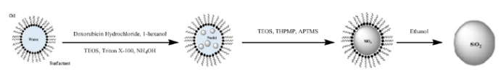
a

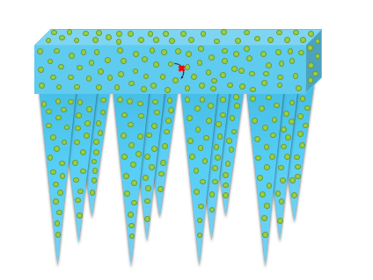
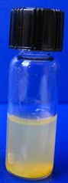
b c

Figure a – Schematic diagram of the microemulsion method used for synthesis of anti-cancer drug-doped nanoparticles
Figure b – Photo of aggregated nanoparticles
Figure c – Diagram of nanoparticles in microneedle array

Recent Publications (minimum 5)
1 C. J. Moore, H. Montón, R. O’Kennedy, D. E. Williams, C. Nogués, C. Crean and V. Gubala, J. Mater. Chem. B, , DOI:10.1039/c4tb01915f.
2 E. Z. Loizidou, N. A. Williams, D. A. Barrow, M. J. Eaton, J. McCrory, S. L. Evans and C. J. Allender, Eur. J. Pharm. Biopharm., 2015, 89, 224–231.
3 J. D. Kim and D. H. Jeong, Drug Deliv., 2018, 24–29.
4 C.-H. Chen, V. Shyu and C.-T. Chen, Materials (Basel)., 2018, 11, 1625.
5 R. F. Donnelly, M. J. Garland, D. I. J. Morrow, K. Migalska, T. R. R. Singh, R. Majithiya and A. D. Woolfson, J. Control. Release, 2010, 147, 333–341.
6 S. Adabi, A. Fotouhi, Q. Xu, S. Daveluy, D. Mehregan, A. Podoleanu and M. Nasiriavanaki, Ski. Res. Technol., 2018, 24, 265–273.
7 M. Mogensen, S. Bojesen, N. M. Israelsen, M. Maria, M. Jensen, A. Podoleanu, O. Bang and M. Haedersdal, J. Biophotonics, , DOI:10.1002/jbio.201700348.

