Nanotechnology based delivery systems for vaccines. 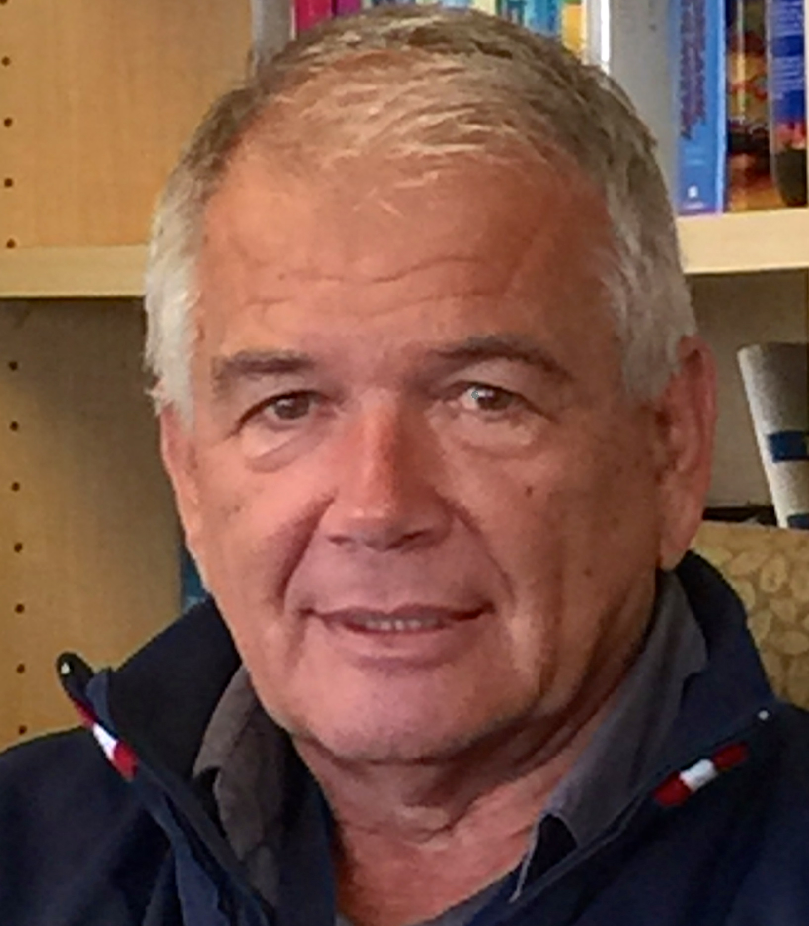
Istvan Toth
¹The University of Queensland, School of Chemistry and Molecular Biosciences, Brisbane QLD 4072, Australia; ²The University of Queensland, School of Pharmacy, St. Lucia, Qld 4072, Australia.
Email: i.toth@uq.edu.au
Abstract
We have developed an oral vaccine delivery system to prevent infection by Gropp A streptococcus (GAS) by encapsulating lipid core peptide (LCP) antigens into the liposomes. We synthesised the LCP construct by attaching C-16 lipoamino acid (Toll-like receptor 2 agonist) to J-14 (B-cell epitope derived from GAS M-protein) and P25 (CD4+ T helper cell epitope). Blank liposomes were formulated and optimized for charge and lipid content using a thin film formation method. Optimized liposomes were coated with positively charged trimethyl chitosan (TMC) then negatively charged sodium alginate in a layer-by-layer approach. These formulations were subsequently characterized by dynamic light scattering (DLS) and transmission electron microscopy (TEM). Optimized formulations were further investigated for their efficiency of uptake by intestinal immune cells and ability to induce mucosal IgA and systemic IgG responses.
Fertility is controlled by decreasing the level of circulating Gonadotropin-Releasing Hormone (GnRH) or stimulating the down-regulation of GnRH receptors on gonadotrope cells. Using two independent approaches we regulated the action of GnRH on gonadotropic cells, thereby controlling fertility in mice and ram models. The first approach was to develop super-agonist by modifying GnRH with lipids and sugars, the second approach was immunocastration.
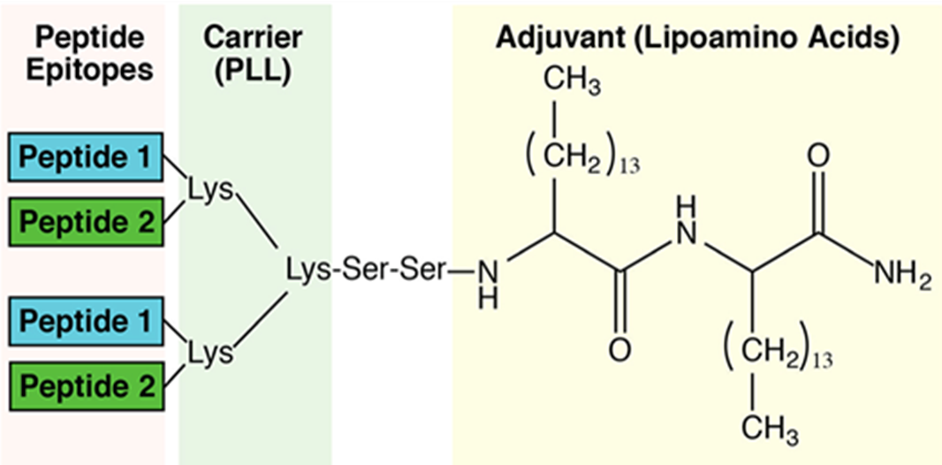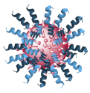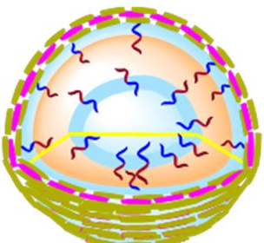

Professor Istvan TOTH is Chair in Biological Chemistry & Professor of Pharmacy, The University of Queensland (UQ), Brisbane, Australia; Affiliated Professorial Research Fellow and Group Leader, Institute of Molecular Biosciences, UQ. He graduated with a degree in Chemical Engineering from the Technical University, Budapest, Hungary in 1969 and was awarded his PhD in 1972 for research in Alkaloid Chemistry. In 1994 he was awarded a DSc for his work on drug delivery. He is an elected RACI Fellow, Fellow of the Queensland Academy of Arts and Sciences and Fellow (External) of the Hungarian Academy of Sciences. He has over 400 peer-reviewed publications (>500 citations/year since 2012), 44 patents, and a strong record in research commercialization.

