Optimization of Nickel Alloy 625 thick deposits by cold spray using KSS Software.
Martha Flores
H. Assadi
Research and Development Cummins Center, San Luis Potosí, México
martha.k.flores@cummins.com

Abstract: Nickel Alloy 625 was selected for the Cold Spray High Pressure process as attractive option due compatibility with cast iron materials and having strengthen alloyed matrix by elements as molybdenum. By other hand, R&D Cummins Center has been exploring and developing Thermal Spray Process to repair damaged zones and remanufacture parts having fully confidence on the final performance. Therefore, one of the main developments to be optimized is Cold Spray. The present document shows the steps developed for a Cold Spray High Pressure (CSHP) application using Nickel Alloy 625 over a gray cast iron flat substrate. Nickel Alloy 625 powder was cold sprayed under design of experiments considering only the pressure gas and spray temperature as key variables to determine the influence on the quality of thick deposits. The coatings developed was tested using the bond strength as ASTM C-633 and deposit efficiency was measured during metallography analysis. Results concluded a positive correlation between the simulations done and results presented in terms of deposit efficiency.

- Introduction

Nickel Alloy 625 it will be used for its high strength and excellent machinability including for joining process and outstanding corrosion resistance. The main alloy elements for this alloy are moly and Niobium helping to form precipitates and permitting have a strength into the nickel chromium matrix. Its ability to resist high stress and wide range of temperatures are the perfect elements to be elected in this experiment where cast iron is one of the main substrates to be repaired and be exposed to high temperatures also.

R&D Center has a technical interest in developing Nickel Alloy 625 coatings on gray iron substrates as ASTM A48 thru Cold Spray because can establish specific precedents on applications for surface technology based on similar conditions as current components manufactured for internal combustion engine and a solid-state additive manufacturing process, thus, a clear understanding of the scope of cold spray technology, advantages, and restrictions could define successful process based on the technical and economic feasibility.

Cold spraying (CS) is a solid-state material deposition technique, where micron-sized particles of a powder bond to a substrate as a
result of high-velocity impact and the associated severe plastic deformation. Acceleration of particles to high velocities is obtained via expansion of a pressurized and (ironically) ‘hot’ gas through a diverging-converging nozzle. Despite heating the process gas e which is to provide higher acceleration of the gas and to facilitate particle deformation through thermal softening e the feedstock remains in the solid state throughout the entire process; hence the name ‘cold’ spraying. CS is used for coating and repair. It is also used for additive manufacturing (AM) at relatively high deposition rates as compared to the methods based on selective laser or electron beam melting. The main advantage of CS is that it alleviates the problems associated with high temperature processing of materials, such as oxidation and unfavorable structural changes.
The aim of the present paper is present simulation results using KSS and physical results obtained from CS operational process, understanding more about the confidence for having available this powerful tool and considerations obtained from the process to determine the best options to use the powder selected and the performance of the coating. [1]

Abbreviations y Symbols
AM Additive manufacturing
ASI Adiabatic shear instability
CS Cold Spraying
CSHP Cold Spray High Pressure
DE Deposition efficiency
SEM Scanning Electron Microscopy
ASTM American Standard Test of Materials
PSD Particle Size Distribution
DoE Design of Experiment

Symbols
cp heat capacity of particle, J kg_1 C_1
d nozzle diameter, m
dp particle diameter, m
f powder feed rate, kg s_1
F* force to compress particle to height of dp/2, N
l nozzle length (supersonic part), m
lpre prechamber length, m
pgas process gas stagnation pressure, Pa
r nozzle expansion ratio, 1
s standoff distance, m
T temperature, C
Tgas process gas stagnation temperature, C
Tm melting temperature, C
Tmin minimum temperature, C
Tmax maximum temperature, C
Tp particle temperature, C
Tref reference temperature, C
Tsub substrate temperature, C
vc velocity of contact point in explosive welding, m s_1
vcr critical particle impact velocity for bonding, m s_1
vgun traverse speed of gun, m s_1
vp particle impact velocity, m s_1
η normalized particle impact velocity (vp/vcr), 1
ρ density of particle, kg m_3
σ flow stress, Pa
σ_{UTS} ultimate tensile strength of particle, Pa
ϖ spraying angle, 1
t time, s

- Principle and setup
The main technical objective in CS is to ensure that the particles of the feedstock powder impinge the substrate at or beyond a critical velocity. This is achieved by means of a pressurized and preheated process gas, typically nitrogen, in some cases helium e that expands through a (converging/diverging) de Laval nozzle, reaching supersonic velocities [13,27]. Fig. 1 shows an overview of a high-pressure CS system. I. For our purpose, Nitrogen gas is used as source to conduct the particle to substrate.

Critical velocity is named by Eta symbol (η) and it depends on several factors, such as particle size, material density, particle velocity and so on. This variable is very important for getting the best results on the deposition efficiency and bond strength.

For convenience, design of experiment is structured only with essential variables and non-essential variables were fixed. Essential variables are temperature and pressure. Non-essential variables defined are surface roughness, thermomechanical metal powder and substrate properties.

The main properties of the coating have been shown to be a unique function of the relationship of the velocity of the particles to the critical velocity, here called (η) [7]. Many previous studies have aimed the understanding of the adherence mechanism, evaluate the critical velocity and, therefore, for different materials and process conditions [4,7-18]. So far, none of the suggested formulas for the critical velocity in η incorporate substrate properties. However, the technology continues to advance in developments that allow modeling the deformation properties of the particle during its flight and also modeling until it reaches the surface of interest, as well as the influence of process parameters such as gas pressure, particle feeding speed, among others. Through a separate gas line, a fluidized powder feedstock is fed into or upstream of the nozzle. The gas stream accelerates the powder thu the gas stream where finally the particle sprayed impacts the substrate at high velocities. Depending of process gas and the spray parameters, impact velocities are between 200 and 1200 m/s.

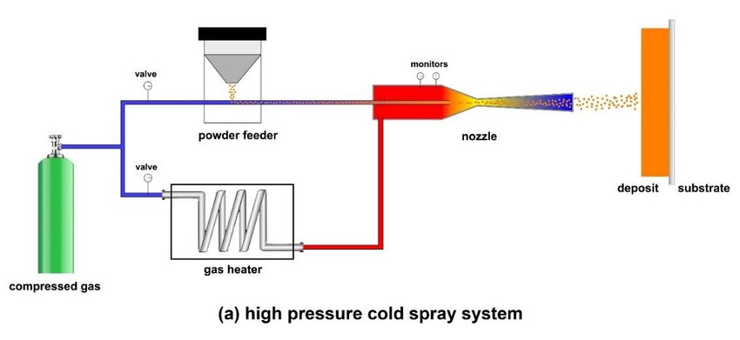
Fig. 1 High-pressure cold spray system: (a) schematics of the main components of the original system

- Deposition mechanism

3.1 Simulation variables definition.

The gas pressure and temperature range used for this DoE is defined by equipment capabilities used. Table 1 indicate the set defined per testing.

Table 1. DoE defined to Nickel Alloy 625 application on cast iron ASTMA48.
 |  | Pressure
Temperature C |  | Minimum pressure  (35 bar) | Maximum Pressure  (50 bar)
Temperature C | Tmin (900C) | Set 1 | Set 2
Temperature C | Tmax (1100C) | Set 3 | Set 4

The simulation of the spraying process will be carried out using KSS software. The 5 variables to be considered as input will be listed below.

1.- Particle size distribution (PSD) of the Nickel Alloy 625. The results obtained shows a range between 20 μm up to 50 μm.

2.- Gas temperature. The temperature ranges are considered from 900C to 1100C

3.- Gas pressure. The working pressure ranges are 35 to 50 bar.

4.- Nozzle used. According to the equipment used, the nozzle is OUT 1.

5.- Gas type. The gas used in the simulation is Nitrogen.

3.2 Calculation of the Parameter Selection Map (PSM)

Calculation of cold spray parameters through the PSM module of the KSS software is performed
initially for the stainless steel, for which material and powder characteristics are provided.
The PSM provides a first approximation of the particle velocity, particle temperature, the critical
velocity for bonding, and the velocity ratio η = vp/vcr, which is used as a measure of quality of the cold-sprayed deposit. As rule of thumb, η = 1.5 is considered as a benchmark to secure a sufficiently high coating quality. Smaller values may be associated with higher levels of porosity,
lower deposition efficiency and lower cohesive strengths. Larger values may result in marginal
increase in the quality at the price of a higher gas consumption and hence higher costs.

3.3 Operational variables definition.

CS process variables require a previous consideration to prepare the samples before to be sprayed, the input considered are:

- Pre-machining: flat cast iron ASTM A48 substrate, roughness > 8 μm.
- Surface preparation. Media used Alumina
- Nitrogen purity: 99.999%
- Nickel Alloy 625 apparent density: 4.7 g / cm3
- Powder feed rate:1.8 kg / h
- Area to be sprayed: 110W x 610L (mm)
- Programmed thickness: 1mm (0. 0393 in)
  - Thickness evaluation. Metallographic analysis must be carried out to determine the thickness obtained vs. the programmed according to the simulation.

- Simulation input parameters

The input parameters for PSM calculations are as shows fig. 2.
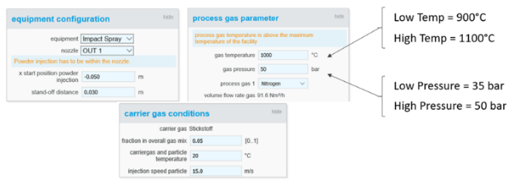

Fig. 2 PSM input: schematics of the main inputs considered for DoE.

- Results
5.1 PSM results
The results include velocity and temperature of particle and the deposition efficiency.

Table 2. PSM results considering inputs from DoE.
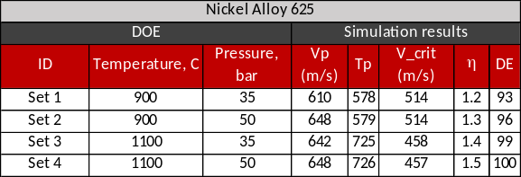

5.2 Operational results

Results measured coming from operational process are summarized in table 3 and the micrography per set shows the measurements done.

Tabla 3. Summary results obtained from operational CS process.
 | Thickness (mm)
Set 1 | 1.004
Set 2 | 1.126
Set 3 | 0.712
Set 4 | 0.111

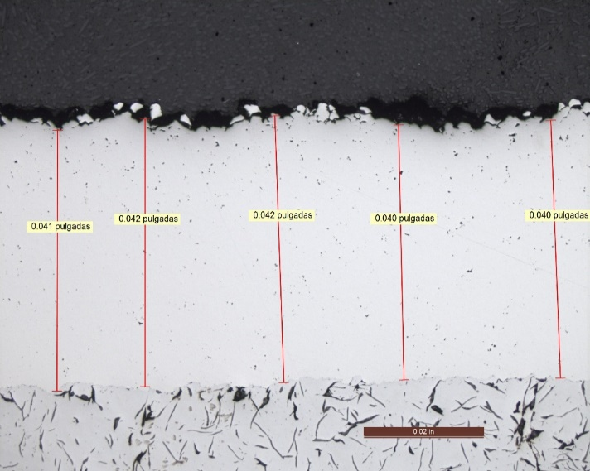
Fig 3. Optical micrograph of cross section of Nickel Alloy 625 on cast iron substrate set 1 coating with thickness measured at 50X sprayed at 900 C and 35 bars
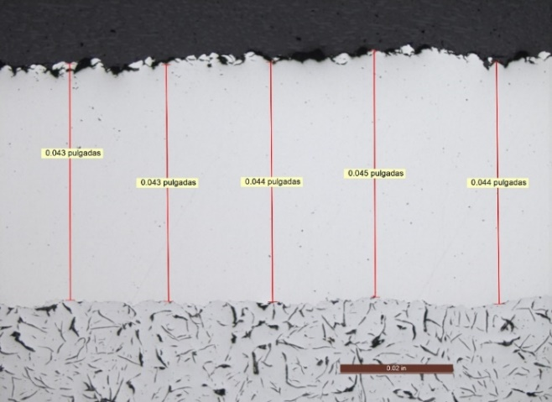
Fig 4. Optical micrograph of cross section of Nickel Alloy 625 on cast iron substrate set 2 coating with thickness measured at 50X sprayed at 900 C and 50 bars.
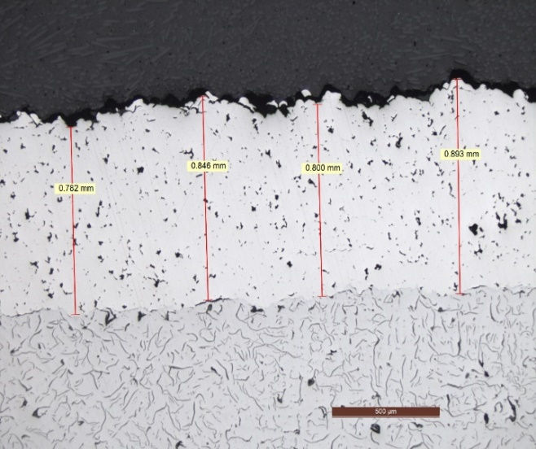
Fig 5. Optical micrograph of cross section of Nickel Alloy 625 on cast iron substrate set 3 coating with thickness measured at 50X sprayed at 1100 C and 35 bars.
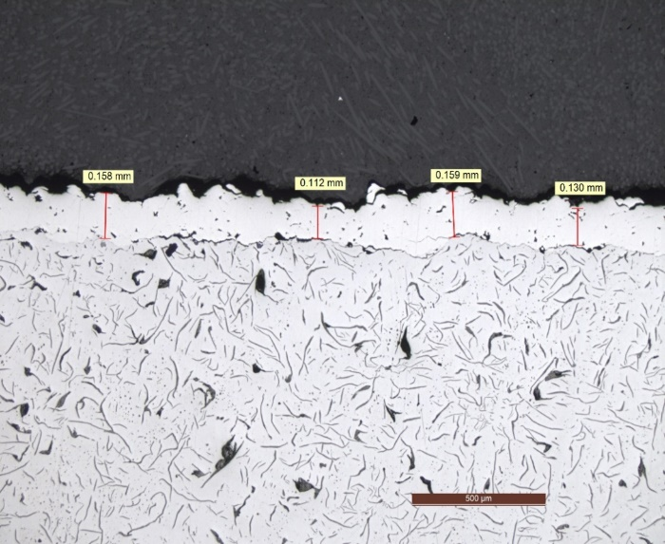
Fig 5. Optical micrograph of cross section of Nickel Alloy 625 on cast iron substrate set 4 coating with thickness measured at 50X sprayed at 1100 C and 50 bars.

5.3 Bond Strength results

- Additional remarks.
The role of powder morphology.

For HP cold spray, spherical powder morphology is desired, because it leads to be better bonding
between the particle and the substrate upon impact. On the other hand, irregular particles may accelerate better because of a higher drag force. However, acceleration to high velocity in HP cold spray is normally not considered as a key problem. Therefore, an irregular powder morphology is unlikely to bring about additional merits in HP cold spray and hence, commonly
undesirable.

- Summary

Nickel alloy 625 has been considered as an excellent option to coating surfaces offering excellent results having low porosity, excellent strength and low oxidation. Results presented from operational process shows good deposition efficiency for set 1 and set 2, however set 3 & 4 were deficient and micrography confirms decrement behavior and the low deposition using high temperatures and high pressures, main reason detected is the power required vs used to reach essential variables during the usage of the maximum limits of the equipment that usually is not highly recommended by the suppliers giving us additional considerations for next developments. For bonding strength, we can observe a good performance in bond strength testing even if the efficiency deposition were not good because as mentioned before, the morphology of the powder used plays a good role here and the principle of cold spray on preserve the mechanical properties of the powder. We can conclude the simulations can offer us an excellent approach for getting good quality of our coatings taking into account both considerations, operational and powder source.

References:
[1] A. Papyrin, Cold Spray Technology, ﬁrst ed., Elsevier, Amsterdam, 2007.
[2] H. Assadi, F. Gärtner, T. Stoltenhoff, H. Kreye, Bonding mechanism in cold gas spraying, Acta Mater 51 (2003) 4379e4394.
[3] T. Hussain, D.G. McCartney, P.H. Shipway, Impact phenomena in cold-spraying of titanium onto various ferrous alloys, Surf. Coat. Technol. 205 (2011) 5021e5027.
[4] G. Bae, S. Kumar, S. Yoon, K. Kang, H. Na, H. Kim, C. Lee, Bonding features and associated mechanisms in kinetic sprayed titanium coatings, Acta Mater 57 (2009) 5654e5666.
[5] M. Grujicic, C.L. Zhao, W.S. DeRosset, D. Helfritch, Adiabatic shear instability-based mechanism for particles/substrate bonding in the cold-gas dynamic-spray process, Mater Des. 25 (2004) 681e688.
[6] T. Schmidt, F. Gärtner, H. Assadi, H. Kreye, Development of a generalized parameter window for cold spray deposition, Acta Mater 54 (2006) 729e742.
[7] H. Assadi, T. Schmidt, H. Richter, J.O. Kliemann, K. Binder, F. Gärtner, T. Klassen, H. Kreye, On Parameter selection in cold spraying, J. Therm. Spray. Technol. 20 (2011) 1161e1176.
[8] G. Bae, Y. Xiong, S. Kumar, K. Kang, C. Lee, General aspects of interface bonding in kinetic sprayed coatings, Acta Mater 56 (2008) 4858e4868.
[9] F.F. Wang, W.Y. Li, M. Yu, H.L. Liao, Prediction of critical velocity during cold spraying based on a coupled thermomechanical Eulerian model, J. Therm. Spray. Technol. 23 (2014) 60e67.
[10] H. Assadi, T. Schmidt, F. Gärtner, H. Kreye, Characteristics of particle bonding and material deposition in cold spraying, in: M. Jahazi, M. Elboujdaïni, P. Patnaik (Eds.), Proc. of Aerospace Materials and Manufacturing Processes: Emerging Materials, Processes, and Repair Techniques, Canada, Montreal, October 2006, pp. 49e59. COM 2006, 1e4.
[11] X.K. Suo, X.P. Guo, W.Y. Li, M.P. Planche, H.L. Liao, Investigation of deposition behavior of cold-sprayed magnesium coating, J. Therm. Spray. Technol. 21 (2012) 831e837.
[12] R. Ghelichi, S. Bagherifard, M. Guagliano, M. Verani, Numerical simulation of cold spray coating, Surf. Coat. Technol. 205 (2011) 5294e5301.
[13] F. Raletz, M. Vardelle, G. Ezo, Critical particle velocity under cold spray conditions, Surf. Coat. Technol. 201 (2006) 1942e1947.
[14] M. Grujicic, C.L. Zhao, C. Tong, W.S. DeRosset, D. Helfritch, Analysis of the impact velocity of powder particles in the cold-gas dynamic-spray process, Mater Sci. Eng. A 368 (2004) 222e230.
[15] D. Goldbaum, J.M. Shockley, R.R. Chromik, A. Rezaeian, S. Yue, J.-G. Legoux, E. Irissou, The effect of deposition conditions on adhesion strength of Ti and Ti6Al4V cold spray splats, J. Therm. Spray. Technol. 21 (2012) 288e303.
[16] R.C. Dykhuizen, M.F. Smith, Gas dynamic principles of cold spray, J. Therm. Spray. Technol. 7 (1998) 205e212.
[17] D.L. Gilmore, R.C. Dykhuizen, R.A. Neiser, T.J. Roemer, M.F. Smith, Particle velocity and deposition efﬁciency in the cold spray process, J. Therm. Spray. Technol. 8 (1999) 576e582.
[18] R.C. Dykhuizen, M.F. Smith, D.L. Gilmore, R.A. Neiser, X. Jiang, S. Sampath, Impact of high velocity cold spray particles, J. Therm. Spray. Technol. 8 (1999) 559e564.
[19] H. Kreye, T. Stoltenhoff, Cold spraying e a study of process and coating characteristics, in: proceedings of the International Thermal Spray Conference, 2000.
[20] T. Xiong, J. Wu, H.Z. Jin, M. Li, X. Liu, T.F. Li, Introduction to a new technology - cold gas dynamic spray, Corros. Sci. Prot. Technol. 13 (2001) 267e269.
[21] V.F. Kosarev, S.V. Klinkov, A.P. Alkhimov, A.N. Papyrin, On some aspects of gas dynamics of the cold spray process, J. Therm. Spray Technol. 12 (2003) 265e281.
[22] F. G€artner, T. Schmidt, T. Stoltenhoff, H. Kreye, Recent developments and potential applications of cold spraying, Adv. Eng. Mater. 8 (2006) 611e618.
[23] V.K. Champagne, The Cold Spray Materials Deposition Process: Fundamentals and Applications, Elsevier, 2007
[24] Q. Wang, M. Zhang, Review on recent research and development of cold spray technologies, Key Eng. Mater. 533 (2013) 1e52.
[25] K. Lee, M. Lee, J. Yu, H. Kim, Effect of powder preheating temperature on the properties of titanium coating layers manufactured by kinetic spraying, Mater. Trans. 55 (2014) 622e628.

