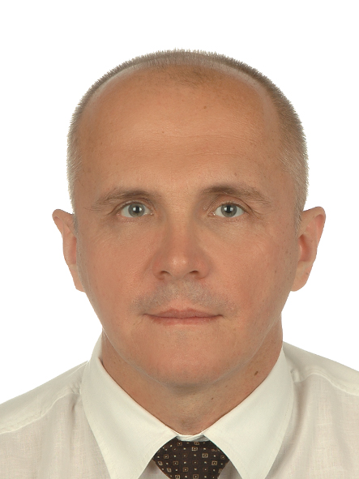

Analysis of the method and conditions impact for the activated carbons preparation on the microporous structure formation

Mirosław Kwiatkowski
AGH University of Science and Technology, Faculty of Energy and Fuels
al. A. Mickiewicza 30, 30-059 Krakow, Poland

The aims of this work were to carry out a comprehensive analysis of the influence of the method and conditions of producing active carbons on the formation of their porous structure and to explain the mechanisms of physicochemical processes occurring during individual stages of the preparation, i.e. carbonisation and activation and their influence on the adsorption properties of the materials obtained, as well as to develop a method of prediction of the properties of active carbons obtained using a given method and under specific conditions of the preparation. The results of the presented work, including knowledge of carbonisation and activation mechanisms, will enable the selection of an appropriate manufacturing method and appropriate conditions to obtain active carbons with the assumed properties. This work also include a unique comparative analysis of selected methods of porous structure analysis, starting from the simplest ones, through methods using the density functional theory or advanced numerical methods, in terms of their reliability, including the possibility of correct identification of mechanisms occurring in the process of preparation of active carbons on the basis of analysis of the porous structure of materials.

Acknowledgments: The work was financed from the Research Subvention from the Polish Ministry of Science and Higher Education for the AGH University of Science and Technology in Krakow No. 16.16.210.476.

Biography
Dr. hab. eng. Mirosław Kwiatkowski in 2004 obtained Ph.D. degree at the AGH University of Science and Technology in Kraków (Poland), and in 2018 D.Sc. degree at the Wrocław University of Technology (Poland). His published work includes more than 45 papers in reputable international journals and 90 conference proceedings. He is the editor in chief of The International Journal of System Modeling and Simulation (United Arab Emirates) and an associate editor of Micro & Nano Letters Journal (United Kingdom) as well as a member of the organizing committees many international conferences. Dr. hab. eng. Mirosław Kwiatkowski is also a regular reviewer in a most reputable scientific journals.

Presenting author details
Full name: Mirosław Kwiatkowski
Contact number: + 48 12 6174173
Session name/ number: Materials Science and Engineering
Category: Oral presentation

