
Title: Nanoscale iridium and tin oxide on titanium surface as electrocatalyst in oxygen evolution reaction during water electrolysis in acidic medium
Name: M.V. Kaneva, L.B. Gulina, V.P. Tolstoy
Department of Solid State Chemistry, Institute of Chemistry, Saint Petersburg State University, Saint Petersburg, Russia

In this work we propose a novel promising route for the direct synthesis of nanoscale iridium and tin oxide nanolayers by a successive ionic layer deposition method (SILD). An aqueous solution of SnCl₂ and the colloidal solution of IrOx∙nH₂O nanoparticles and Na₂[Ir(OH)₆] mixture, obtained by alkaline hydrolysis of H₂IrCl₆ solution, were used as precursors for the synthesis. A number of samples were obtained by the SILD method at various numbers of cycles and heat-treatment temperature. The synthesized nanoscale oxide exhibited electrocatalytic properties in the oxygen evolution reaction (OER) upon water splitting in the acidic medium. It was found that the films obtained as a result of 30 SILD cycles and heated in argon at a temperature of 300°C had the best electrocatalytic properties in the reaction of oxygen evolution in HClO₄ solution. For them, an overpotential value with a current of 10 mA/cm² was 288 mV and a Tafel coefficient value totaled 56 mV/dec. Methods of SEM, TEM, EDX, XRD, XPS and FTIR spectroscopy allowed to define that the samples consisted of Ir_{x}SnO_{y}∙nH₂O amorphous nanoparticles with the size of 10-20 nm and iridium content, namely, x value equaled 0,7. Based on the obtained results, schemes of chemical reactions proceeding at each stage of the synthesis were constructed. It is suggested that the proposed new synthetic method may serve as the basis for creating a wide range of coatings for electrodes in electrochemical devices, including electrolyzers of water, power sources, electrochemical sensors, electrical stimulators, electrochromic devices, etc.
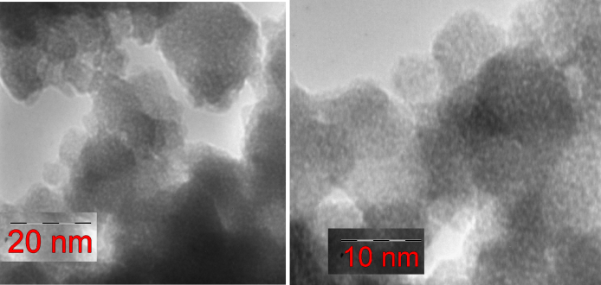
Fig. 1. The TEM micrographs of Ir_{x}SnO_{y}∙nH₂O nanolayer synthesized by SILD method and after heat-treatment at 300°C.

Biography
M.V. Kaneva is a PhD student at Saint Petersburg State University. She has published 3 articles in journals, indexed in Web of Science and Scopus. Her research interests include the synthesis of new electrocatalysts for hydrogen energy by successive ionic layer deposition method.
Presenting author details
Full name: Kaneva Maria Vitalievna
Contact number: +79091263739
E-mail: skt94@bk.ru
Session name/ number: Nanotechnology for Energy and Environment
Category: Oral presentation

