The Effect of Freeze-drying on Mucoadhesive Acrylated Chitosan Nanoparticles in the intestine Shaked Eliyahu The Russell Berrie Nanotechnology Institute, Technion-Israel Institute of Technology, Haifa, Israel

Abstract
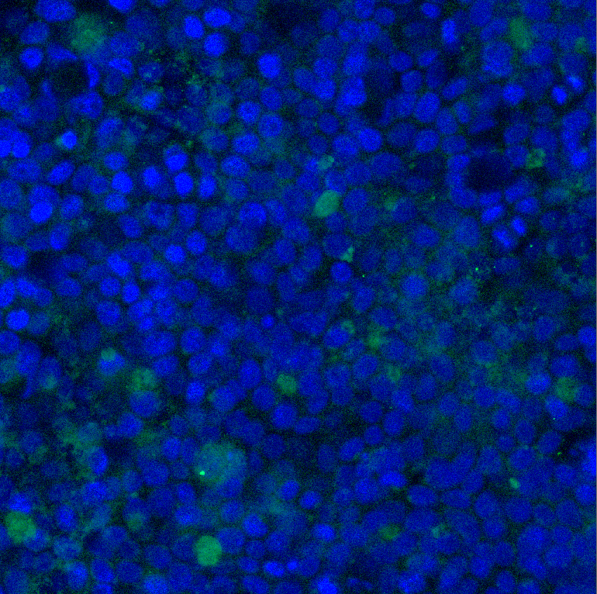
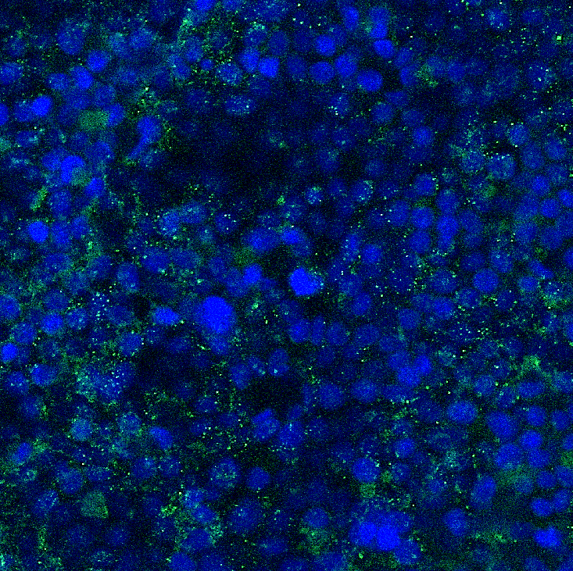
The ability to adhere to mucosal surfaces, termed mucoadhesion, has attracted much attention in the last few decades. This adhesive property is considered valuable for pharmaceutical purposes, as mucosal drug delivery has great potential to provide improved drug absorption and bioavailability. Recently we investigated a novel mucoadhesive nanoparticulte system composed of acrylated chitosan. These nanoparticles have not only demonstrated increased mucoadhesion, but also fast adhesion kinetics in the order of minutes. This new type of nanoparticles can be useful for prolonging the residence time of drugs in the gastrointestinal tract because of their improved mucoadhesion, yet the long-term stability of the formulation had to be improved. It is known that the stability of polysaccharide-based nanoparticles in aqueous solutions is limited, due to hydrolysis. Freeze-drying has been considered to be a good technique to improve the long-term stability of colloidal nanoparticles. Our overall goals are to engineer a mucoadhesive drug delivery system to the intestine based on acrylated chitosan nanoparticles and characterize its physico-chemical properties and its efficacy in a cell model monolayer which mimics the intestinal tract.
Fluorescent imaging from HT29-MTX cell monolayers used in the flow through assays. (a) Fresh FITC-labeled ACS nanoparticles, (b) Freeze-dried FITC-labeled ACS nanoparticles. Green and blue signals are from FITC and DAPI (cell nuclei), respectively. Scale bar of 20 µm.
(a)
(b)

Image

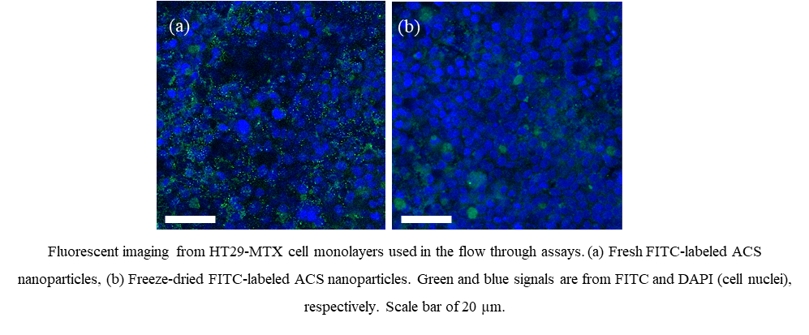
Recent Publications
- Eshel-Green, T., Eliyahu, S., Avidan-Shlomovich, S., & Bianco-Peled, H. (2016). PEGDA hydrogels as a replacement for animal tissues in mucoadhesion testing. International journal of pharmaceutics, 506(1), 25-34.‏
- Eliyahu, S., Aharon, A., & Bianco-Peled, H. (2018). Acrylated chitosan nanoparticles with enhanced mucoadhesion. Polymers, 10(2), 106.

 Biography (150 word limit)
As a PhD student in a multidisciplinary Nanotechnology program, I have had the opportunity to gain experience in several fields, including Bio-Nanotechnology, Emulsions, Physical and thermodynamic properties of polymers. My field of expertise is mucoadhesion of polymers. I believe in the importance of my research, which will hopefully be able to help millions of people worldwide.
Email: shaked@campus.technion.ac.il

Notes/Comments:

