Chloroform-injection (CI) and Spontaneous-phase-transition (SPT) are Novel Methods; Simplifying the Fabrication Liposomes with Versatile Solution to Cholesterol Contents and Size Distribution
Muhammad Ijaz Khan ^{1, 2}*, Naveed Ahmad ¹, Muhammad Farooq Umer ¹, Amina Riaz ¹, Nasir Mehmood Ahmad ³ and Gul Majid Khan ¹*,
¹ Department of Pharmacy, Quaid-i-Azam University, Islamabad 45320, Pakistan
² Department of Pharmacy, University of Swabi, Anbar, 23561, Swabi, KPK, Pakistan
³ SCME, National University of Sciences and Technology (NUST), H12, Islamabad

Abstract (300 word limit)
Statement of the Problem: Intricate formulation methods and/or use of sophisticated equipment limit the prevalence of liposomal dosage-forms. Simple techniques are developed to assemble amphiphiles into globular lamellae while transiting from immiscible organic to the aqueous phase. Methodology & Theoretical Orientation: Various parameters are optimized by injecting chloroform solution of amphiphiles into the aqueous phase and subsequent removal of the organic phase. Further simplification is achieved by reorienting amphiphiles through a spontaneous phase transition in a swirling biphasic system during evaporation of the organic phase under vacuum. Findings: Although the chloroform injection yields smaller size and PDI yet spontaneous phase transition method overrides simplicity and productivity. The size distribution of liposomes and solid/solvent ratio in both or any phases of formulation show direct relation. Surface charge dependant large unilamellar vesicles with a narrow distribution have PDI <0.4 in 10 µM saline. As small and monodisperse liposomes are prerequisites in targeted drug delivery strategies. Hence the desired size distribution <200 d.nm and PDI <0.15 is obtained through serial membrane-filtration method. Phosphatidylcholine/water 4 µmol/ml is achieved at a temperature of 10°C below the phase-transition temperature of phospholipids ensuing suitability for thermolabile entities and high entrapment efficiency. Both methods furnish the de-novo rearrangement of amphophiles into globular lamellae aiding in the larger entrapped volume. The immiscible organic phase facilitates faster and complete removable of the organic phase. High cholesterol content (55.6 mol%) imparts stability in primary hydration medium at 5+3°C for 6 months in light-protected type-1 glass vial. Conclusion & Significance: Collectively the reported methods are novel, scalable, time-efficient yielding high productivity in simple equipment.

Image
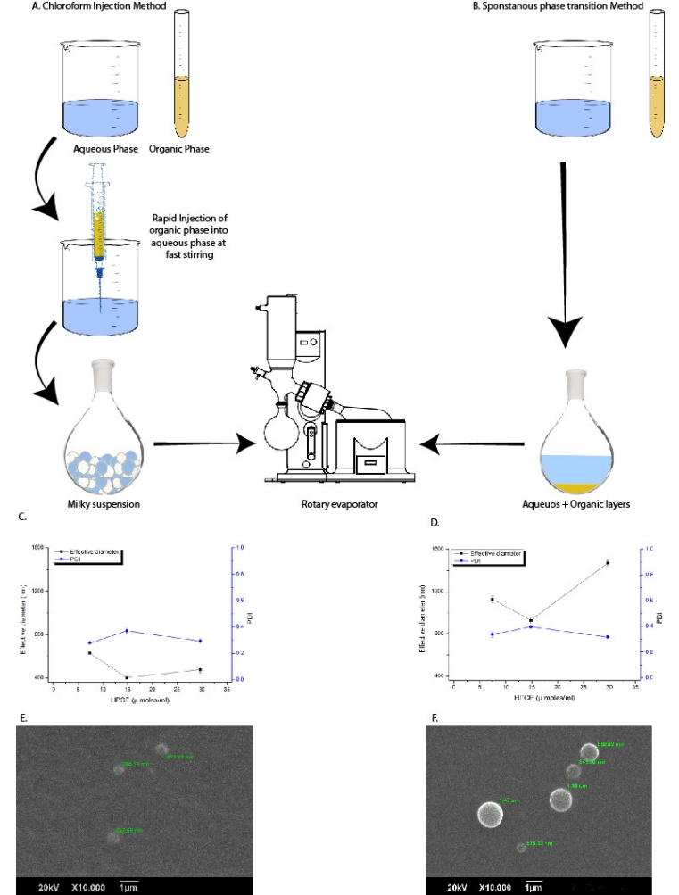
Figure1 Comparison of CI and SPT liposomes produced with optimized parameters and without sizing ^{a:} CI method ^{b:} SPT method ^{c:} Z-av and PDI of unsized CI-liposomes ^{d:} Z-av, and PDI of unsized SPT-liposomes ^{e:} SEM image of unsized CI-liposomes ^{f:} SEM image of unsized SPT-liposomes
Recent Publications (minimum 5)
- Patil, Y.P.S. Jadhav, Novel methods for liposome preparation. Chemistry and physics of lipids 2014. 177: 8-18.
- Wagner, A.K. Vorauer-Uhl, Liposome Technology for Industrial Purposes. Journal of Drug Delivery 2011. 2011.
- Kuroiwa, T., H. Kiuchi, K. Noda, I. Kobayashi, M. Nakajima, K. Uemura, S. Sato, S. MukatakaS. Ichikawa, Controlled preparation of giant vesicles from uniform water droplets obtained by microchannel emulsification with bilayer-forming lipids as emulsifiers. Microfluidics and nanofluidics 2009. 6(6): 811
- Mijajlovic, M., D. Wright, V. Zivkovic, J. BiM.J. Biggs, Microfluidic hydrodynamic focusing based synthesis of POPC liposomes for model biological systems. Colloids and Surfaces B: Biointerfaces 2013. 104: 276-281
5. de Meyer, F.B. Smit, Effect of cholesterol on the structure of a phospholipid bilayer. Proceedings of the National Academy of Sciences 2009. 106(10): 3654-3658.

Photograph
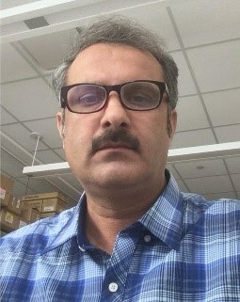

Biography
Mr. Muhammad Ijaz Khan is Assistant Professor in the Department of Pharmacy University of Swabi, KPK, Pakistan. He served various Pharmaceutical industries for 14 years before joining the academia. His professional skills include formulation development of various dosage forms, their validation and scale-up to commercial batch production. He has keen interest in natural medicines and their targeted delivery strategies. His research interest areas include neuroprotectives regimens for neurodegenerative diseases. He believes in targeted drug deliveries to overcome toxicities and improve amelioration. His key interests include monocytes mediated drug cargo to the brain in the treatment of neurodegenerative diseases. Unconventionally, he believes in the simplification of complicated scientific approaches to make them available for global humanity.
Email: ijazkhattak@uoswabi.edu.pk

Notes/Comments:

