Electronic, magnetic and magnetoelectronic properties of perovskite ABO₃ and double perovskites A₂BB'O₆: Density functional theory and Monte Carlo simulations
Rachid Masrour, PhD, Faculty of Sciences Dhar El Mahraz, Sidi Mohamed Ben Abdellah University, Fez,

Abstract (300 word limit)
In this work, we have studied the electronic and magnetic properties of ABO₃(B=Cr, Fe, Sr, M,..) and double perovskites A₂BB'O₆ (B=Cr, Sr, Fe, Mn,..; B’=Co, Fe, Mo, ..), by using the full potential linear augmented plane wave method employing the GGA approximation. The obtained results were used as input in Monte Carlo study with metropolis algorithm to study the magnetic properties of ABO₃ and double perovskites A₂BB'O₆. The obtained results are comparable with those obtained by experiments results.

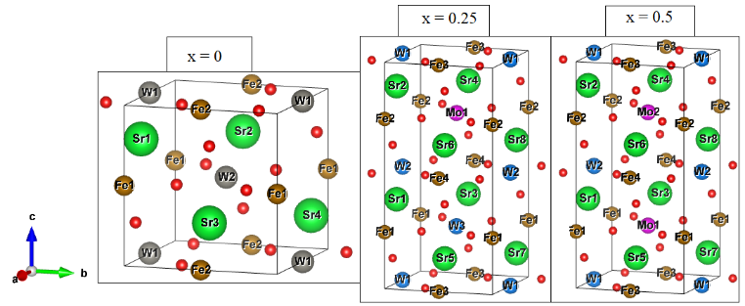
Crystal structure of 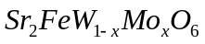
Recent Publications (minimum 5)
- R. Masrour, A. Jabar, G. Kadim, M. Ellouze. Inorganic Chemistry Communications 134 (2021) 109047
- S. Labidi, R. Masrour, A. Jabar, M. Ellouze. Journal of Magnetism and Magnetic Materials 523 (2021) 167594
- G. Kadim, R. Masrour, A. Jabar, E.K. Hlil. Physica A 573 (2021) 125936
- Poorva Sharma, R. Masrour, A. Jabar, Jiyu Fan, Ashwini Kumar, Langsheng Ling, Chunlan Ma, Caixia Wang, Hao Yang. Chemical Physics Letters 740 (2020) 137057
- A.S. Erchidi Elyacoubi, R. Masrour, A. Jabar. Applied Surface Science 459 (2018) 537–543
- G. Kadim, R. Masrour, A. Jabar. Journal of Crystal Growth 581 (2022) 126509
- M. Bessimou, R. Masrour, A. Jabar, G. Kadim, E.K. Hlil. Journal of Crystal Growth 581 (2022) 126497



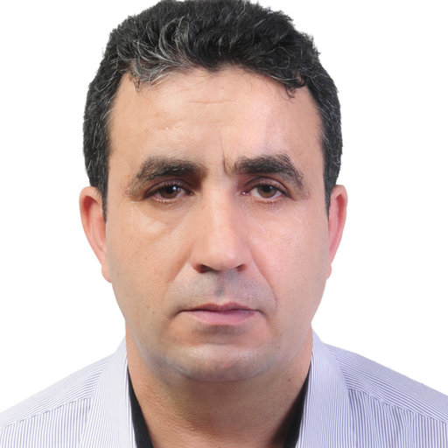Biography (150 word limit)
Rachid Masrour, from Morocco, actually, is research professor in the Faculty of Sciences at Sidi Mohamed Ben Abdellah the University, Fez, Morocco. Dr. Rachid Masrour completed his Ph.D. in March 2006 at same University. His research interests lie in the area of Solar energy, artificial neuronal networks Condensed Matter Physics. He has 280 articles published in Web of Science and 10 book chapters published in international journal. He participated in more 80 Moroccan and international congress. He's a Referee of a several articles and also Editorial Board Members in different international journal. He has a lot of collaboration with laboratories from abroad.
Email: rachidmasrour@hotmail.com
Notes/Comments:
Presenting author details
Full name: Rachid Masrour
Contact number:00212664317525
Twitter account:
Linked In account:
Session name/ number: Session name/ number: Session name/ number: Track 3-3Computational Materials Science
Category: (Oral presentation/ Poster presentation) Oral presentation

