Title: Development of ternary polymer blend nanofibers membrane as potential electrolyte for lithium ion battery
Deoram V. Nandanwar
Department of Physics, Shri Mathuradas Mohata College of Science, Nagpur, India
Email: deoram.nandanwar@yahoo.co.in

Abstract
Poly (vinylidene fluoride ) (PVdF), poly (methyl methacrylate) (PMMA) and polystyrene (PS) with different proportion of PMMA and PS nanofibrous blend polymer electrolyte membranes were fabricated by electrospinning, to study the effect of PMMA and PS on performance of lithium ion battery. The thermal and crystalline properties were characterized by thermo gravimetric analysis (TGA) and differential scanning calorimatry (DSC). PVdF: PMMA: PS nanofibrous polymer electrolyte membrane were prepared by soaking the blend nanofibrous membrane in 1M LiPF₆ (lithium hexaflurophosphate) in ethylene carbonate: Dimethyl carbonate (EC: DMC) in 1:1(v/v) ratio. PVdF: PMMA: PS (80:15:05) polymer electrolyte membrane showed highest ionic conductivity 2.50 x10⁻² S/cm and electrolyte uptake 544% at room temperature. After 50 cycles the discharge capacity 163 m Ah/g of Li/PE/LiFePO₄ cells with PVdF: PMMA: PS (80:15:05) polymer electrolyte membrane was found to be retain around 94.88%.The electrolyte uptake, ionic conductivity and discharge capacity retention were improved by optimizing the proportion of PMMA and PS in PVdF. Nanofibrous PVdF: PMMA: PS (80:15:05) polymer electrolyte membrane was found to be a good separator for lithium ion batteries.
Keywords: Polymer materials, Polymer composites, Polymer electrolyte, Nanofibers, Lithium ion battery.

Biography

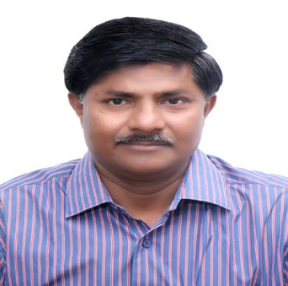

Deoram Nandanwar is presently working as Associate Professor in Post Graduate Teaching Department of Physics, Shri Mathuradas Mohota College of Science, Nagpur, India. He has published more than 60 research papers in reputed journals and conferences. Under his supervision 03 students have been awarded Ph. D. degree. Presently 05 Students are perusing their research work. He is recipient of “Best Teacher Award, Instituted by Nagpur Shikshan Mandal, Nagpur. He has authored 03 Books and 01 Chapter. He has presented research papers in 20 International Conferences in Singapore, Miami (USA), Stockholm (Sweden), Busan (South Korea) and Taipai (Taiwan) and India.

